Chapter 10 Standards
10.1 The Use and Abuse of the standards process
A recent blog post from the Vice President of technical standards at Qualcomm complained that the 3GPP standards process was being manipulated by other participating companies exploiting an overly simplistic contribution count system.Some might say this is an example of the pot calling the kettle black but the blog makes useful points about the need to improve the present standards process. In this Chapter we explore the inherent disconnects between standards making, spectrum allocation, auction policy and competition policy and suggest that an adversarial approach to the repurposing of spectrum and related changes to spectral access rights is not a good basis for standards integration.
But finding a better approach is not easy.
For vendors, the incentive for participating in standards groups is that 3GPP members can seek intellectual property rights in accordance with the IPR policies of the regional standards setting authorities, the European Telecommunication Standards Institute (ETSI), the Association of Radio Industries and Businesses (ARIB) in Japan, the Alliance for Telecommunication Solutions (ATIS) in the US, the China Communications Standards Association (CCIS), the Telecommunications Standards Development Society (TSDI) in India, the Telecommunications Technology Association (TTA) in Korea and Telecommunications Technology Committee (TTC) in Japan.
While this is understandable, it must be remembered that the purpose of a standard is to realize market efficiency by facilitating interoperability and market scale. In communication systems, interoperability and market scale are dependent on spectral harmonisation.
The harmonisation process and the standardization process has to be consensus based but in practice are influenced by special interests.
These special interests can be region or country specific and the differences can be subtle but significant, wider pass bands or different OOB requirements for example mean that either scale benefits have to be sacrificed or RF hardware has to be characterized for the worst case conditions, in this example the highest protection ratios. This will have an impact on device and network cost and performance.
The present structure used for 4G and 5G standards dates back to 1998 with the formation of 3GPP, partly driven by the recognition that US and rest of the world cellular standards needed to be brought together. Release 99 was the first standard issued by 3GPP with the intention that future Release dates would happen yearly. Given that we are now on Release 15 this has not quite happened, but the principle still applies.

Release 15 is the first Release to specifically address 5G physical layer standards and upper stack optimisation.
20 years of 3GPP standards have had to couple into 150 years of spectrum policy making under the auspices of the ITU. The ITU divides the world into three regions, Region 1 Europe and Africa, Region 2 America and Latin America and Region 3, the Asia Pacific and Australia.
Historically this has encouraged regional specific standards to be deployed into region or country specific spectrum, the Personal Digital Cellular Standard in Japan at 1.5 GHz and IS95 CDMA and IS54 and IS136 TDMA in the US 800 MHz band were two examples.
Legacy allocation decisions taken on a regional basis, for example the allocation of an ISM band between 902 and 928 MHz in the US continues to influence band plans and explains why the US does not have any 900 MHz cellular networks. An apparently minor regulatory decision can have a major long-term impact. A cellular band at 800 MHz in the US means that the whole sub 1 GHz band plan is different to the rest of the world.
However spectral access rights are ultimately a sovereign responsibility. Every nation has a right to the final say on how spectrum will be used within its borders provided that coexistence with other geographically adjacent countries meets internationally agreed criteria.
In practice scale economies dictate that counties chose to harmonise their spectrum band plans regionally and when possible globally.
There are however also operator specific requirements. These have become increasingly complex due to the perceived need to support channel aggregation.
Dish Networks Band 70 is an example from the US, a concatenation of their AWS 4 spectrum (2000MHz to 2020 MHz), their H Block PCS spectrum (1995-2000 MHz) and unpaired AWS-3 spectrum (1695-1710 MHz). Sprint are another US operator specific example with their ’Gigabit LTE’ tri band proposal combining their 800 MHz, 1900 MHz and 2.5 GHz band allocations.
3GPP address these regional, country and operator specific requirements by producing technical specifications - a specification, as the word implies, is specific to a particular requirement.
In 5G an additional level of complexity is introduced by the need to accommodate vertical markets. This is broadly covered by developing work streams for different requirements, for example enhanced mobile broadband (eMBB), massive machine type communications (mMTC) and ultra-reliable low latency communication (URLLC).
In practice, particular industries are going to have particular requirements that will need to be met. 3GPP has to work with parallel standards making organisations including IEEE and higher layer protocol standards bodies such as the IETF developing vertical market specific profiles and with the vertical market standards bodies. Utilities for example have different standards in different countries, even countries within the EU can have marked differences in the way that electricity, water and gas are managed, monitored, measured and regulated.
The ongoing work to develop a 5G automotive industry offer is another example. Automotive industry standards are at least as complex as telecommunication standards and have multiple touch points with IEEE standards making including 802.15.4 and 802.11 based connectivity. Specifically, work outputs from 5GAA (the 5G automotive association) will need to be closely coupled with IEEE 802.11p standards and spectrum band plans.
This is made harder by the move within 3GPP to introduce licensed spectrum standards into unlicensed spectrum (LTE-U and LTA Licensed Assisted Access). Coexistence issues whether real or imagined are not a good basis for constructive standards engagement.
However there will also be a need to integrate 5G vertical market work items with vertical market work outputs from other parts of the telecommunications supply chain including the satellite industry. The announcement that the Non Stand Alone (NSA) implementation of the 5G ‘new radio’ (NR) physical layer will be complete by the end of this year with large scale trials and deployments in 2019 suggests an ambition that will not be welcomed by the existing satellite operator incumbents in the target bands (3.5 GHz, 4.5 GHz, 28 GHz and 39 GHz).
This brings us to the thorny question of competition policy.
The purpose of competition policy or the related discipline of antitrust policy is to counter monopolistic behaviour and to ensure efficient markets.
Antitrust legal cases can take years to resolve. Intel is still fighting a $1billion dollar fine imposed seven years ago by the European Commission for alleged anti-competitive behaviour against AMD. Qualcomm has been facing resistance from the European Commission to their proposed takeover of NXP.
The mobile operators are additionally constrained by auction policies which are country specific but which have generally followed the principle that five operators per market produce the most market effective though not necessarily most cost effective outcome. In practice deploying multiple parallel networks can be ludicrously wasteful and particularly expensive for market entrants who do not have existing fibre and site assets.
The standard process in its own right could be considered anti-competitive because it makes market entry disproportionately expensive, a lesson that Intel and Broadcom learnt with LTE.
However it is easy to identify weakness in existing practices and processes but hard to suggest better alternatives. To quote Mr Churchill, ‘Democracy is the worst form of government except for all the others’ and it may be that our existing standards and spectrum policy making procedures are as good as they are going to get.
With the words of Mr Churchill ringing in our ears let us move on to the magical world of 5G and satellite standards.
10.2 5G and satellite 3GPP Release 15 Work Items
There have been several unsuccessful attempts to develop integrated mobile broadband and satellite standards for example in 3G with the S-UMTS standard.
There have also been attempts to standardize hybrid terrestrial and satellite connectivity through the Auxiliary Terrestrial Component Specifications in the US, Canada, Europe and Asia and in China, the Satellite and Terrestrial Multi Service Infrastructure.
At a 3GPP Technical Standards (TSG) Group meeting in March 2017, it was agreed that a 5G and non-terrestrial networks (NTN) study would be produced within the 3GPP Release 15 standards process (New Radio NTN, NR.NTN).
The sponsors include Thales, Dish Networks, Fraunhoffer, Hughes, Inmarsat, Ligado, Motorola, Sepura (emergency service radio), the Indian Institute of Technology, Avanti, Mitsubishi, China Mobile and Airbus Group.
A list of sponsors is not a guarantee of future progress but at least a minimum of progress has been made. The relevant standards references are linked to use cases as listed below:
- the support of “5G connectivity via satellite” within 3GPP TR23.799
- the “Higher availability” requirement within 3GPP TR22.862
- the “Wide Area Connectivity” requirement within 3GPP TR22.863
- the “Satellite Access” requirements within 3GPP TR 22.864
- the “5G Connectivity Using Satellites” use case of 3GPP TR 22.891
- the “Satellite extension to Terrestrial” within 3GPP TR 38.913
The definition of a non-terrestrial network is a network or segment of networks using an airborne or space borne vehicle for transmission. Space borne vehicles include LEO, MEO and GSO satellites and Highly Elliptical Orbiting (HEO) satellites). Airborne vehicles include Unmanned Aircraft Systems (UAS), tethered UAS (blimps), Lighter than Air UAS (LTA), Heavier than Air UAS (HTA) and High Altitude UAS Platforms (HAPs).
The statement of work states the desired outcome as:
- Enabling ubiquitous 5G service to UEs (especially IoT/MTC, public safety/critical communications) by extending the reach of terrestrial based 5G networks to areas that cannot be optimally covered by terrestrial 5G networks.
- Enabling 5G service reliability and resiliency due to the reduced vulnerability of air/space borne vehicles to physical attacks and natural disasters. This is especially of interest to public safety or railway communication systems.
- Enabling connectivity of 5G-RAN elements to allow ubiquitous deployment of 5G terrestrial networks.
- Enabling connectivity and delivery of 5G services to UE on board airborne vehicles (including air flight passengers, UASs and drones).
- Enabling connectivity and delivery of 5G services to UE on board other moving platforms such as vessels and trains.
- Enabling efficient multicast/broadcast delivery of services such as A/V content, group communications, IoT broadcast services, software downloads (for example to connected cars) and emergency messaging.
- Enabling flexibility in traffic engineering of 5G services between terrestrial and non-terrestrial networks.
The Release 15 work items are divided into two activities:
Activity A:
- Study Physical layer impact through the characterisation of the operational conditions of NR (New Radio) in the non-terrestrial networks. Key design requirements will be identified along with possible solutions for an efficient operation of NR.
- Characterise the operational conditions of NR in selected non-terrestrial networks, identify key design requirements and issues that need to be solved for an efficient operation of NR such as synchronization, initial access, random access, data channels, channel estimation, low PAPR modulation, link establishment/maintenance, focussing on:
- Channel model: Study whether existing channel models (3GPP or ITU) can be applied for these links and identify/define improved channel model(s) if necessary. In addition to the outdoor-to-outdoor, the study shall include outdoor-to-indoor scenarios (e.g. providing services to UEs inside a ship, train, or building). [RAN1]
- Interference: Non-terrestrial systems have different interference characteristics (intra and inter systems) compared to traditional cellular networks. Thus, one objective of this study is to understand the interference characteristics. [RAN1]
- Doppler effects: Characterise the impact and identify solutions to compensate for Doppler shift and its spread associated with non-terrestrial communication links. [RAN1]
- Propagation delays: Characterise the impact of Propagation delay associated with non-terrestrial communication links (Non-terrestrial vehicles operate at various altitudes from very low and comparable to terrestrial networks as UAS and HAPs to Low and medium altitude LEO/MEOs as well as high altitude GEO/HEOs) and identify appropriate solutions. [RAN1]
Activity B:
- Study impact on Layer 2 and above, and RAN architecture based on NR (New radio) Phase 1 findings and other operational requirements.
- In this activity, requirements related to higher layers will be studied and potential solutions will be identified including analysing their performance gains. In particular, the following aspects will be studied.
- Propagation delay: Identify solutions related to Layer 2 protocols and timing relationships to support non-terrestrial network propagation delays. [RAN2]
- Inter RAT Handover: Study and identify mobility requirements that may be needed for some non-terrestrial vehicles (such as LEO/MEO satellites) that move at much higher speed but over predictable paths. [RAN2]
- Architecture: Identify needs for the 5G’s Radio Access Network architecture to support non-terrestrial networks [RAN3]
The study has to be regarded as only the start of a potentially long and difficult journey. The table below lists nineteen 3GPP work groups that would need to be included in order to realize a comprehensive implementable and testable global standard.
Additionally the group only started work in October 2017.
Figure 10.1 3GPP Work Groups
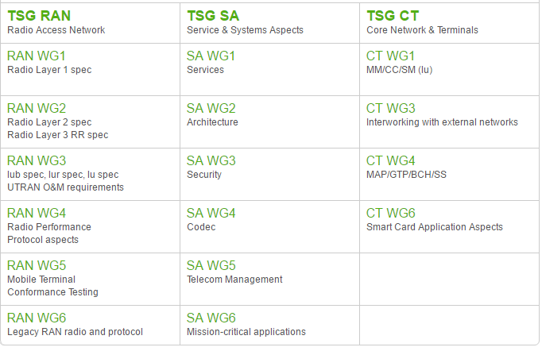
Generally speaking, the satellite industry does not have a legacy of robust standards making and has a history of implementing a range of different system specific proprietary air interfaces that are only compatible at the higher layers of the protocol stack. This frustrates potential economies of scale particularly in terms of RF hardware compatibility.
10.3 Parallel Guided Media Standards
Mobile broadband operators and their vendors and satellite operators and their vendors assure us that our wireless connectivity experience will be similar and sometimes better than our wireline connectivity experience.
In practice the wireline connectivity experience is steadily improving and represents a moving target which wireless needs to track. This implies a need to keep an eye on copper, cable and fibre standards.
This includes standards such as DOCSIS 3.0 and 3.1, vectored VDSL and G.fast variants, and the recently announced MoCA Access. So copper still counts and it is getting better or rather we are able to access more channel bandwidth by working at higher frequencies, for example 8.5 MHz, 17.7 MHz and 35.33 MHz
Figure 10.2 Coaxial and copper standards 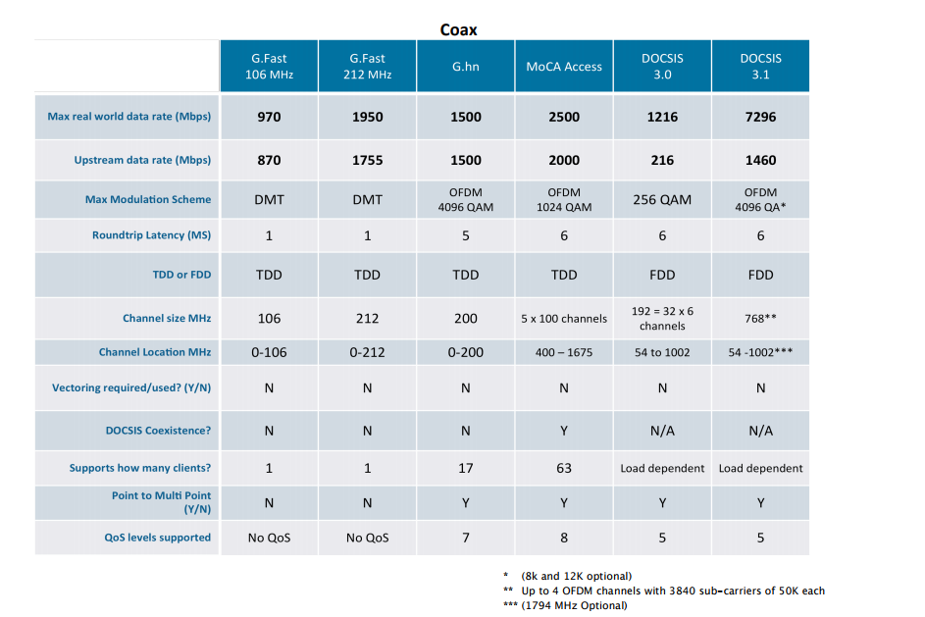

https://www.qualcomm.com/news/onq/2017/08/02/top-5-drawbacks-contribution-counting-3gpp-dont-count-it
http://tec.gov.in/pdf/Studypaper/S_UMTS_Final.pdf
http://www.ic.gc.ca/eic/site/smt-gst.nsf/eng/h_sf09857.html
http://www.rttonline.com/tt/TT2010_011.pdf
3GPP TSG RAN meeting#75, RP-170132

