Chapter 9 Commercial innovation
Throughout this book we have been arguing the case for collaboration between the 5G mobile broadband community and national, regional and sovereign satellite operators.
While fine in theory, potential collaboration even if perceived useful is frustrated by an adversarial spectrum auction and allocation process. This can only be resolved if both parties recognise that they have a problem to solve and that the other party is part of the solution.
Other third parties and their supply chains also have a role to play, for example the automotive industry. Automotive manufacturers need to add value to their products and connectivity is part of the answer. In return they offer scale by volume and value. Ford sell over 6 million cars per year. Theoretically at least, every car could function as a base station and be connected by satellite. Our task in this chapter is to explore how commercial innovation can create this type of scale opportunity.
9.1 The problem that the satellite industry needs to solve – a lack of scale
We finished our last Chapter with a brief review of the Apple3 Watch, making the point that products that set new benchmarks for functionality in a small form factor require market scale to be viable. Scale viability can be estimated in terms of customer reach, cash resources or borrowing capability or some combination of all three.
9.2 The double dozen rule.
As a rough rule of thumb, scale viability in the global smart phone and 4G and 5G infrastructure industry requires an annual R and D budget of the order of $12 to $14 billion dollars. This is typically 12 to 14% of the turnover of companies such as Samsung or Apple. We call this the double dozen rule. The 4G and 5G base station and infrastructure business has a similar scale. Ericsson, Nokia and Huawei all have R and D budgets of the order of $12 billion to $14 billion per year which is 12% to 14% of their revenue.
Being in the double dozen club does not however guarantee success. In the last Chapter we referenced the investment by Google of over $12 billion dollars in Motorola Mobility with the business sold to Lenovo three years later for $3 billion. Being the world’s favourite search engine has not to date translated into smart phone market success. HTC, the company from which Google bought the team that designed and manufactured their first smart phone was in the double dozen club, but its own smart phone market share dropped from 12% to 1 %. Intel invested at least $12 billion dollars attempting to buy market share in the LTE baseband business. Broadcom tried a similar strategy and ended up merging with Avago, a much smaller but in retrospect more prudent company.
Joining the double dozen club does not come cheap either. Tesla are spending more on research and development and manufacturing investment, those three lovely factories, than they are earning from their combined automotive and energy businesses. This is only possible because the venture capitalist and investor community believe the company has sufficient future earnings potential to provide a return on the risk.
9.3 National, regional and global operator national, regional or global scale.
Self-evidently with 4 billion customers the mobile industry does not have a scale issue but with over 600 individual operators world-wide it is inevitable that some of them or even many of them are sub scale indeed our very good friends at MOWO Global are of the opinion that only the top ten operators in the world are scale efficient. Scale efficient operators do not necessarily have to be global operators. AT&T are a national operator with limited holdings in rest of the world markets, but their home market has sufficient scale by volume and value to provide a comfortable profit base. AT&T is also profitably invested in fibre, copper and cable assets. Telstra in Australia are in a similarly fortunate position. The US and Australia are high ARPU markets and AT&T and Telstra both have an EBITDA well above the industry average. The National Broadband Network operated by Telstra in Australia provides a reasonably cost-efficient mix of LTE mobile and fixed wireless and fibre with deep rural coverage and some back haul provided by two geostationary high throughput satellites. The GSM network was turned off in 2017.
Figure 9.1 The NBN in Australia
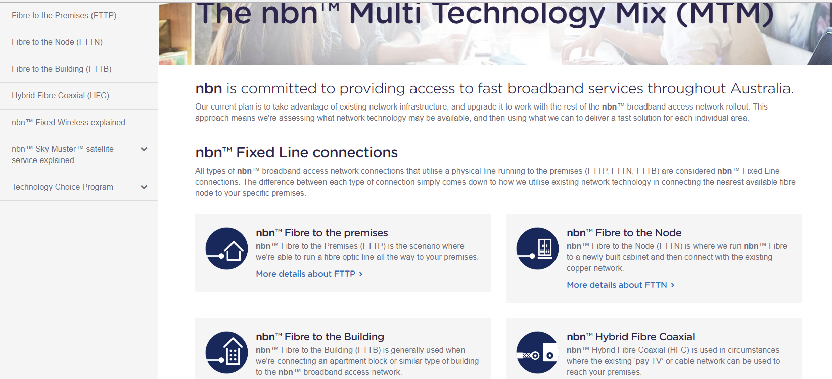
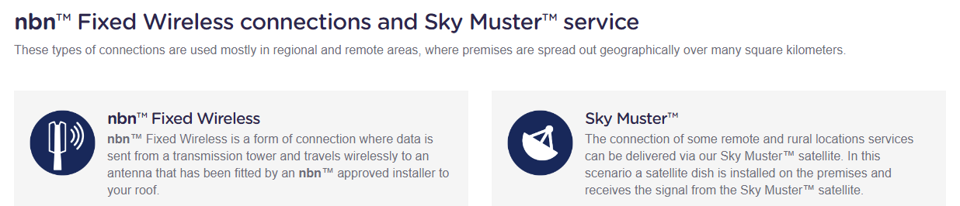
China Mobile is also an example of a national operator with a local market large enough for it to be the world’s largest operator by volume and one of the largest operators by value.
There are also successful though highly geared operators such as Telefonica who started off as regional operators (Latin America and Spain) and then expanded to other markets, including for Telefonica, the UK.
Going in the other direction, Vodafone started in the UK in 1985 as Racal Vodafone to provide competition for BT Cellnet. In the heady days of the 1990, s, Vodafone’s share price soared but the tiger of the stock market needed to be fed with year on year growth which could only be achieved by aggressive overseas expansion. Thus, Vodafone became arguably the first truly global mobile cellular operator. Many of the national operations retain substantial management and financial independence though research and development and global strategy are overseen from the UK. Other operators also have substantial holdings in markets overseas. These are reported in their corporate annual returns as ‘proportionate subscribers’. More recently newer companies such as Digicel have moved from being a national operator to regional to aspiring global operator.
Whether this is the start of a trend towards more global companies running what looks to the user or corporate customer like a global network is probably going to be determined by regulatory and competition policy. In the 1990, s Professor Martin Cave at the University of Manchester came up with the theory that the price of spectrum would be maximised if 5 operators were allowed and encouraged to engage in the bid process. This was a popular theory with regulators and widely adopted throughout the world. It was less popular with operators and in many markets the five-operator model has proved to be commercially and technically inefficient. This is particularly the case for smaller operators who come into markets years after the incumbents. Companies already operating networks had often started life as a monopoly national operator or been part of a long-term duopoly. The US market is an example. These established operators have customer assets, site assets and backhaul assets including fibre. Regulators can and do legislate to try and enforce fair access for example to fibre but this is often a less than perfect process. The problem becomes more acute as terrestrial networks densify. Hardware costs reduce but the cost of digging holes in the ground remains constant. This is an opportunity for satellite operators though by implication it means they are engaging with the smaller operators in each market.
9.4 The impact of standards on commercial innovation
The emergence of GSM as an increasingly dominant global standard meant that global operators could benefit from global scale. Alternative technologies continued to be promoted during and after the introduction of 3G, most notably Wi-Max and were modestly successful mainly because 3G had underlying power efficiency and performance issues. LTE, first introduced in 2009, has had its critics and some would argue wrongly prioritised spectral efficiency over power efficiency. It has however become almost completely dominant across the world and now works rather well. Its success has been consolidated by the relentless rise of the smart phone as the companion of choice for billions of subscribers. Standards are critical to the process of commercial innovation and cost reduction including the active management of intellectual property costs through the FRAND process. The amount of man hours spent in standards meetings is awesomely large, bigger even than the number of man hours spent on spectrum issues. The satellite industry has nothing remotely similar in scale. The standardisation of the SIM thirty years ago provided the foundation for the fabulously profitable global roaming industry. Standards delivered the market scale to make smart phones viable. Standards have provided the framework on which modern app stores are built and cloud computing is delivered. Standards are enabling operators to develop new markets such emergency service provision and industrial and consumer IOT.
9.5 Do mobile operators have any problems they need solving?
Overall it could be said that mobile operators see have spent the last thirty years managing rather well. They have managed to implement four technically complex standards and oversee a spectrum allocation and auction process that is byzantine in its complexity and developed a business that has grown from no subscribers to four billion subscribers, many with multiple devices.
9.5.1 Backhaul costs, public safety and deep rural and desert coverage
However, there are problems emerging where the satellite industry could be the solution or at least a part of the solution. We have already mentioned backhaul. Mr Musk, never a man to be underestimated, believes the SpaceX constellation could deliver 50 percent of all terrestrial backhaul communications traffic and up to 10 percent of local internet traffic in high-density cities. OneWeb have stated that they are confident they can substantially reduce 5G backhaul costs both in dense urban and deep rural areas and provide more cost effective mobile and fixed broadband geographic coverage for rural connectivity. This includes IOT connectivity and developing market connectivity where base station electricity is particularly expensive. These are statements of intent rather than reality but provide an insight into the ambition and fiscal need of the NEWLEOS to couple with the cellular industry more closely.
We have also suggested that counter intuitively, satellite systems, particularly LEO satellite systems with inter satellite switching can deliver long distance end to end latency gain but the biggest opportunities are probably determined by the fact that many of the emerging applications in 4G and 5G require geographic rather than demographic coverage.
AT&T and their FirstNet contract provide a contemporary example. This is the first foray by AT&T into providing services to the public safety sector. The traditional two-way radio industry has a seventy-year history of servicing mobile radio connectivity to emergency services such as the police, fire brigade, ambulance and ‘first responder’ public protection and disaster relief agencies but has struggled to keep pace with LTE device and network functionality. This is because it is a relatively small market with at least three competing technical standards. AT&T have been gifted 20 MHz of 700 MHz spectrum and draw down rights on $6 billion dollars of funding to deliver the geographic data and voice reach needed for the First Responder market in the US. BT and EE are structuring a similar deal in the UK and this looks likely to become a default approach to next generation public safety and protection mobile connectivity.
Whether this is an opportunity or a challenge for the satellite industry is open to debate. AT&T and any other operator with emergency service sector ambitions will need to invest substantial amounts of money in new sites to meet the geographic service obligations of these new contracts. While it is unlikely that satellite functionality will be added in to LTE 700 MHz FirstNet smart phones, it might make economic sense to provide LTE compatible and in the longer term 5G connectivity to emergency service vehicles.
This amounts to many thousands of vehicles and highlights the fact that satellites are often a more effective and efficient option for connecting objects that move particularly objects that move quickly which includes trains and boats and planes. Bear in mind that there are 11000 registered passenger planes in the world, (very hard to service from a 4G or 5G terrestrial network, 50,000 registered merchant ships, (impossible to service from a terrestrial 4G or 5G network), 1.5 billion cars in the world (more efficiently connected via a satellite network particularly from high inclination angles). No one seems to know how many trains there are in the world. It is possible to connect a train travelling at up to 500 kilometres per hour with an LTE network but not particularly efficient. The handover rate from a satellite network will be lower and in many cases, the link will be line of sight, for example down into railway cuttings.
There are also 7.5 billion people in the world which given that there are ‘only’ 4 billion cellular phone users suggest there are 3.5 billion people who are living without the delights of a smart phone. However, many of them are living at close to subsistence in deep rural areas and the deserts of the world. This is the geographic scale problem compounded by the demographic scale problem. A lot of countries have a lot of empty space where few people live and the ones that do live there do not earn or own very much. This paragraph for example is being written on a plane two hours from Sydney having spent the last two hours flying over more or less nothing else but desert and Australia is a small country (4000 kilometres west to east) compared for example to Africa (8000 kilometres north to south).
Figure 9.2 How small is Australia
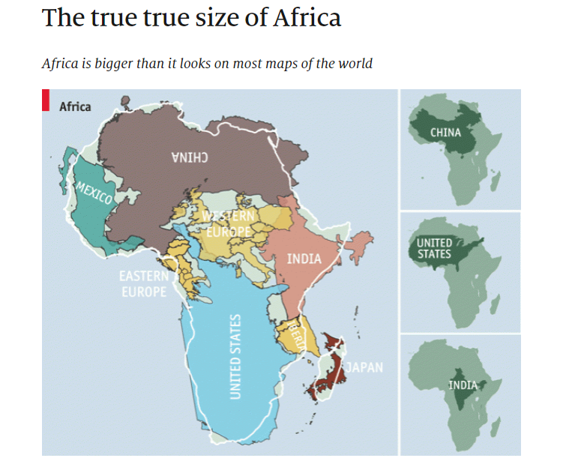
Figure 9.2 shows the true enormity of the African sub-continent, easily swallowing the United States, China, India, Eastern Europe, France and Spain and it has very little fibre.
Device costs and network costs however must be at least two orders of magnitude lower to make services affordable to the for people living in these empty places.
9.5.2 The deep rural network and device cost issue and satellite solution
In effect this means producing a smart phone for the cost of a transistor. Even if Softbank persuaded ARM to persuade its customers to give their chips away for free it is hard to see how this could be realised even for a simple Wi-Fi enabled device.
The answer is to find another reason to provide connectivity. Figure 9.4 shows what is effectively a Coca Cola vending machine on wheels and at least partly explains why Coca Cola were an early investor in the OneWeb consortium (add in Coca Cola turnover).
Figure 9.4 The Coca Cola Network
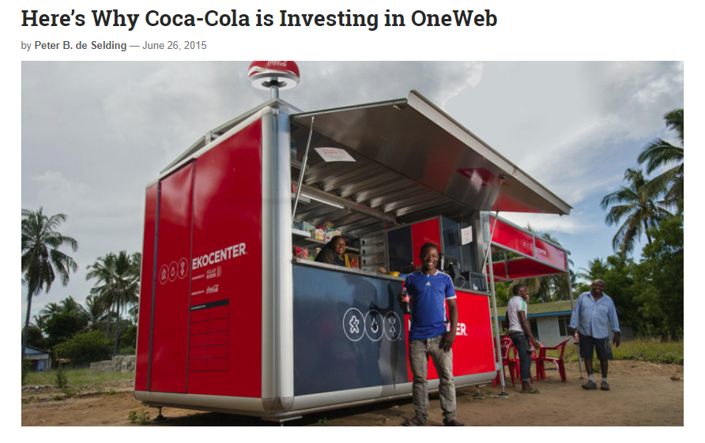
The project is linked to the Coca Cola 5.20 campaign which aims to create five million women entrepreneurs by 2020. You might say this is cynical public relations, but the net outcome is worthwhile though not great for the dental health of Africa and other developing economies.
Figure 9.5 The Coca Cola 5.20 campaign
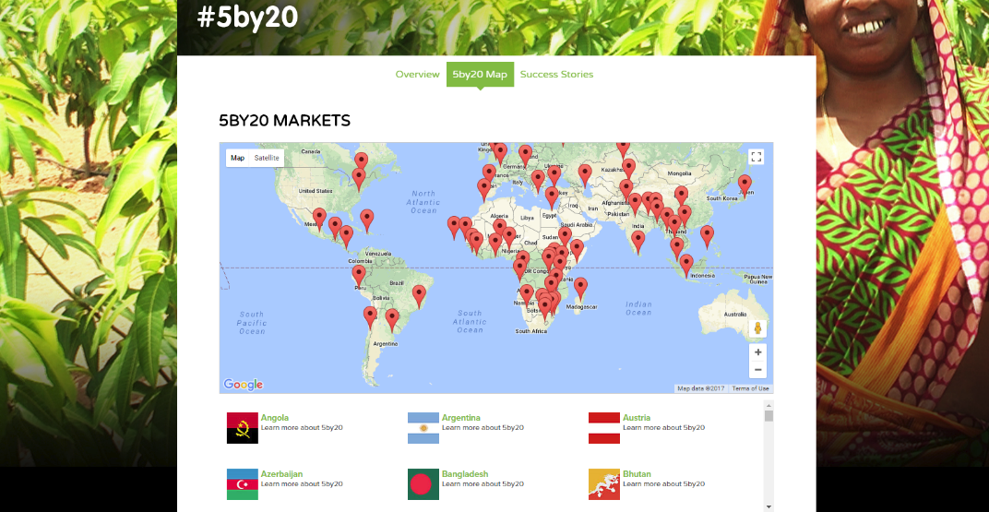
In October 2015 Facebook and Eutelsat made an agreement to provide Wi-Fi to Africa via the AMOS Ka-band GSO satellite as part of Mark Zuckerberg’s internet.org initiative. The intended footprint is shown in Figure 9.6
Figure 9.6 Beam coverage from the AMOS Ka-Band satellite
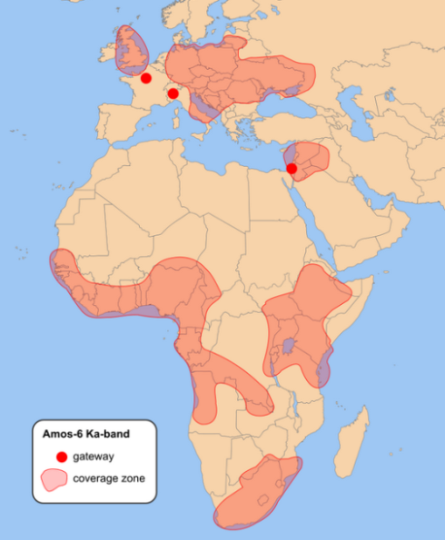
In practice there was a launch failure and the satellite was destroyed on the launch pad but Mark Zuckerberg, the founder of Facebook, remains committed to developing low cost world connectivity projects. This can only happen if device pricing drops to $30 dollars with monthly connectivity costs at a similar level. The connectivity cost is shared between multiple users on the local Wi-Fi. Progress with a pilot project in Uganda suggests that this is achievable. Zuckerberg has announced similar plans for Indonesia.
9.5.3 Low cost IOT- can satellite deliver?
This issue of device and service cost translates across into the industrial and consumer IOT market. In an earlier chapter we referenced Orbcomm as an example of VHF satellite IOT connectivity coupled with an Inmarsat L band and cellular modem. However, their users are large heavy earth moving machines and ships, the internet of large expensive slow-moving objects. The NEWLEO players talk of IOT as a major market but they are competing with long range sub GHz narrow band terrestrial modems and with terrestrial LTE.
Figure 9.7 Orbcomm OG2 satellite modems
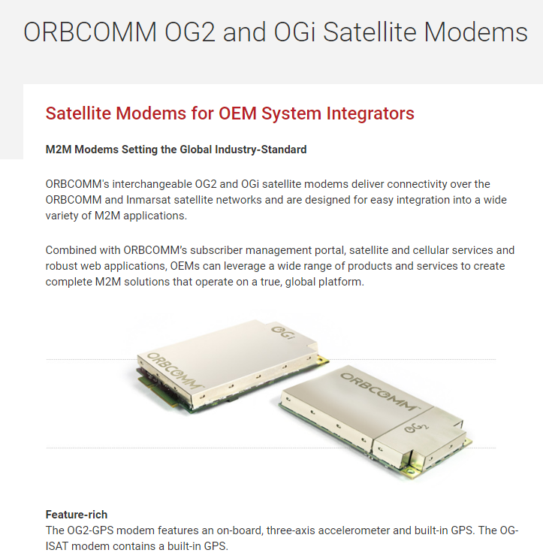

Chinese vendors are crashing the cost and price of 4G LTE devices and network hardware. These cost levels are being matched (reluctantly and with some difficulty) by Ericsson and Nokia. The result is that Verizon can introduce sub $30 Cat 1 LTE modems coupled to $2 dollar per month access costs and have stated a longer-term ambition to reduce device cost down towards $3 rather than $30. Whether satellite operators would be willing or able to match these price levels is open to debate. The difficulty is that you cannot charge one set of customers $2 dollars per month for IOT connectivity and another set of customers $200 dollars per month for the same thing. The same tension exists between the legacy SATS and NEWSATS. The legacy SATS have borrowing ratios based on high margins. Reducing margins in anticipation of volume gains that may or not materialize is not intrinsically attractive.
9.5.4 Terrestrial trash bin Wi-Fi- competition or a new target market
Sometimes also there may be a local connectivity solution which is more cost efficient because the site costs are amortized by some other function. An example from Singapore is the use of trash bins to provide Wi-Fi from11.00 am to 5.00pm? Note that this would not work in all countries. Trash bins do not normally have power available and are not normally connected to the internet. If they are connected then you know they are full or probably as important, know when they are not full and do not need emptying. Whether this delivers sufficient value to justify satellite connectivity is open to debate.
Figure 9.8 Rubbish Wi-Fi in Singapore?
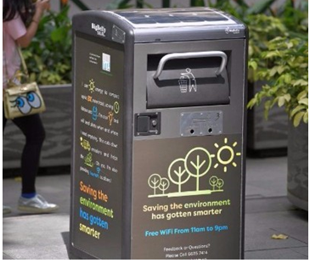
9.5.5 Energy and carbon targets- can satellite deliver?
While we are on the topic of recycling and saving the world, can satellites help 5G to meet its energy efficiency and carbon targets? And what are those targets? Hidden deep in the IMT specification documents is a general statement that the energy consumption for 5G should not be larger than present LTE networks. In the NGMN White Paper on energy efficiency the suggestion is that the energy consumption should not be larger than half of existing network consumption but that the network should be capable of supporting a 1000X capacity increase. 3GPP wants to study the topic in more detail. Most discussion documents reference small cells as part of the solution but as already suggested there is strong evidence that small cells increase rather than decrease energy consumption. The positive start point is that existing networks send most of their RF energy in the wrong direction or backwards. The wrong direction issue can be resolved by using narrow beam width antennas and dynamic beamforming though this can consume significant processing power (though also reduces system to system interference so you may have helped someone else meet their energy targets). The issue of energy going backwards can be resolved by improved matching in RF fronts ends particularly at higher frequencies.
9.6 Above the Cloud Computing- Ali Baba and Ten Cent as the future?
But at least we can measure and manage how much damage we are doing to the planet and make some money out of gathering the information, analysing the information and selling the information back to the agencies who are charged with the task of telling us what to do. In an earlier chapter we referenced Planet.com as an example of a space based earth imaging and sensing platform. We can only manage a problem when we can measure it so the start point is to find an efficient way of delivering the measurement process. In a roundabout way that brings us to cloud computing and its role as an enabler of commercial innovation in the 5G and satellite industry.
In our opening chapter we provided an example of the Beach in Bournemouth as an analogy of how value can be derived from monitoring how we interact with the physical world around us. I am writing this paragraph in a kitchen in my cousin’s house in Sydney (I have finished flying over the desert, that was earlier in the Chapter) and I am uploading the text to somewhere in the cloud over Wi-Fi though it might be LTE but in the process someone somewhere knows where I am and what I am doing. The general point to make is that commercial innovation in the 5G and satellite industry is not just about connectivity but the control of that connectivity.

Average Revenue Per User
https://www.nbnco.com.au/learn-about-the-nbn/network-technology.html
Fair Reasonable and Non-Discriminatory- the process of arbitrating intellectual property disputes.
http://www.worldatlas.com/
https://spaceflightnow.com/2016/09/01/spacex-rocket-and-israeli-satellite-destroyed-in-launch-pad-explosion/
https://info.internet.org/en/ and;
https://techcrunch.com/2017/02/27/facebook-digs-into-mobile-infrastructure-in-uganda-as-tip-commits-170m-to-startups/
Recommendation ITU-R M.2083-0
https://www.ngmn.org/5g-white-paper.html
3GPP TR 38.913 (section 7.19)
https://www.planet.com/

