Chapter 8 Production and Manufacturing Innovation
8.1 Aviation Manufacturing- A Fairy Tale
In a previous incarnation, the author sold spot welding equipment. The Hawker Siddeley Company in in Kingston was a customer. The company employed 5000 skilled craftsmen to assemble parts for the Harrier Jet including a small army of men in leather aprons hand fettling titanium cowlings with small hammers.
15 years earlier (in 1963) Prime Minister Harold Wilson gave a famous speech about ‘The White Heat of Technology, talking about how Britain would remain at the forefront of technology and manufacturing innovation. The Hawker Siddeley Factory could best be described as the Snow White Heat of Technology.
Figure 8.1 The Hawker Siddeley Head Office in Kingston- now a luxury housing estate
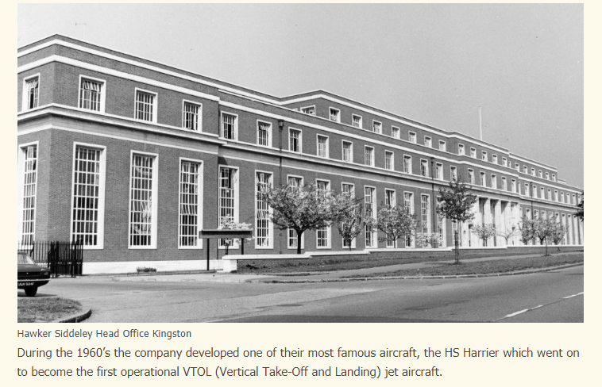
Even forty years on the manufacturing of fighter jets remains essentially a craft industry. The companies that build fighter jets also build satellites. Hawker Siddeley for example was nationalized in 1977 (those were the days) and became British Aerospace and in 1999 became BAE systems. BAE is a joint contractor with Lockheed Martin on the F35 fighter jet. This $1.3 trillion dollar project is at time of writing $387 billion dollars over budget.
8.2 Satellite Manufacturing- a similar story?
So is satellite manufacturing still a craft industry?
To an extent, yes
The satellite industry has spent the last sixty years servicing customers who either cannot be connected any other way or who find it difficult to connect via terrestrial networks. The industry is currently based on a low volume (both for satellites and terminals)/high cost business model and has been able to be keep device and access prices at a relatively high level when compared to terrestrial networks.
The satellite industry supply chain has always been sustained by high added value defence work and this remains as a dominant source of margin and profit. It also means the supply chain is not geared up to deliver low cost devices or low cost network hardware and software and system support. Companies like Lockheed Martin or Boeing or Airbus or Thales or Hughes or Northrop Grumman are not structured to deliver equipment at consumer price points.
However this started changing twenty years ago when Motorola set out to source the first generation of Iridium satellites using what at the time was a large number of satellites (66 satellites + 6 orbital spares) as the basis for a horizontally integrated moving production line which by 1997 was capable of producing a satellite in 4.3 days. Motorola had the advantage of significant experience in handset and base station manufacturing including a rigorous Six Sigma approach to quality which was transferred very effectively across to the production line. Note that Six Sigma was explicitly a quality standard aimed at reducing build cost both for the satellites and back through the supply chain. The fact that the satellites lasted three times as long expected (21 rather than 7 years) suggests that this marked a significant move forward in satellite manufacturing. This was achieved without the added cost of a clean room environment or use of traditionally space qualified components. Boeing is using similar production line techniques for replacement GPS satellites albeit at lower volumes
Twenty years on Iridium have produced their NEXT generation satellites at the Orbital ATK Satellite Manufacturing Facility in Gilbert, Arizona under the supervision of the lead contractor Thales with a total production run of 81 satellites (66 +9 orbit spares +six ground spares). Orbital ATK was acquired by Northrop Grumman in October 2017.
Thales was also the lead contractor for the replacement satellites for the Globalstar constellation. Globalstar claim that the build out cost for the replacement at $1 billion was 20% of the build out cost of the original constellation ($20 billion). Part of this saving can be ascribed to lower production and manufacturing costs.
OneWeb have stated that they need to need to produce 15 satellites a week from their new Florida based production facility, a joint venture between OneWeb and Airbus.
Figure 8.2 OneWeb announcement of the Florida manufacturing facility
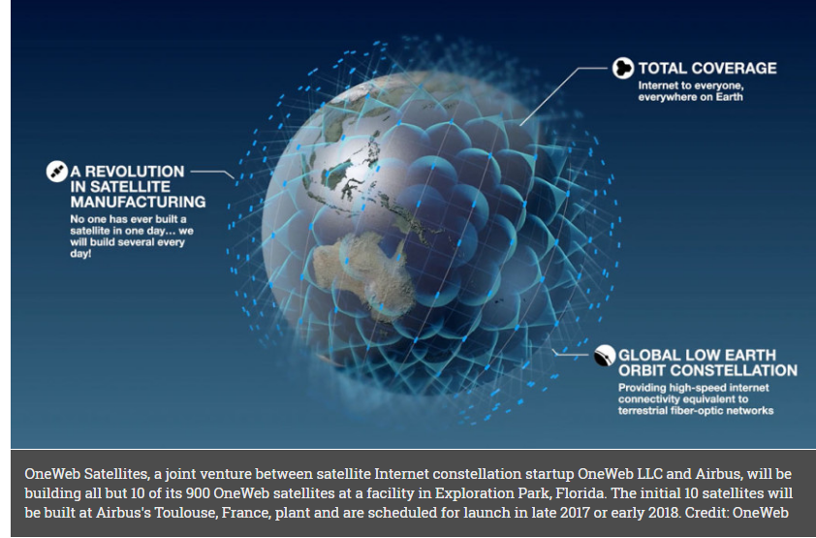
The Airbus Corporation is initially manufacturing the OneWeb satellites in Toulouse. Airbus currently ships perhaps 10-20 (high value) satellites a year but needs to meet the challenge of producing 15 satellites per week (but note that this rate is very similar to shipments of Airbus airliners which averages 13 a week).
Generally it can be stated that the satellite industry has a supply chain with profits derived primarily from military work. This is not a supply chain optimised to produce devices and networks at commercial price points and probably needs a dose of automotive manufacturing efficiency to become competitive.
8.3 The Automotive Industry as a source of satellite manufacturing innovation
8.3.1 Mr Ford and Mr Musk
In our last book we referenced Mr Ford as the doyen of low cost high quality volume manufacturing with the Ford Model T being the prime example of performance gain through close management of production tolerances combined with the use of vanadium steel (lighter and stronger) and a meat hook production line copied from the local abattoir
110 years later Mr Musk can almost certainly transfer the lessons learnt manufacturing Tesla cars and batteries into his Space X constellation venture.
Figure 8.3 Tesla Car Factory in Freemont, California
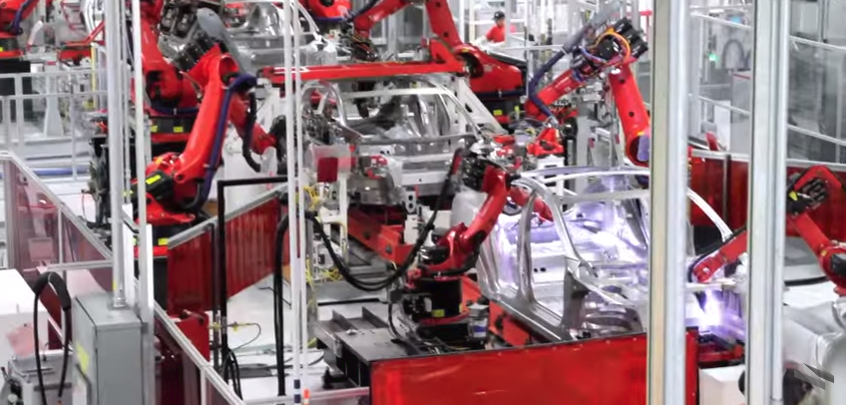
8.3.2 Production innovation for 5G smart phones – why scale is important for performance
The equivalent automated production line in a 4G and 5G user device and base station factory would be a state of the art pick and place machine. Figure 8.4 shows a Panasonic machine capable of placing 100,000 components per hour. To put this in perspective, the last time the author walked round a (3G) production plant (San Diego 2002) the fastest pick and place could manage 7000 components an hour. This machine can chew its way through anything from exceedingly small and narrow 0402 (1005)mm(inch) and 1005 (0402)mm(inch) chips to 90x 00mm on up to 18 inch by 20 inch boards. It achieves this by using exquisitely high resolution fast imaging.
Incidentally the factory also had Philips Pick and Place machines and a wondrous Sony machine that could do everything including make tea but that took 18 months to programme.
Figure 8.4 Panasonic Pick and Place Machine
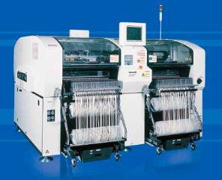
Note that as with the automotive industry, scale is needed in order to invest in manufacturing technology in order not to compromise component performance in order not to compromise product performance
This is particularly important for RF active and passive components at higher frequencies and for high performance static sensitive memory products. Figure 8.5 shows a typical taping system used to feed a pick and place machine. Taping systems are used to place components in the correct orientation and position and order and condition (protection from damp and static) on a tape that is then fed in to the pick and place machine.
Figure 8.5 Taping Technology – With thanks to Murata
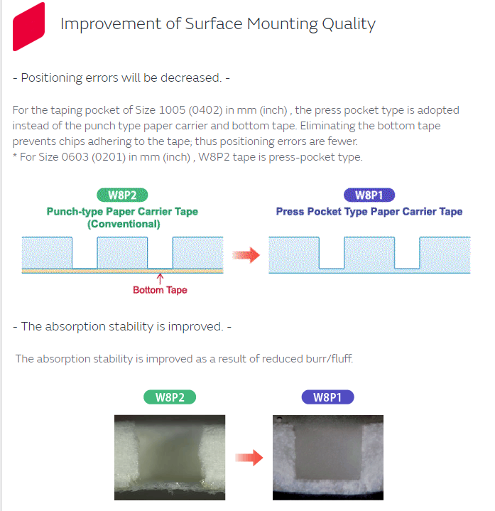
Note that scale effectively confers performance gain. We referenced Nokia’s ability fifteen years ago to produce GSM phones within minutes but Nokia also used their production scale to bully their supply chain into delivering more tightly toleranced RF components. The result was a steady year on year improvement in RF Performance. A GSM phone in 1992 from any vendor barely based the conformance specification threshold of -102 dBm sensitivity. BY 2002, Nokia phones could be measured with receive sensitivity of the order of –102 dBm.
Much of this manufacturing expertise has now moved to China but remains crtically important.
8.3.3 Materials and manufacturing innovation in the 5G supply chain
The same principle applies to the supply chain and particularly the RF component supply chain and particularly the RF component supply chain for centimetre band and millimetre band smart phones and IOT devices.
In 1982 it was a major challenge for the industry to produce cellular phones at consumer price points that could work at 800 MHz (the US) or 900 MHz (Europe). For example standard FR4 printed circuit board material was barely adequate. Over the following 35 years the industry had to accommodate higher frequencies, initially 1800/1900 MHz then 2 GHz then 2.6 GHz then 3.4 GHz. As frequency increases, RF gain becomes more expensive and noise becomes more problematic. It also becomes harder to switch and filter RF signals. As always, a technical challenge became a commercial opportunity. Higher frequency radio and radar systems were widely used in military radio and radar systems but used more exotic materials such as gallium arsenide for RF Power amplifiers and low loss linear switch paths. These materials required innovative manufacturing techniques. The additional cost of the materials compared for example to basic silicon meant that it was particularly important to maximise yield (the percentage of devices meeting the agreed performance specification).
Companies such as Rockwell Semiconductor translated these material innovations and manufacturing techniques into new companies specializing in supplying RF components for 3G and 4G smart phones. Put in biblical terms, Rockwell Semiconductor begat Conexant begat Skyworks who today are a major supplier of 4G RF power amplifiers. Hewlett Packard Semiconductors (founded in 1961) begat Agilent Technologies (1999) begat Avago who are a major supplier of acoustic filters and switches to the industry (and recently acquired Broadcom). RF Micro Devices and TriQuint became Qorvo and Peregrine Semiconductor morphed into Murata (RF switch products and filters for 4G smart phones.
It is worth noting that all these companies are US companies. They also supply the military radio and radar market and are an increasingly important part of the automotive industry supply chain. All of these companies regard 5G and particularly 5G products implemented in the centimetre and millimetre band as a critical target market.
8.3.4 Meanwhile Back at the Battery Farm
Mr Musk meanwhile has also turned his attention to battery manufacture (coincidentally also with Panasonic). Figure 8.6shows an aerial image of his very large factory in the desert.
Figure 8.6 Tesla Battery Manufacturing Plant in Nevada (Joint venture with Panasonic)
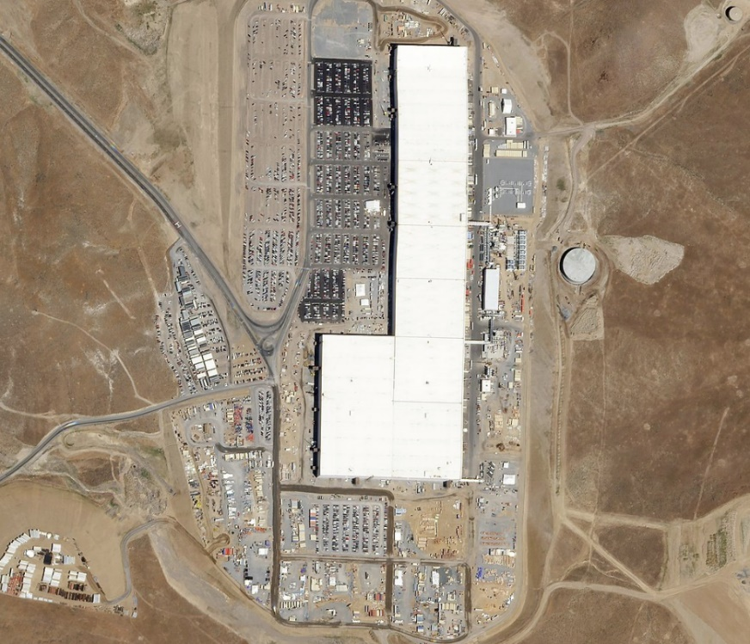

8.3.5 In the desert where the sun shines
To complete the picture, the very handsome solar powered solar panel factory in Buffalo, New York.
Figure 8.7 Tesla Solar Panel Factory in Buffalo New York
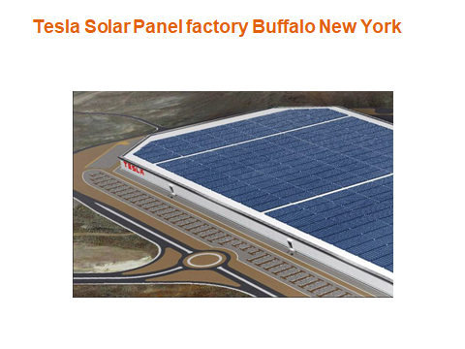
The investment by Mr Musk in automotive manufacturing, solar panel manufacturing and battery manufacturing provide him with many of the manufacturing skill sets needed to manufacture satellites. This is obviously complementary to the Space X investment in rocket launch technology and constellation technology.
8.3.5 Automotive enterprise value- Mr Musk as a modern Marconi
Figure 8.7 is an image of the Tesla X, one of three cars now available from Tesla. As a matter of record, Ford produces 6.6 million cars a year and makes a profit on every car. Ford has an enterprise value of $46 billion dollars. Tesla produces 120,000 cars a year and makes a loss on every car. Tesla has an enterprise value of $48 billion dollars. This enterprise value is used as a mechanism for raising capital which is used to invest in manufacturing technology and manufacturing assets (factories). Conveniently these factories are built in areas that are politically important, Florida for example.
In many ways, Mr Musk is the modern Marconi, the man who ‘networked the world’, the supremely effective self-publicist adroit at turning disaster (the sinking of the Titanic in 1912) to commercial advantage.
Figure 8.7 Tesla Model X
8.4 Automotive radar supply chain as a source of satellite and 5G antenna manufacturing innovation
The automotive industry also has visibility (literally) to the automotive radar supply chain.
Companies such as Delphi have been producing automotive radars now for twenty years
Present day products include short range, mid-range and long range radar products with very similar angular power detection requirements as 5G AES (Adaptive Electronically Steerable) antenna arrays and similar algorithmic processing requirements for angle of arrival, speed and distance of nearby slow and fast moving objects (and stationary objects as well).
Figure 8.8 Delphi Long Range Automotive Radar
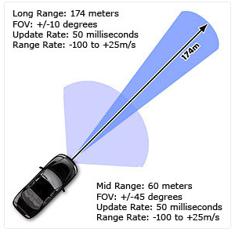
In common with other automotive safety product vendors, Delphi supply a range of radar based. Lidar and imaging based products many of which have potential applications particularly in space, for example for docking systems and for self-autonomous satellites.
Figure 8.9 Delphi Automotive safety systems

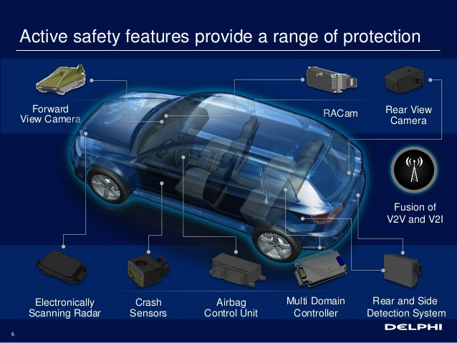

8.5 Supply Chain Comparisons
We have said that traditionally, companies manufacturing satellites have income predominantly derived from military markets. These companies have R and D budgets paid for almost entirely by the defence community. By contrast, the mobile operator vendors, Huawei, Ericsson and Nokia have R and D budgets of 12% to 14%, similar in actual and ratio terms to the automotive majors.
Table 8.1 Supply Chain Comparisons
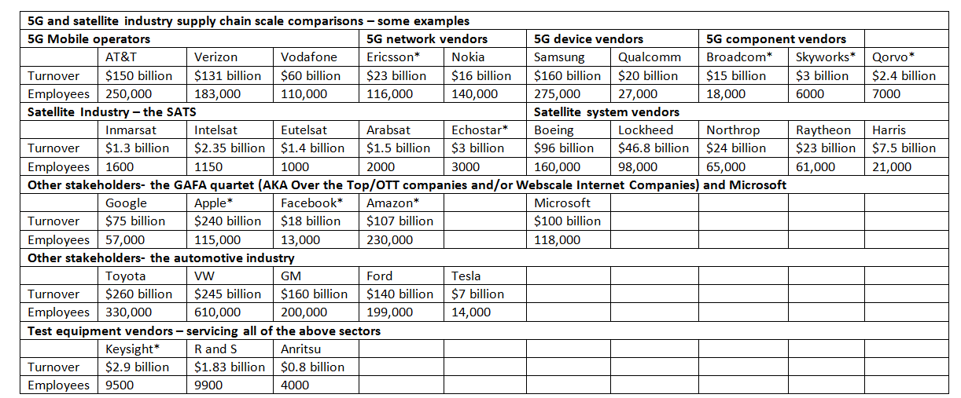
It can be seen that generally the satellite industry is two orders of magnitude smaller in turnover. In terms of customer reach, there are over 4 billion cellular phone users. The number of users of satellite products depends on who and what you count. If you include satellite TV it is a big number though nowhere near 4 billion. If you exclude satellite TV, served users and devices in the satellite sector are counted in the order of millions or at most low tens of millions.
As profiled in the last Chapter 7, The GAFA quartet has two major assets, cash and customers. Google has over a billion users, Facebook has two billion users, Amazon has 65 million Prime users, Apple has 588 million users who own 1 billion devices (1.7 devices per user) and PayPal (founded by Mr Musk) has over 200 million registered accounts.
8.6 Why scale is important
These numbers are important because of the impact of scale on user and IOT device availability, functionality and cost. If we take a time line of 40 years and go back to 1977, coincidentally the last time the author visited the Hawker Siddeley Factory, this was the BC era (Before Cellular). There was minimal market volume. The low cost cordless phone pictured was hand assembled and hand soldered.
Figure 8.10 1977 Cordless Phone
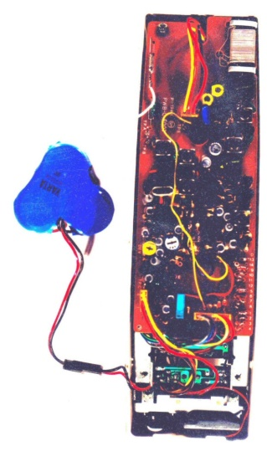
Ten years later (1987) life had moved on but it still took Motorola 8 hours to manufacture and test a Dynatac cell phone.
Figure 8.11 Motorola Dynatac cell phone
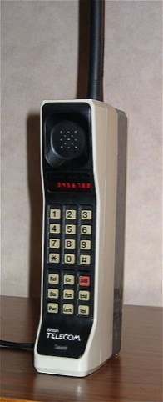
The big shift came between 1992 and 2002 as GSM volume increased. By 2002 Nokia were manufacturing GSM phone in minutes and owned the components in the phone for less than a minute, an exemplary example if supply chain optimisation and control.
Figure 8.12 2002 Nokia GSM Phone

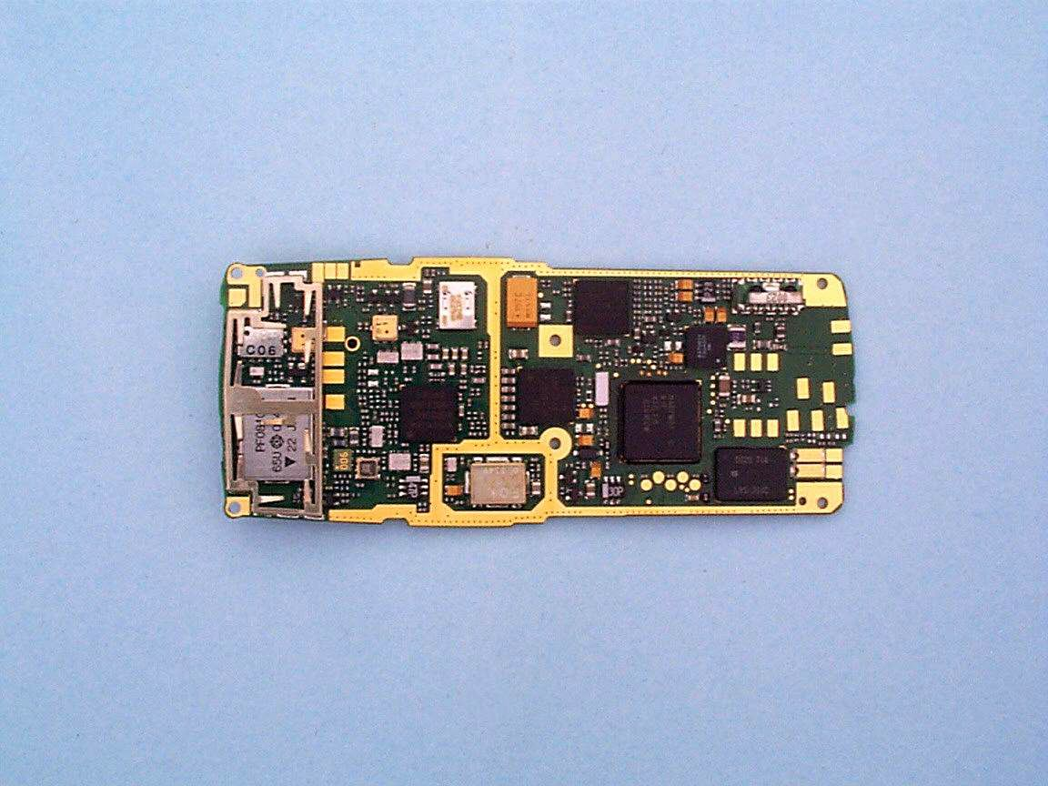
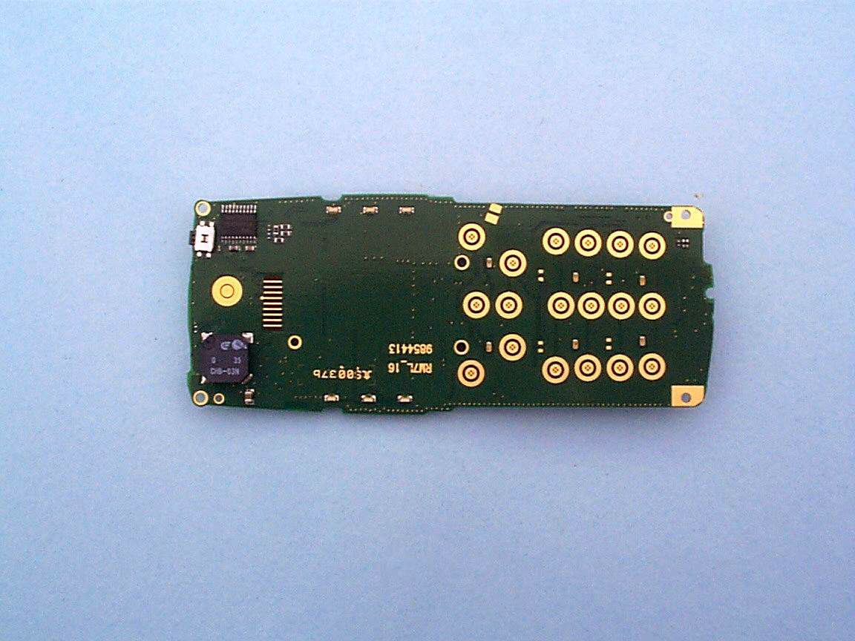

Figure 8.11 2002 GSM Phone

Google Lenovo HTC

In 2007 Apple introduced the iPhone. The success of this product over the next ten years has been extensively documented but can be summarised as the driver behind Apple’s ascendance to a dominant position in the mobile broadband value chain, only challenged in the user device market by Samsung.
Notably Google has found it far harder to emulate this success story. In 2012 they acquired Motorola Mobility for $12.5 billion in cash. This was subsequently sold on to Lenovo for $3 billion two years late. In 2017 Google paid just over $1 billion dollars to acquire the division of Taiwan’s HTC Corp that had developed the US firm’s Pixel smartphones but the success of this venture has yet to be proven. HTC’s worldwide smartphone market share declined to 0.9% last year from a peak of 8.8% in 2011 and Google’s Pixel had less than 1% market share since it was launched a year ago, with an estimated 2.8 million shipments,
This highlights an important point for the satellite industry. There are confident assertions within the industry that the eSIM will change everything and all that is needed to enable satellite connectivity in next generation smart phones is a downloadable app.
In 2011 Apple were granted a patent an eSIM to create a virtual mobile network (MVNO) requiring operators to bid for the right to sell their services to iPhone customers. An eSIM replaces a physical SIM card (a piece of plastic with a bit of memory and microcontroller on it) with a server based virtual SIM. The ESIM has been technically feasible for at least twenty years but fiercely resisted by the mobile operator community. The launch of the Apple Watch Series 3 with an eSIM in 2017 was heralded as the start of a new era.
Figure 8.13 Apple Watch Series 3 with eSIM
This device is for sure a great example of how financial fire power (Apple cash) can be translated into device innovation that in turn is dependent on innovative material and manufacturing techniques. For example LTE connectivity in the device is achieved by using the screen as an antenna; the device is water resistant to 50 metres and includes a barometric altimeter and GPS receiver and power optimised Wi-Fi and Bluetooth (the battery needs to last all day for the device to be useful).
While this might be an effective mechanism for Apple to corner an even bigger slice of mobile broadband service added value, its role as an enabler of satellite connectivity is less clear.
As we have discussed in Chapters 2 and 7, some of the satellite pass bands for example in L band and S band are adjacent to LTE spectrum but it will be hard to motivate smart phone manufacturers, particularly the two largest manufacturers by volume and value (Apple and Samsung) to extends existing pass bands or add another switch path both of which will add cost and compromise performance particularly in products like the Apple Watch where space and energy consumption are at a premium.
This would only be justifiable if Apple or Samsung had a direct fiscal interest in adding satellite connectivity. There is no present evidence of either of these two companies that they would wish to even consider this as an opportunity though this may change.
8.7 Production and manufacturing challenges of centimetre band and millimetre band smart phones
The alternative would be to look at hybrid satellite smart phone RF hardware in the centimetre and millimetre bands. This would depend on the satellite operators being willing to share the spectrum which is an initial hurdle.
The benefit of these shorter wavelength bands is that antennas are more compact but there are many manufacturing issues associated with high volume RF products at these shorter wavelengths. For example any surface roughness on printed circuit boards can result in significant losses, there are many parasitic capacitance effects that need to be managed, and RF gain is far more expensive; a GSM Class C power amplifier at 1 GHZ has a power added efficiency of 50 %. This falls to 10% for a Class A amplifier at 28 GHz. Test and measurement and modelling are trickier as well.
All the products available in these bands at present, for example point to point backhaul products, are low volume and hand assembled and individually optimised. This is a big expensive hill to climb and you need specific climbing skills to get to the top both in terms of RF materials innovation and manufacturing innovation.
8.8 Wi-Fi or Bluetooth or sub GHz IOT connectivity as an option
The alternative is to provide Wi-Fi connectivity and or Bluetooth connectivity and or sub GHZ IOT connectivity. A number of SAT-Fi products already exist though none are as yet at price levels where mass market adoption in developing economies could be achieved without significant subsidy.
But note also that Wi-Fi is a low power (10 milliwatt) radio designed for local area connectivity and does not scale to larger diameter cells partly due to the low transmit power, partly due to limited sensitivity (a function of the TDD physical layer) and partly due to TDD inter symbol interference in larger cells
This is the reason why the Apple Watch 3 has an LTE transceiver. Admittedly it also has a GPS receiver but this is a low data rate receive only physical layer. Getting a satellite uplink to work technically and commercially in an Apple Watch or in similar products in this emerging wearables device sector is going to be a major technical and commercial challenge for the satellite industry.
8.9 Access Points and Base Station Hardware
Last but not least it is important to recognise that the LTE base station business is now a high volume business scaling from low cost pico and micro base stations to surprisingly low cost macro base stations where the site costs substantially outweigh the RF hardware and baseband hardware and antenna costs.
LTE base stations are manufactured on highly automated production lines in volumes that are in the tens and hundreds of millions per year. The ambition will be to leverage this scale into 5G base station and access products in the centimetre band and millimetre band. In band backhauling would further consolidate this scale gain and help to amortise centimetre and millimetre band RF Research and Development.
8.10 Server and router hardware manufacturing innovation
The three major LTE vendors, Huawei, Ericsson and Nokia are also heavily invested in next generation server and router hardware. The general assumption is that server hardware is largely commoditised with a limited number of processor and memory suppliers who closely control component production and manufacturing.
It is however possible that new hardware architectures will emerge in the future. These could create new software optimisation opportunities. Quantum computing is a possible candidate but remains curiously dependent on manufacturing innovation (resolution of the noise problem).
8.11 Summary
The mobile broadband industry has a major (two orders of magnitude) scale advantage over the satellite industry. This scale advantage translates directly into an ability to invest in optimised mass market production and manufacturing techniques.
The satellite industry is consummately good at producing products of the very highest quality but at high cost. Mobile broadband industry scale means that it can deliver quality at low cost with a contemporary smart phone being an exemplary example.
It is possible that the smart phone will become a less important part of the mobile broadband value chain but as yet there is no great sign of this happening and the high expectations for the IOT market have yet to be realized in both volume and value terms.
It is the stated ambition of many players in the satellite industry to deliver far more than just ‘a bit more backhaul’. The NEWLEO entities in particular want to reinvent connectivity but it is at the moment hard to see how this will be achieved without a pervasive presence in next generation smart phones and wearable devices such as the Apple Watch and without structuring a commercial eco system where both the 5G and satellite community gain from working together
This brings us on to our next chapter.

http://www.baesystems.com/en-uk/heritage/british-aerospace-uk
https://www.isixsigma.com/new-to-six-sigma/history/history-six-sigma/
OneWeb Satellites Breaks Ground On The World’s First State-Of-The-Art High-Volume Satellite Manufacturing Facility - OneWeb | OneWorld
http://www.murata.com/en-eu/products/capacitor/mlcc/packaging/pockettaping
http://www.murata.com/en-eu/products/capacitor/mlcc/packaging/pockettaping
http://pwcircuits.co.uk/fr4.html
http://www.rockwellautomation.com/global/industries/semiconductor/overview.page
https://www.bloomberg.com/research/stocks/private/snapshot.asp?privcapId=155172
https://www.broadcom.com/
http://www.qorvo.com/
https://www.statista.com/
https://www.gsma.com/iot/embedded-sim/
https://www.apple.com/uk/newsroom/2017/09/apple-watch-series-3-features-built-in-cellular-and-more/

