**Chapter 6 Antenna Innovation**

**6.1 The impact of antenna innovation on energy costs in terrestrial and non-terrestrial networks**

**6.1.1 The function of antennas in noise limited networks**

In the five chapters so far we have touched on the importance of energy efficiency in terrestrial and non-terrestrial networks.

In terrestrial networks, energy efficiency is directly related to energy cost and therefore has a direct impact on network operational costs. These costs vary from country to country and can be particularly problematic in countries with a limited electricity grid, for example in parts of Africa where the only power available is either solar or diesel. Solar panels disappear from remote sites and supplying diesel incurs additional operational overheads. Solar panels also require battery backup. Lead acid and lithium based batteries are expensive, take up space and have limited capacity and a limited life.

Energy costs in terrestrial networks are a composite of the RF power needed across the radio interface, the base band processing overhead and the backhaul overhead.

You might think that as network density increases, energy costs would reduce as less RF power is needed to service local users and devices. In practice, the opposite is true partly because RF interference becomes a dominant constraint and partly due to the power required for backhaul. The extra energy needed to support denser networks is a subject of debate but one reliable estimate suggested that energy costs could multiply by a factor of three as networks transition from kilometre cell sizes to cell radii of 100 metres or less.[1] The good news is that LTE is more power efficient than 3G despite modulation and multiplexing that requires more linear amplification. This is due to the need for 3G to deliver symbols at equal power level which is easily compromised by inaccuracies in uplink and downlink power control loops.

In space, it could be argued that as with solar powered terrestrial base stations, the energy comes for free but in practice there are associated costs. Theft is not a problem in space but the size and weight and build quality of the solar panels on a satellite adds to the cost of the satellite and increases launch cost. Antenna arrays can be damaged by debris impact and degrade over the lifetime of the satellite. In our last chapter, we also pointed out that large solar panel arrays made satellites less manoeuvrable. This can be a problem for satellites that implement progressive pitch control partly due to the additional spin mass but the solar panels also ideally need to point towards the sun for as much time as possible. When solar panels are pointing in the wrong direction then battery backup is needed. Batteries in space add to launch cost and take up space that could be used for income bearing payloads.

As a rule of thumb, about half the power requirements in a terrestrial base station or access points or Wi-Fi transponder are related to the RF power budget which in turn is related to the link budget (See Chapter 2). However if a transceiver is working close to its receive sensitivity or maximum power limit then additional channel coding will be incurred. This absorbs radio layer capacity but also consumes additional clock cycles which increases power consumption.

It is therefore important to ensure that RF energy is sent where it is needed. Ideally antennas would produce a narrow beam of concentrated energy, effectively recreating the characteristics of guided media such as copper, cable or fibre.

They achieve this through isotropic gain. Narrow beam antennas include fractional beam width antennas defined as antennas with a 3dB half power beam width of between half and one and a half degrees. These can deliver of the order of 40 to 50 dBi of isotropic gain.

However narrow beam and fractional beam antennas have a cost in terms of the aperture size, cost and weight of the antenna particularly at lower frequencies/longer wavelengths. If there is a problem with pointing of the antenna, for example in terrestrial systems due to high winds or in satellites due to poor yaw and pitch control, then much of this isotropic gain will be absorbed by pointing loss.

There are of course antennas at both ends of the radio link. Generally terrestrial base stations, terrestrial access points and satellites have sufficient space to support high performance high gain antennas. This includes antennas systems that can adapt to changing noise conditions for example high levels of noise coming from a particular angle of arrival.

This is harder to achieve in small form factor user and IOT devices particularly at lower frequencies /longer wavelengths where space constraints mean that antennas are not inherently efficient with less than optimum ground planes. In smart phones, this is made worse by the need to support multiple antennas in a small space. It is not uncommon to have user and IOT devices working at sub 1 GHz with a negative gain of the order of -7 to -10 dB.

Figure 6.1 shows the inner workings of a smart phone including the multiple antennas.

**Figure 6.1 The Inner workings of a smart phone showing multiple antennas**

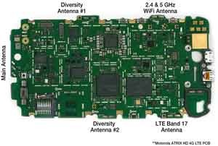

Antennas are happiest working within 10% of their centre frequency.

They can be forced to work over wider bandwidths either by switching in additional lengths of antenna or by electrically lengthening the antenna but this will compromise the noise matching and power matching of the antenna.

The physics of this process are outside the scope of this book but can be researched by delving into the inner magic of the Smith Chart developed by Mr Smith in 1939.[2]

**Figure 6.2 The Smith Chart**

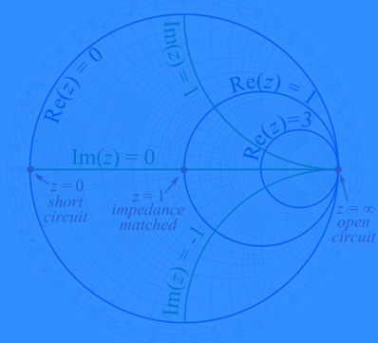

Antennas working across wider bandwidths will also be vulnerable to hand capacitance effects where how you hold the phone has a major impact on the RF performance of the device. There are adaptive matching techniques to mitigate this but these in turn have a power budget cost.

It is hard to realize any useful directivity in small form factor user and IOT devices. In base stations and Wi-Fi access points, narrow beam antennas should reduce the amount of unwanted energy transferred into spectrally and geographically adjacent radio systems though not if they are pointing in the wrong direction.

Satellites are essentially base stations in the sky normally using dish antennas to focus on specific geographic areas with the objective of providing enough flux density for ground based receivers to detect a wanted signal above the noise on the radio channel, for example to receive TV broadcasts.

For two way communications there has to be sufficient gain on the satellite receive antenna to overcome the uplink path loss bearing in mind that the device on the ground may have relatively low output power of the order of one or two watts. These are usually described as spot beam antennas.

If implemented using dish antennas, the spot beams can be mechanically pointed to provide coverage and capacity on demand. If implemented using flat panel antennas with multiple antenna elements the beam forming is achieved electrically by changing the phase of each antenna element

**Figure 6.3 Spot beam dish and flat panel antennas on an Inmarsat Geostationary satellite**

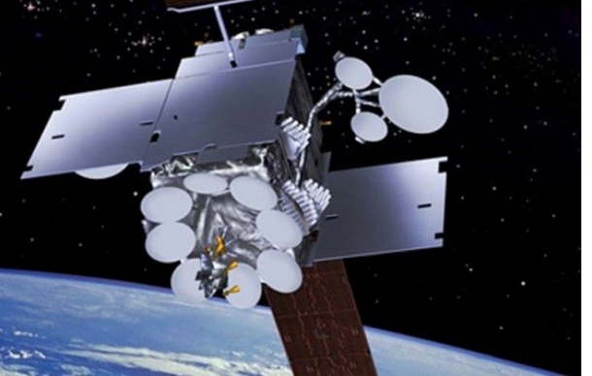

At higher frequencies/shorter wavelengths, these antenna systems provide highly focussed coverage. An example is the V band LEO constellation proposed by Boeing at 37.5-40 GHz and 51.4-52.4 GHz with 1 GHz channels supporting cells with a diameter of between 9 and 11 kilometre. It is proposed that the satellites would also have C band antennas.

**Figure 6.4 Boeing LEO constellation showing terrestrial cell patterns**

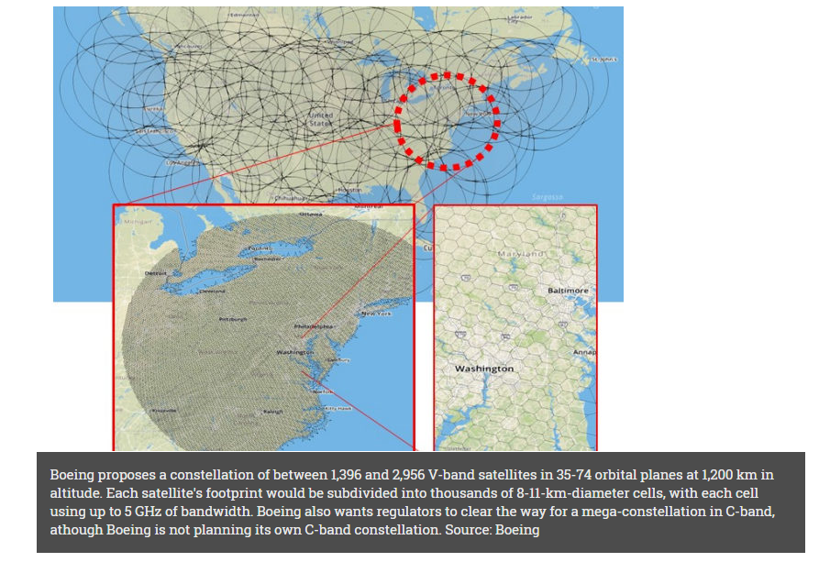

Self-evidently antennas on ground devices need to be capable of looking at the sky either physically or electrically. This results in some distinctive antenna designs, for example the Iridium user terminal in the Figure below with L band antenna.

**Figure 6.5 Iridium User Terminals with L band antennas and Wi-Fi unit for local connectivity**

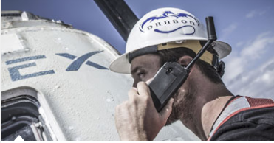

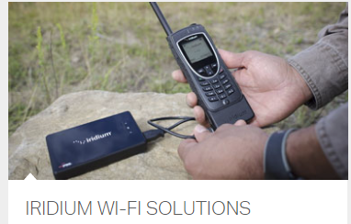



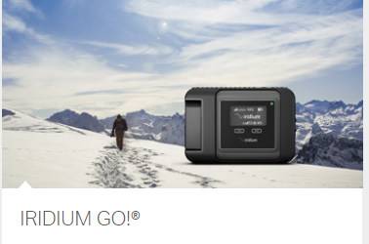

**6.1.1 The function of antennas in interference limited networks and satellite and terrestrial coexistence**

This brings us to the function of antennas in interference limited networks. If two or more simple collinear antennas (long single pole antennas containing an E and H plane) are moved close to each other (less than a fraction of a wavelength apart) then they will start coupling together and the phase of each antenna will be influenced to create a change in the gain and null of the radiation pattern from the combined antennas. This means that interference from a particular direction can be nulled out. This technique has been used for over fifty years in VHF and UHF networks, for example to protect emergency service radio systems from unwanted TV signal energy.

Modern antenna arrays achieve the same effect by electrically changing the phase relationship between antenna elements. This has the significant advantage that the radiation pattern can be changed in response to changing interference conditions, for example high levels of unwanted noise though more commonly high levels of unwanted signal energy (interference).

The beam pattern can be changed in azimuth to minimize interference coming sideways from left or right of an antenna or in elevation. As covered in Chapter 2, satellites can be at low elevation. For example, satellite TV dishes in high northern and southern latitudes are pointing close to the horizon in order to receive signals from satellites broadcasting TV signals from geostationary orbits over the equator. The same dishes at the equator, for example in Singapore, will be pointing directly upwards.

LEO and MEO constellations can be anything from low elevation to directly overhead. Generally the best link budget will be directly upwards as this minimizes the amount of atmosphere through which the signal has to travel but this requires a high count satellite constellation.

However it can be seen that there are substantial opportunities for achieving angular power separation between terrestrial and non-terrestrial networks. By implication this makes co sharing of satellite spectrum with terrestrial networks feasible and potentially commercially attractive. As we shall see in later chapters this is a contentious issue and open to technical and legal challenge but the spectral efficiency gains from frequency reuse could be substantial.

We revisit angular power separation in the next chapter (Chapter 7, Constellation Innovation) but before we get there, we should usefully review some of the ways in which terrestrial and satellite antennas and antenna arrays need to be matched to specific channel conditions.

**6.1.2 Four things antennas are supposed to do but cannot do at the same time**

Figure 6.6 summarizes the four functions that terrestrial antennas can perform - spatial diversity, coherent gain, interference mitigation and spatial multiplexing. Each function requires specific baseband processing so only one of these functions can be performed at any one time.

**Spatial diversity**

In terrestrial networks, both in-building and in urban and rural environments, there can be significant signal energy that arrives at a receiver having bounced off hard surfaces on the way and the composite signal transmitted will have followed several different paths on its journey to the receiver. This is known as scattering. Spatial diversity is the use of antennas to capture each of these paths so they combined constructively in the receiver. The signals need to be aligned in time which is achieved by a channel equaliser and in phase, achieved by the use of a phase locked loop. This reduces the required fading margin though the gain achieved is dependent on the number of signal paths and their relative strength.

At higher frequencies/shorter wavelengths, particularly in the millimetre band above 30 GHz, any surface roughness on walls or other reflective surfaces will be similar to the wavelengths of the radio signal being reflected and will result in significant signal absorption. This is why spatial diversity using multi path becomes less effective as wavelengths get shorter.

**Coherent Gain**

Coherent gain is where several antennas are used to collect the same signal following the same path from transmitter to receiver. Coherent gain is most useful in line of sight conditions, for example from nearly always nearly overhead high count LEO constellations.

**Interference Mitigation**

As covered briefly already, this is where phase off sets between multiple antennas or multiple antenna elements are changed in order to null out unwanted signal energy.

**Spatial Multiplexing**

This is widely used in TDD Wi-Fi and is also intensively standardized in 5G standards as a mechanism for achieving very high data rates within a small area, often indoors.

User bits are mapped on to symbols which are then coded on to multiple antennas or antenna elements which effectively create a deterministic multi path which can be correlated with a similar number of antennas and antenna elements at the receiver. They are more effective in TDD systems because the uplink and downlink are on the same frequency and the channels are therefore reciprocal. Spatial multiplexing does not scale efficiently to larger cells and higher frequencies. In many propagation environments FDD will provide a higher throughput gain. Separating the receive path from the transmit path in the frequency domain (frequency duplex separation) in a user or IOT device delivers a sensitivity gain. FDD also provides frequency separation between user and IOT devices and access points. An example is a home with multiple Wi-Fi access points deployed to support an Amazon Echo network or Google Home. This is the reason why the latest 802.11ax standard supports FDD.

**Figure 6.6 Four things antennas are supposed to do but cannot do at the same time- with thanks to Arraycomm**

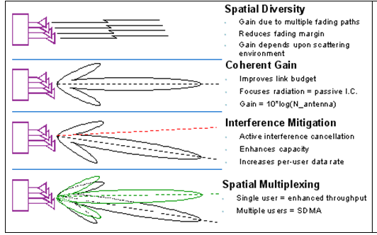

**6.2 Signals from multiple access points, multiple base stations and or multiple satellites**

There is an additional option which is to send the same signal from multiple access points and or multiple base stations and from multiple satellites.

This is done in LTE broadcast[3] to deliver a link budget gain by summing signals from multiple sources and is one of the mechanisms proposed for Cube SATS in order to sum a large number of small low power transmitters together to provide effectively one very large aperture (horizon to horizon) antenna.

**6.3 Satellite channel models and antennas – standards work as a starting point**

So hopefully it is clear that the choice of antenna system is determined by the characteristics of the radio channel which in turn is determined by channel models that are derived from measurements and empirical observation.(see also link budgets and latency in Chapter 2).

Earth to space and space to earth propagation has been intensively studied as a by-product of near earth and deep space communication but only in the context of existing space network GSO, MEO and LEO topologies. Modelling high count constellations is less advanced partly because these constellations do not exist yet and therefore do not have the empirical data available to calibrate existing or future theoretical models.

From October 2017 this is being addressed by the non-terrestrial networks group sponsored by ThalesAlenias, Dish Networks/Echostar and Hughes Networks, Inmarsat and Ligado.[4]

There have been several unsuccessful attempts to develop integrated mobile broadband and satellite standards for example in 3G with the S-UMTS standard.[5] There have also been attempts to standardize hybrid terrestrial and satellite connectivity through the Auxiliary Terrestrial Component Specifications in the US, Canada, Europe and Asia and in China, the Satellite and Terrestrial Multi Service Infrastructure.[6]

At a 3GPP Technical Standards (TSG) Group meeting in March 2017, it was agreed that a 5G and non-terrestrial networks (NTN) study would be produced within the 3GPP Release 15 standards process (New Radio NTN, NR.NTN). The sponsors included Motorola, Sepura (emergency service radio), and the Indian Institute of Technology, Avanti, Mitsubishi, China Mobile and Airbus Group.

The standards work extends across six domains

* The support of “5G connectivity via satellite” within 3GPP TR23.799
* The “Higher availability” requirement within 3GPP TR22.862
* The “Wide Area Connectivity” requirement within 3GPP TR22.863
* The “Satellite Access” requirements within 3GPP TR 22.864
* The “5G Connectivity Using Satellites” use case of 3GPP TR 22.891
* The “Satellite extension to Terrestrial” within 3GPP TR 38.913

But our specific interest in this chapter is the modelling activity associated with these work streams.

There are five proposed deployment scenarios including geostationary, non-geostationary and sub space (HAPS high altitude platform systems) with a range of considered FDD bands including 2 GHz, 6 GHz and 20 GHz and 30 GHz deployed either as bent pipe or with on board processing with channel bandwidths of 20 MHz, 80 MHz and 800 MHz, outdoor or outdoor/indoor (sub space) with either fixed or moving beams.

The five scenarios are shown in Figure 6.7

Note there is a double Doppler effect that has to be accommodated. Low earth orbit satellites are travelling at a speed of about 28,000 kilometres per hour (7.7 kilometres per second) depending on their orbit altitude. The satellite Doppler is a known constant; the moving object with which the satellite is communicating will typically be moving at different and variable velocity. Although Doppler might be considered problematic it is a well understood effect exhibiting itself as an increase or decrease in frequency depending on whether the objects are travelling towards each other (an increase in frequency) or away from each other(a decrease in frequency). The strong Doppler signature of low earth orbit satellites can be used to provide precise positioning and location services so can be regarded as an asset rather than a problem.

**Figure 6.7 Deployment scenarios for satellite channel modelling- with thanks to ThalesAlenia**

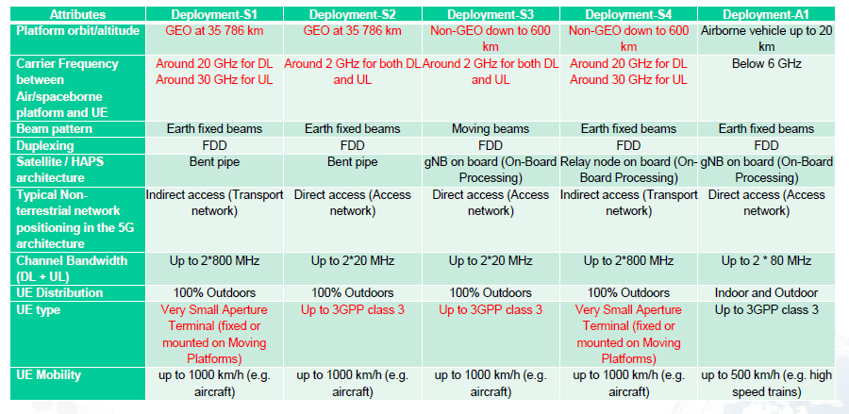

Within the group, Hughes Network Systems are providing inputs to the free space loss assumptions which are shown in Figure 6.8. The assumptions highlight the need for additional gain from the antennas at both ends of the link with a particular need to address antenna design issues for user and IOT terminals in Ka-band.

**Figure 6.8 Free space loss assumptions for non-terrestrial networks with thanks to Hughes Networks/Echostar.**

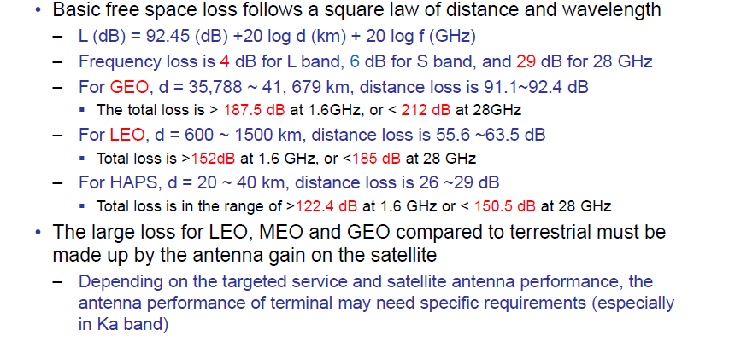

Gain is a function of beam width but the link budget will also be affected by other factors including ground reflection. As you might expect, the path loss is significantly greater in a GEO network and lowest for a HAPS network due to the shorter path length. The path loss from a terrestrial base station to a user a few metres away will be theoretically better than any non-terrestrial connection but by less of a margin than you might expect particularly at millimetre frequencies where non-line of sight losses and surface absorption absorb significant amounts of RF signal energy.

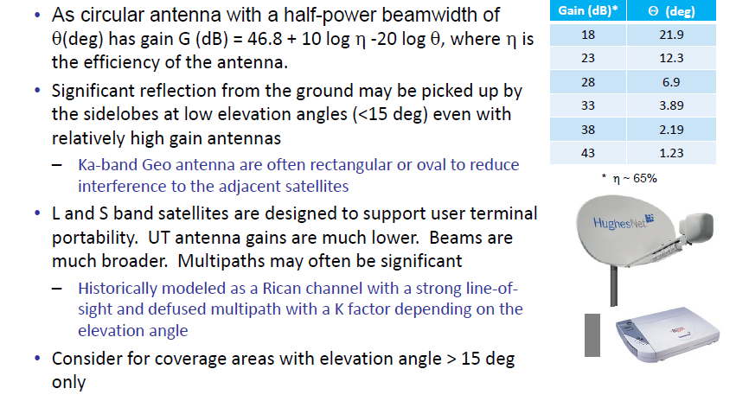

The propagation models will be divided into <15 or 20 degrees and > 15 or 20 degrees. Directly overhead models are not directly addressed. K factor is the ratio of dominant power to scattered power.

Figure 6.9 summarises the ITU and European research and standards work on propagation and channel modelling.

**Figure 6.9 Satellite propagation studies - with thanks to ThalesAlenia and Fraunhofer**

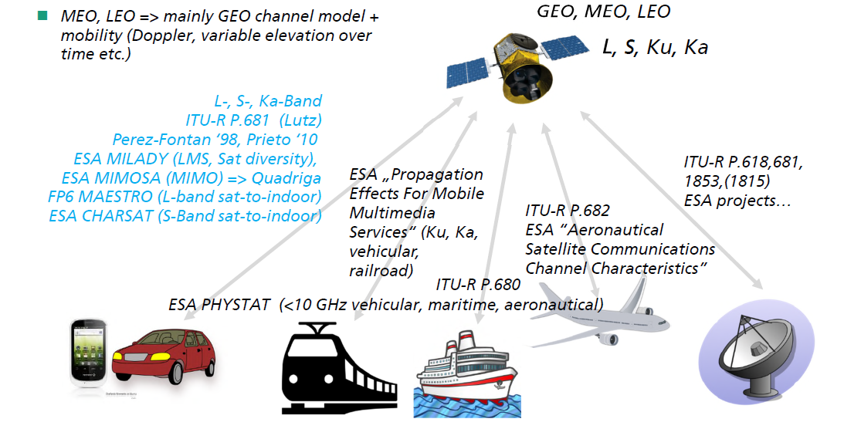

**6.4 Back to earth – 5G antenna trends**

In our last book, 5G Spectrum and Standards, we covered 5G antennas featuring products from Blu Wireless at 60 GHz, Huber and Suhner (millimetre band antennas), antenna tilt techniques in the sub 1 GHz band from Quintel and for good measure, the Ryle radio telescopes at the Mullard Radio Astronomy Observatory and automotive radar antennas.

In this next section we review the technology innovations and new products that have emerged in the two years since the last book was written and published.

We talked briefly about antennas for backhaul but increasing network density and the growing recognition that 5G backhaul operational and capital costs need to be constrained has placed increased attention on backhaul connectivity so that seems like a good place to start.

**6.4.1 5G Backhaul**

But before we get going on this let us remind ourselves of the band naming regimes because it is super confusing.

We have probably just about got our heads around the IEEE 521-1984 radar band designations with Ku-band at 12-18 GHz, K-band at 18-27 GHz, Ka- Band at 27-40 GHz, V band at 40-75 GHz and W Band at 75-110 GHz.

In fixed point to point hardware specification sheets you will also come across bands described using the WR22 waveband designation[7], for example the bands at 40 GHz which are described as Q band and the WR12 waveguide designation, for example the 71-76 GHz and 81-86 GHz allocations known as E Band.[8]

This is because these products have typically been implemented as wave guides, horn antennas manufactured to very close tolerances.

A typical product is shown in Figure 6.10. This is a dual polarized horn antenna covering 50-75 GHz with 15 dBi nominal gain and a half power beam width of 28 degrees in the E plane and 33 degrees in the H plane.[9]

This is variously described as a V band antenna or WR-15 waveguide.

If you want to be the pub quiz champion of waveguide naming conventions follow the link.[10]

**Figure 6.10 Dual Polarized Horn Antenna- with thanks to Sage Millimetre**

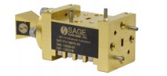

There are a bewildering number of fixed point to point products available across a bewildering range of frequencies and channel bandwidths. Essentially these are hand crafted products built in hundreds or thousands rather than millions or billions.

A nicely documented summary of a contemporary fixed point to point product range has been produced by RF Com.[11]

**Figure 6.11 RF Com Dish with integral transceiver for point to point backhaul in a 4G or 5G network**



Figure 6.12 provides comparison of the relative gain available at Q band and E band for a 2 foot dish antenna at Q band and E band across channel bandwidths from 250 MHz to 2 GHz and related maximum throughputs per channel. As can be seen, significant additional gain can be achieved at E band due to the additional aperture gain available from the dish antenna at these shorter wavelengths. There are additional propagation losses at E band and receiver sensitivity may be a bit less than a Q band receiver due to a higher noise floor but generally speaking it is possible to get significantly higher throughput over an E band link without a significant loss of range with 10 gbps being the highest claimed thoughput on this particular RF hardware platform. Thoughput can be increased by using higher order modulation but range would decrease. As a rule of thumb, every doubling of modulation state will take 3 dB off the link budget.

**Table 6.1 Gain and range from RF Com Q and E Band dish antennas**

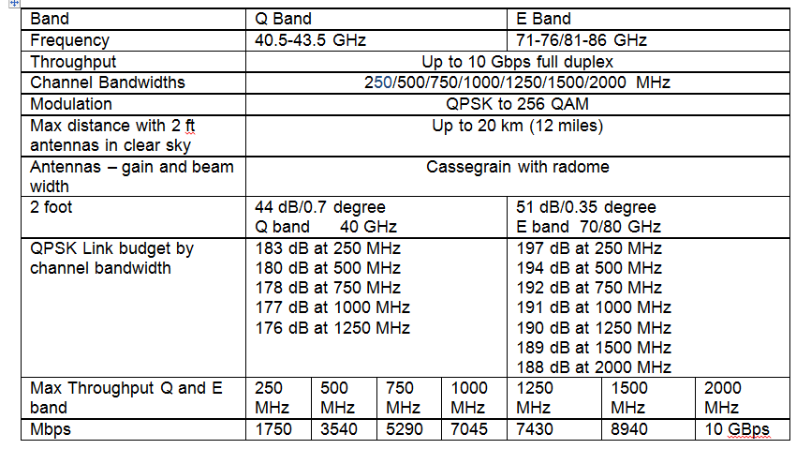

**6.4.2 Self- Backhauling/In Band Backhauling in 5G**

However it has been recognised that 5G will probably be deployed into some urban environment’s at a density which would separate RF backhaul hardware and fibre economic and inefficient. The economic cost is a consequence of the sunk cost (literally) of fibre and or hardware cost of separate point to point dishes and transceivers.

The performance cost is a consequence of any demodulation/modulation or channel coding added at the transition points between the 5G physical layer and fibre backhaul. RF over fibre[12] is a partial answer to this but an increasingly promoted option is to implement self-backhauling in which the same radio resources are available for users and backhaul. This is sometimes known as in-band backhauling.

**Figure 6.12 Self- Backhauling/In Band Backhauling for Millimetre Wave Cellular – with thanks to Nokia Networks**[13]

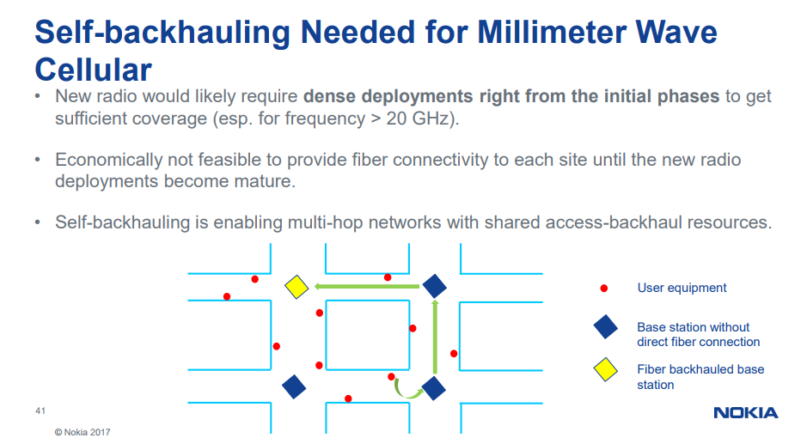

The backhaul market is a market which new high count LEO satellite operators such as OneWeb are keen to penetrate. The advantage of self-backhauling is that a terrestrial operator can reuse RF hardware base station resources across the user plane, control plane and backhaul plane but, as can be seen from the graphic, there is a requirement to go round corners which may or not be convenient depending on where base stations can be sited.

Satellite operators presently have a small percentage of the mobile broadband terrestrial backhaul market, less than 1% with much of that in hard to reach deep rural areas.

Increasing satellite connectivity into local ultra-dense urban backhaul competing against self-backhauling would be dependent on meeting latency constraints at a cost that was equal to and preferably lower than in band backhauling bearing in mind that the in band option amortises hardware and bandwidth costs across users and base station to base station backhaul. The one advantage that satellites have, particularly nearly always nearly overhead satellites is that there may be a higher probability of a clear direct line of site to all the base stations within a confined area. This would avoid the mesh protocol overheads incurred in self-backhauling. Note that latency introduced by mesh protocols will be variable with the variability dependent on the local base station deployment topology. Satellites may introduce additional latency (see Chapter 2) but the latency, at least from nearly always nearly overhead LEO constellations, will be essentially constant which would mean that any higher layer protocol overheads into, across and out of the backhaul plane could be minimised.

**6.5 Innovation in terrestrial 5G and non-terrestrial network antennas**

**6.5.1 Steerable mechanical antennas**

Dishes are an efficient option for achieving directional gain in terrestrial backhaul networks and in satellite networks.

They can be mechanically repointed to send and receive signals in other directions though this is a relatively slow and cumbersome process. Mechanical beam steering has been used in radar systems since the Second World War. If the mechanical pointing failed the truck could be driven round in a circle which would change the azimuth (though not the elevation).

The example shown is an AA3 MK7 mobile trailer-mounted, second level, anti-aircraft gun control radar station dating from the mid-1940s then used with various UK and Commonwealth Armed Forces and rumoured only to have been retired during the Falklands War.

**Figure 6.13 AA3 Mk 7 Anti- Aircraft Gun Control Radar Code named Blue Cedar at Duxford Imperial War Museum** [14]

**Copyright ww.alamy.com**

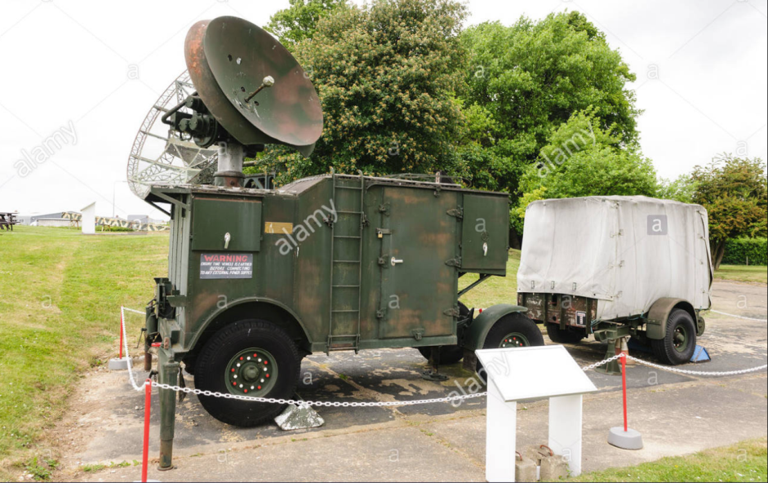

**6.5.2 Electrically steerable antennas using conventional components and materials**

In the 1990’s companies such as Arraycomm[15] and later Quintel[16] began to introduce electronically steerable antennas in which the phase offsets between antenna elements are changed to create nulls to mitigate interference and gain to improve directional range and throughput. At lower frequencies, particularly bands below 2 GHz, these antenna arrays can be large and the weight and wind loading can add significantly to mast costs but they do solve specific interference problems in specific places.

Electrically steerable antennas at higher frequencies/shorter wavelengths have the advantage that elements can be closer together and it becomes more viable to build flat panel antennas that are compact enough to survive high winds and the occasional or not so occasional hurricane. They can also switch beam pattern far faster (milliseconds or microseconds and potentially picoseconds) than mechanically pointed arrays (seconds). Flat panel electrically steered antennas have now become widely deployed in military radio and radar systems and automotive radar (See pages 264-273 in 5G Spectrum and Standards Chapter 10). They can be built using conventional components and materials with elements of various lengths so that the antennas are steerable and wideband.

These antennas can also be constructed using a class of materials called metamaterials.

**6.5.3 Electrically steerable antennas using metamaterials**

Metamaterials[17] are materials that have properties that are not found in nature and are usually arranged in repeated patterns at scales that are shorter than the wavelengths of the medium with which they are intended to interact. It is therefore the structure and its shape and orientation and arrangement as much as the base material that influences the performance and behaviour of the device.

It could be argued that PIFA antennas[18] are a precursor to metamaterials and are one example of size efficient shapes and structures in conventional antennas coupled with innovative ground planes. However metamaterials are more complex and elaborate. As with electrically steerable conventional antennas, metamaterial based antennas are becoming widely used in military radio and radar systems including wide band radio systems scaling from UHF to K- band. They can enhance and block and absorb and bend electromagnetic waves. As with conventionally structured antennas they cannot do all these things at once so interpret marketing material and specification sheets with a measure of care.

**Figure 6.14 Example of a metamaterial structure for a millimetre band antenna (need to check source and credit).**

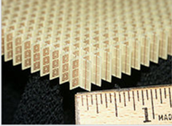

**6.5.4 Metamaterial antennas combined with electromagnetic band gap material**

A second class of material known as electromagnetic band gap (EBG) material[19] can be combined with metamaterials to mitigate the distance separation issue of antennas at lower frequencies.

Developed by the US Army Research Laboratory at the University of Michigan, these materials are claimed to realize an antenna in S band at 2.72 GHz with a 3 centimetre physical separation but with a42 dB isolation between the antennas, 24 dB above the isolation achievable with conventional antenna materials. Put another way to realize a three centimetre separation distance using EBG material is acclaimed to be equivalent to a metre separation using conventional materials.

**Figure 6.15 Electronic Band Gap materials applied in size and volume limited antenna designs – with thanks to the US Army Research Laboratory at the University of Michigan.**

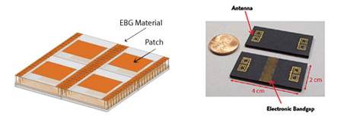

Xerox Parc have used these materials and manufacturing techniques to develop scanning radars for the automotive industry.[20]

**Figure 6.16 Xerox Parc Scanning radars for the automotive industry**

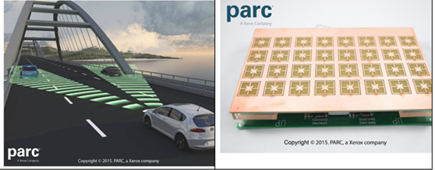

Kymeta have a similar product but more generally applied for connectivity in Ku-band, emphasising the inteference null form capabilities of the device.

**Figure 6.17 Kymeta Ku-band metamaterial antenna**

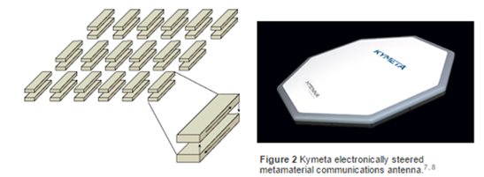

Kymeta have a number of cae studies of connected transport appications using their antennas including projects in the USA with Toyota.[21]

**6.5.4 Active conformal and flat and almost flat antennas**

Conformal antennas are antennas that can be moulded to any shape, for example a car or truck or military tank roof or superyacht bridge or train roof or aircraft hull. Often they are almost flat with a small amount of curvature. A conformal antenna for a completely flat surface, unsurprisingly, will be completely flat.

Phasor Solutions[22] presently produce these antennas for high end luxury or highly specified military use but it can be imagined that these would be very effective as a flat roof mounted antenna on a car roof pointing at satellites. The active beam steering allows unwanted angular power to be nulled out but also enables RF power to be delivered and received across a wide range of elevation angles. For instance a vehicle at high northern or southern latitude served by a geostationary satellite would be focused on an elevation close to the horizon and be configured to have minimal visibility to unwanted signal energy coming for example from LEO satellites directly overhead.

**Figure 6.18 Phasor Solutions Active Conformal Antenna**

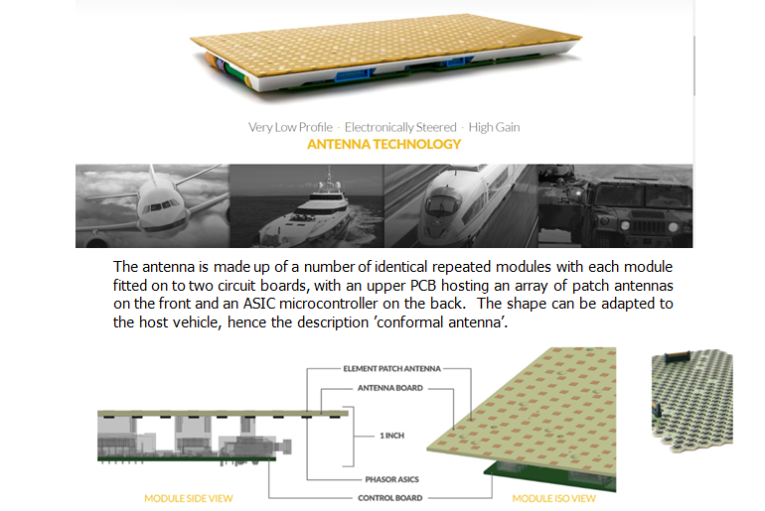

Tables 6.2 summarises the performance specification of an X band and Ku-band conformal antenna including operational temperature range.

**Table 6.2 X- band and Ku-band Active Conformal antenna performance specification**

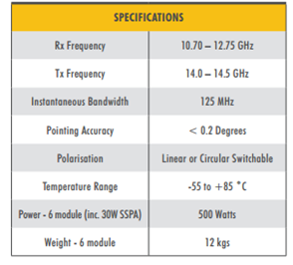

Table 6.3 compares performance of the active conformal antenna against a conventional dish antenna.

**Table 6.3 Active conformal antenna compared to a conventional dish antenna.**

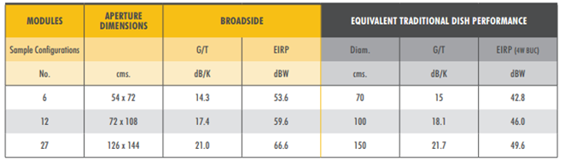

**6.5.5 Passive conformal antennas**

Active antennas arrays are at the moment inherently expensive as each element has its own RF power and low noise amplifier and associated filter and matching networks. They could also be required to work across a wide temperature range, for example + +125 degrees C in some automotive roof mounted applications (compared to the +85 degrees specified in the example above). This is hard to realize cost economically and can also result in performance degradation caused by frequency drift with temperature and noise rise from the heat energy absorbed by the device.

An alternative is to construct conformal antennas with elements that are mechanically and electrically arranged to look directly upwards and nowhere else. Effectively this is a passive antenna with multiple antennas with phase offsets created using passive delay lines and one RF power and low noise amplifier which can be remotely mounted. These devices do not have adaptive capabilities and just look at the same bit of sky but they are lower cost, thinner and less temperature sensitive. They could be very adequate when used with high count LEO always directly overhead constellations.

**6.5.6 Active electronically steered array (AESA) antennas for military radar, SATCOM, 5G terrestrial and 5G backhaul applications**

The principle of an active conformal flat panel antenna array is that it can detect and analyse the angular power received into the antenna both in terms of elevation and azimuth and therefore determine where RG energy should be focused on the return path.

This is similar in principle to the 1945 radar shown in Figure 6.13 though here the return path is anti-aircraft fire. Modern anti-missile missile systems provide contemporary leading edge examples of how digital processing can work out angle of arrival and the trajectory and speed of a close or distant object. Switching speed can be in the order of nanoseconds.[23] Figure 6.19 shows a Thales radar system mounted on a Rafale fighter jet. These antennas systems are referred to as active electronically steered array (AESA) radar. When used in communication systems they are known simply as AESA systems.

AESA radar and communication systems are manufactured by a wide cross section of the military systems supply chain including Raytheon and Boeing, Lockheed Martin, Northrop Grumman and BAE systems. IBM, Intel and Si-Beam are also invested in the sector.

**Figure 6.19 Thales AESA Radar on a French Rafale fighter jet**.

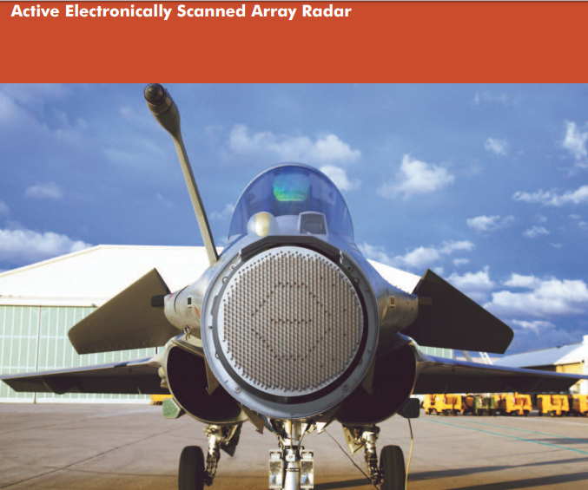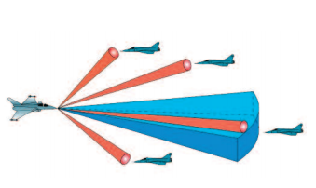

Automotive radar (page 264 onwards in 5G Standards and Spectrum) essentially does the same calculation though with a different desired outcome (to miss rather than hit the object ahead).

Figure 6.20 shows an active antenna integrated circuit (IC) product from Anokiwave which can be used across SATCOM, radar and 5G terrestrial applications.

**Figure 6.20 Anokiwave Active Antenna Integrated Circuit for active electronically steerable array antennas**[24]

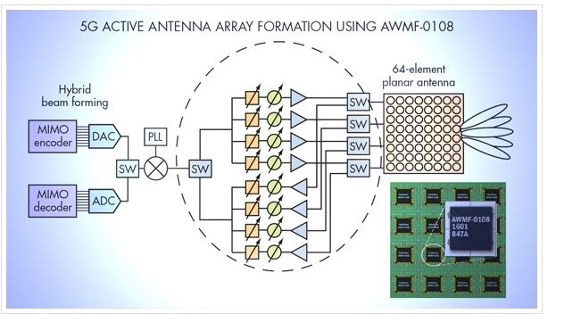

**Table 6.4 Anokiwave Product Range**

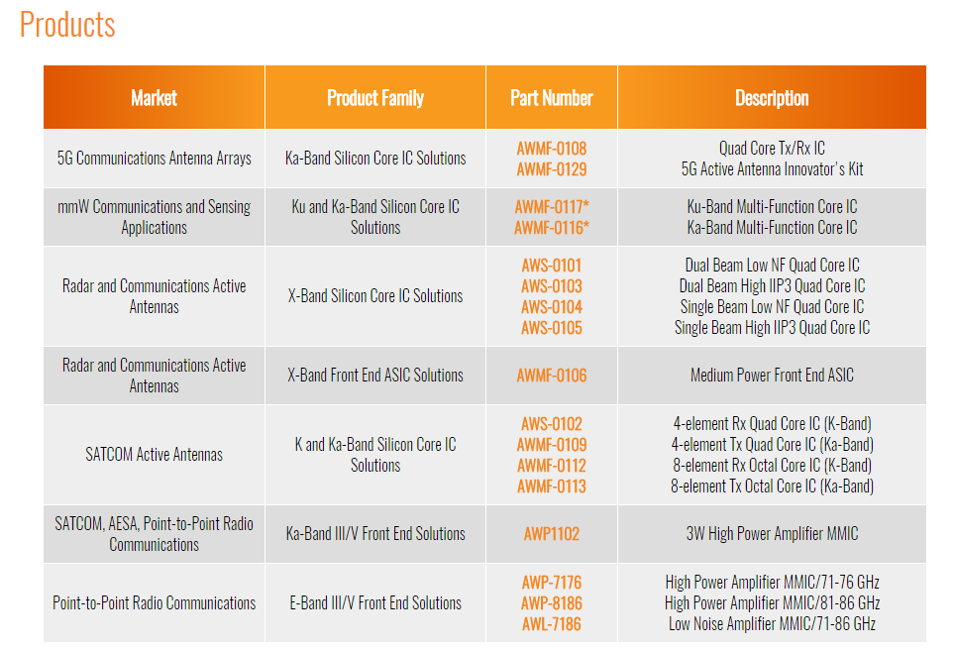

The ability to amortise development costs across these multiple markets both in terms of spatial processing algorithmic development and optimised hardware architectures is a significant advantage. The 5G market offers very substantial volume opportunities but only at a price point several orders of magnitude below more specialist applications. A $3000 dollar antenna on a superyacht or $30,000 dollar antenna on a fighter jet or tank cannot be translated directly to a sub $10,000 dollar base station or sub$100 dollar Wi-Fi access point. There are also different design requirements. Switch speed in radar systems for example is a critical performance parameter.

**6.6 4G and 5G Terrestrial AESA systems – flexible MIMO**

This brings us to a discussion of how terrestrial MIMO systems might evolve over the next few years. Each of the major Tier 1 vendors (Huawei, Ericsson and Nokia) has invested substantial effort in developing MIMO systems for high throughput 4G and 5G networks. The challenge is to make these platforms flexible and fast enough to respond to changing channel conditions including changes in the angular direction of arrival of wanted and unwanted signal energy but delivered at price points several orders of magnitude lower than the military radar systems described above. The products are described as flexible MIMO.

**6.6.1 Automotive AESA**

Automotive radar has a similar pricing and cost issue though the automotive supply chain seems to be making remarkable progress

**Figure 6.21 Bosch Automotive Radar – are cars the stars?**

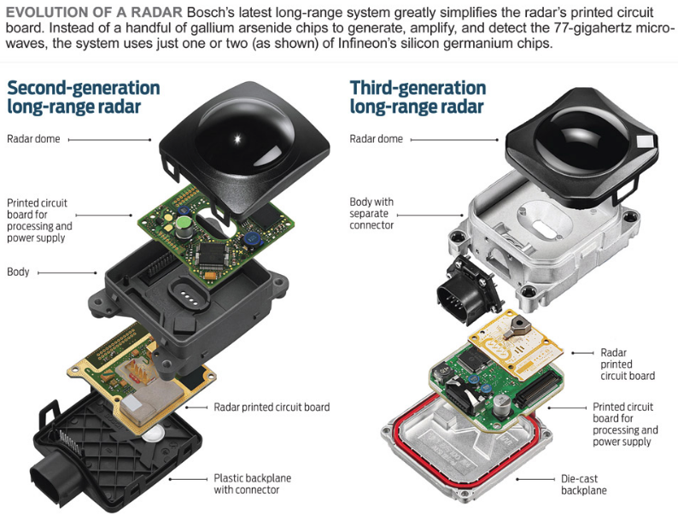

This is partly due to the scale value of the automotive industry. We revisit this in later chapters but consider

* The number of planes in the world 11000
* The number of trains in the world 15000?
* The number of ships in the world   50,000
* The number of cars in the world 1.5 billion
* The number of people in the world 7.5 billion
* The number of connected devices in the world 10 billion

Planes and trains and ships have a higher value than cars but the car market is bigger in volume terms. The economic value of people and devices is a philosophical debate which we do not have time to tangle with in this chapter but it can be seen that antenna vendors have to find a sweet spot between volume and value in their development and market plans.

**6.6.2 Some Nokia examples of 5G ‘Flexible MIMO’ antenna arrays**

5G vendors may have an ambition to service all of the above markets but generally can be considered to be dominant in people and device connectivity.

As discussed in various other parts of this book, people and devices have a huge range of different connectivity requirements (and hugely different amounts of money to spend) which means that antennas have to do very many different things and can be hard to optimize for general tasks. The starting point is to decide whether functions such as beam forming are implemented in the analogue or digital domain or a combination of both of these.

**Figure 6.22 Antenna array architectures for scalable flexible MIMO – with thanks to Nokia Networks**

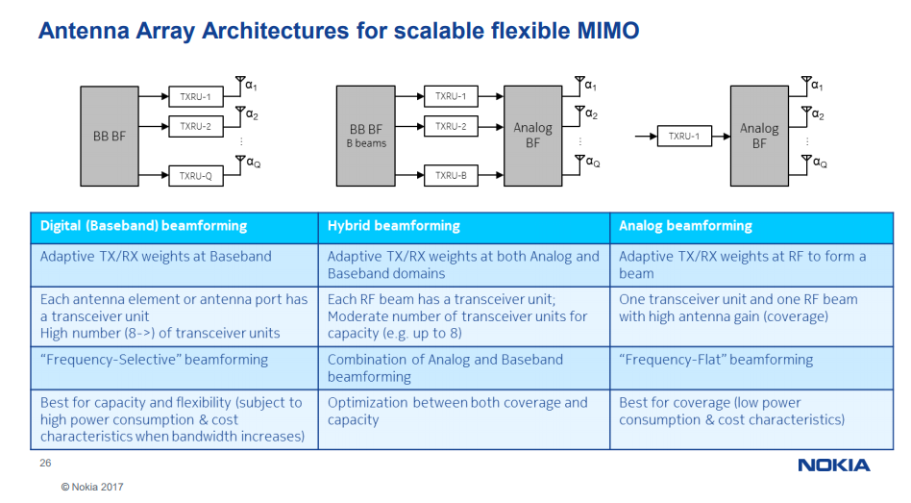

Note the trade-offs between coverage and capacity and power consumption and bandwidth limitations. The all-digital option for example is the most flexible but constrained in terms of channel bandwidth due to the limitations of present digital signal processing technology.

Figure 6.23 makes the case for massive MIMO in terms of <6GHz and >6 GHz applicability and highlights the transition to a ‘beam based interface’ in 5G

**Figure 6.23 Transition to a 5G Beam Based interface- with thanks to Nokia Networks.**

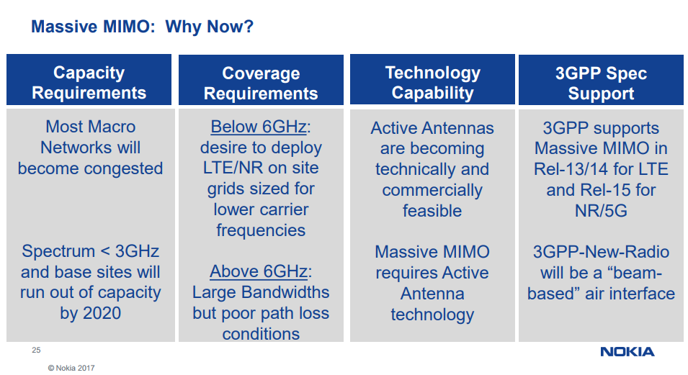

Figure 6.24 describes how beam forming is integrated into 4G and 5G coordinate multipoint (CoMP) architectures servicing multiple users from multiple base stations.

**Figure 6.24 Beam Management below and above 6 GHz- with thanks to Nokia Networks.**

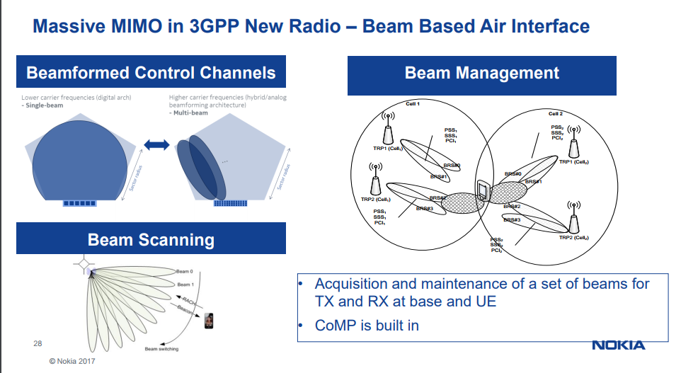

Figure 6.25 shows the impact of moving from 28 GHz to 39 GHz to 73 GHz in terms of the overall aperture size and physical size of the 5G array and the realisable gain.

**Figure 6.25 Antenna Array Comparisons – with thanks to Nokia Networks**

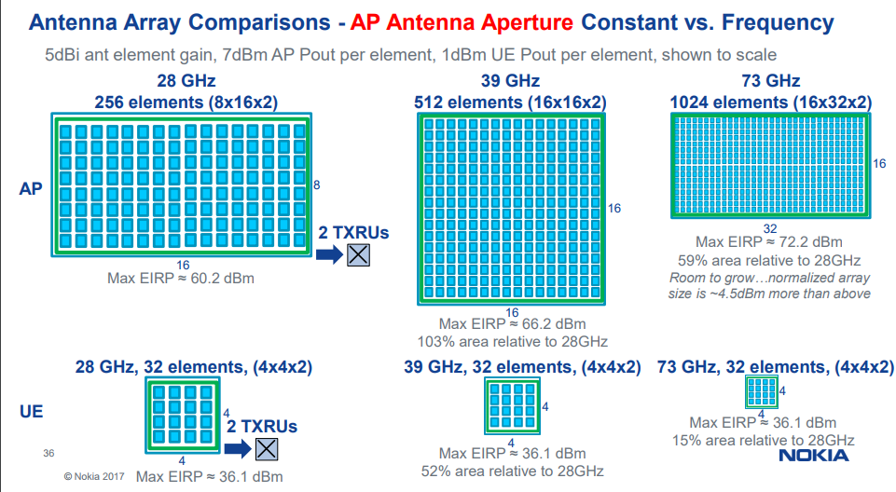

**6.7 Plasma Antennas**

So far we have described antennas that use copper and similar high conductivity materials to construct structures that can translate RF signal energy into an induced voltage.

There is another alternative known as a plasma antenna.

Plasma antennas, as the term implies, are radio frequency structures that use plasma as the guiding medium for achieving resonance with modulated radio carriers. First patented in 1919 they may be having their millennial moment in mobile communications.

**Figure 6.26 Principle of a plasma antenna**

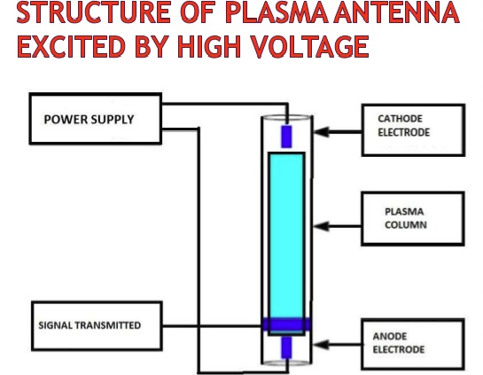

There are pros and cons associated with plasma antennas that can be summarised as

The length of an ionized filament can be changed rapidly, thereby “re-tuning” the antenna to a new frequency

The antenna can be “turned off” to make it electrically invisible for the purpose of reducing its scattering signature and eliminating its coupling and interference with other nearby antennas.

But

The use of plasma adds complexity to the antenna design.

Equipment for establishing and maintaining the ionization must be provided.

The glow from the plasma increases its visible signature, and plasma decay generates noise

A plasma antenna can be established in air at atmospheric pressure by using lasers, high power microwave beams, or ultraviolet rays. A plasma can also be generated within a tube containing a noble gas (a gas that is unreactive except under extreme conditions) for example neon and argon. Methods that use a tube require less energy to excite and maintain the plasma state, because the gas is pure and the presence of the tube prevents dissipation but the use of a tube increases the antenna weight and volume and makes the antenna less durable.

There are demonstration products available in bands targeted for 5G including products from Plasma Antennas Limited. These devices can be stacked to form and steer beams in azimuth and elevation to form multiple beams.

**Figure 6.27 Plasma Antenna 28GHz 5W 16dBi gain 360˚ field of view beam forming and steering antenna- with thanks to Plasma Antennas.**[25]

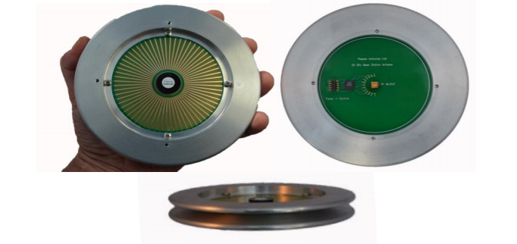

**6.8 Summary**

In the last three chapters we have covered launch technology innovation, satellite technology innovation and antenna innovation. Antenna innovation is beneficial to all radio networks, terrestrial and non-terrestrial. In the context of satellite delivery economics, the specific benefits are that cell sizes (radius) can be scaled from 2 kilometres to 2000 kilometres to deliver geographic and demographic bandwidth on demand at a sufficient flux density on the downlink and sensitivity on the uplink to support mobile and fixed broadband connectivity.

Crucially, the active antennas and the signal processing algorithms that have been developed initially for military and more recently automotive radar are being repurposed into terrestrial and satellite communication although delivering these products at consumer price points remains a challenge. The particularly interesting capability of these antenna systems is that they can calculate the angle of arrival and signal strength of both wanted and unwanted RF signal energy. This means that they can also calculate the required angle and power needed for the return path.

This is a critical part of the narrative that we hope is becoming apparent as we reach this half way point in the book. There are many emerging opportunities to separate out multiple radio systems in terms of the angle of arrival of wanted and unwanted signal energy. This includes the potential capability to reuse spectrum between users separated in three dimensions, for example enabling high count LEO constellations to co-share spectrum with MEO and GSO constellations and with 5G terrestrial networks.

Satellite networks have an evolving role in helping terrestrial network’s to meet their 5G energy efficiency and carbon footprint targets both in terms of backhaul power consumption and base station and user device IOT power drain.

Antennas are a critical part of this story with the challenge of producing adaptive electronically steerable antenna arrays (AESA) that can achieve efficient and effective angular power separation at consumer price points.

Twenty years ago, Marty Cooper, the man credited with developing the first commercial cellular phone[26] suggested that spatial separation would prove to be an important aspect of terrestrial cellular system design and one of the ways in which spectral efficiency could be improved.

The eponymous Cooper’s Law of spectral efficiency states that the maximum number of voice conversations or equivalent data transactions that can be conducted in all of the useful radio spectrum over a given area doubles every 30 months.

**Figure 6.28 Coopers Law of spectral efficiency**

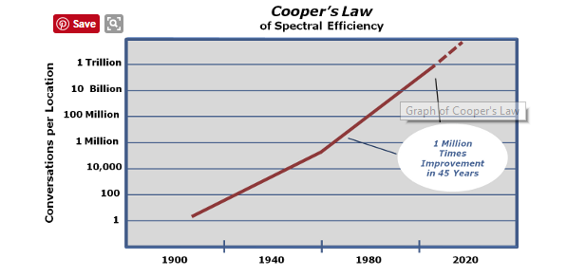

His company Arraycomm produced many of the initial processing algorithms that have been subsumed into present day MIMO and AESA systems.

The story is not however just about new antenna materials and manufacturing techniques or just about spatial processing but about integrating that innovation with constellation innovation which brings us on to our next Chapter.

1. Informal discussions with vendors
2. <http://ethw.org/Smith_Chart>
3. https://5g.co.uk/guides/what-is-lte-broadcast/
4. 3GPP TSG RAN meeting#75, RP-170132
5. http://www.etsi.org/technologies-clusters/technologies/satellite/satellite-umts-imt-2000
6. http://www.ic.gc.ca/eic/site/smt-gst.nsf/eng/h_sf09857.html
7. <http://www.radio-electronics.com/info/antennas/waveguide/rf-waveguide-dimensions-sizes.php>
8. https://www.everythingrf.com/tech-resources/waveguides-sizes
9. http://www.pennengineering.com/e-and-h.php
10. http://miwv.com/images/Waveguide-Chart.pdf
11. http://www.rfcom.co.uk/index.php
12. http://www.photonicsinc.com/index.html
13. IEEE webinar September 20th 2017 Dr Amitabha Ghosh
14. http://www.duxfordradiosociety.org/restoration/equip/aa3mk7/aa3mk7.html
15. http://www.arraycomm.com/
16. http://www.quintelsolutions.com/
17. Meta, from the Greek, meaning beyond.
18. http://www.antenna-theory.com/antennas/patches/pifa.php
19. http://www.mrs.org/58th-emc-topics/wide-bandgap-materials
20. https://www.parc.com/services/focus-area/metamaterials/
21. https://www.kymetacorp.com/markets/connected-car/connected-car/
22. http://www.phasorsolutions.com/
23. A nanosecond is one thousand-millionth of a second.
24. http://www.anokiwave.com/company/company-news/releases/awmf_0108.html
25. http://plasmaantennas.com/technology/psian-plasma-antennas/
26. http://www.destination-innovation.com/how-startrek-inspired-an-innovation-your-cell-phone/