Chapter 5 Satellite technology Innovation
5.1 The Power of Power
This chapter follows a similar trajectory to the previous chapter on launch technology and the common theme is power. We discussed the positive impact of the planned Mars Missions on propulsion system development. For satellites we will find that the planned Mars missions are having a similar positive impact on power system development.
We finished the last chapter with a comparison of small rockets and large rockets and the trade-off between going a long way, to Mars and beyond, with a relatively small payload, or a short way, a run into Low Earth Orbit, with a large payload. We highlighted that the development spending on vehicles capable of fulfilling deep space missions beyond the moon is having a directly beneficial effect on the lifting power available for new generation communications satellites. These can either be huge satellites, thousands of kilogrammes in weigh or tiny satellites a few kilogrammes in weight. Medium size satellites such as Iridium (around 500 kilogrammes) can be launched ten at a time from these big rocket systems, alternatively a hundred small sats can be packed into a single nose cone and spread into low earth orbit. Orbcomm, the VHF constellation referenced in earlier and later chapters has 31 satellites in Low Earth Orbit at 775 kilometres. Seven replacement satellites were launched in 2017 by Space X as a secondary payload.
The common denominator is the amount of thrust available and the economic cost of providing that thrust either once (with expendable rockets) or multiple times (reusable rockets). The ambition is to reuse rockets up to 100 times. This will substantially change the economics of delivering consumer, commercial and military payloads into space.
We also referenced the close coupling between military spending on rockets including intercontinental ballistic missile development and present day commercial rocket systems particularly in terms of liquid fuel engine development and guidance systems and added in the impact of materials innovation, in particular the use of carbon composite materials and new manufacturing techniques.
However in the specific context of satellites we are not talking just about propulsive power but a combination of propulsive power and processing power. The birth of the satellite industry sixty years ago was only made possible by advances in component technology including the transistor in the early 1950’s. The development of satellite capability since then has been driven by the development of the microcontroller in the 1970’s; the digital signal processor in the 1980’s and low cost high performance memory in the 1990’s. As we shall discuss later in Chapter 9, the combination of these innovations is opening up a host of new space based opportunities including servers in the sky, above the cloud computing and new dot.space business models.
Crucially these new satellite constellations will co share spectrum with existing MEO and GSO satellites. They achieve this through angular power separation which requires the satellites to roll as they fly towards the equator (progressive pitch control).
This is a cumbersome process made more cumbersome by the solar arrays. Progressive pitch will also compromise the efficiency of the solar arrays (they will spend a significant amount of time pointing away from the sun).
Progressive pitch will be easier to achieve if the satellites have an alternative power source to solar.
Solar panels have a number of other disadvantages. They are vulnerable to damage, create additional space debris in the event of a collision and make it harder to dock multiple satellites together. Sometimes known as buddy sats, docking multiple satellites together at the same orbital position is a useful potential option for scaling bandwidth particularly for GSO constellations constrained by the need to have 2 degrees of separation between orbital slots.
Solar panels are relatively inexpensive compared for example to nuclear power sources and more environmentally benign though if additional launch weight and volume cost is taken into account, the cost difference reduces and solar panels can also cause environmental damage (see space debris above).
If radioactive power sources could be reduced in cost there would be a new market for space optimised weight optimised small nuclear power sources with a unit volume potential of at least 10,000 satellites, a market volume many orders of magnitude larger than any existing maritime or terrestrial nuclear power source application.
Nuclear power in space could also help meet the energy efficiency and carbon foot print targets for 5G terrestrial networks, a topic to which we will return in later chapters.
Last but not least, alternative power sources could provide the additional power needed to keep low earth satellites in orbit for longer. This is particularly important for small satellites in lower low earth orbits. The 170 kilogramme Orbcomm satellites at 775 kilometres have an expected lifetime of five years rather than the 15 year life expectation of the larger Iridium satellites at a similar orbit height (781 kilometres).
5.2 The Sun as a Source of power
Close to earth, in LEO, MEO and GSO orbits, there is sufficient sunlight to power most communication satellites. Solar energy is measured in W/m2, energy per unit area. Outside the Earth's atmosphere this is roughly 1,350 W/m2. On the Earth's surface this is a maximum of around 1,000 W/m2 for extreme desert areas. In addition on Earth there are night and day cycles, so there is more solar energy in space (it’s official - it’s sunnier in space).
5.2.1 Solar Panel efficiency
Consumer grade solar panels that you may have at home typically have an efficiency of 15%. Solar panels for use in space use optimized manufacturing techniques based on germanium rather than silicon with cells that have multiple p-n junctions that capture different portions of the energy spectrum. These panels can achieve efficiencies approaching 30% The systems also depend on the ability to manufacture space qualified cover glass to protect large arrays of solar panels from impact damage. The Opportunity Mars Land Rover has just finished 11 years exploring the surface of the planet from the original landing sight. The original expectation was that the solar panel arrays would not survive for longer than 90 days. The solar panel supplier for many of these deep space projects is a subsidiary of the Boeing Corporation
Figure 5.1 Mars Opportunity Land Rover with solar panels
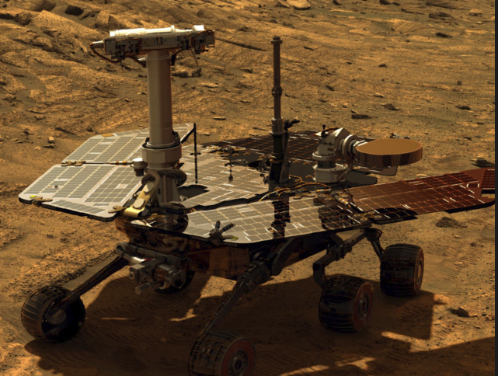
5.2.2 The International Space Station as an example of big solar panels in low earth orbit
The poster child of large solar arrays is the International Space Station orbiting in a LEO orbit at 350 kilometres with four sets of solar arrays each 33 metres long and over 12 metres wide producing 200 kilowatts of electricity. Together the arrays contain a total of 275,0000 solar cells and cover an area of about 2,500 square meters, more than half the area of a football field.
Figure 5.2 Solar Arrays on the International Space Station – credits- NASA
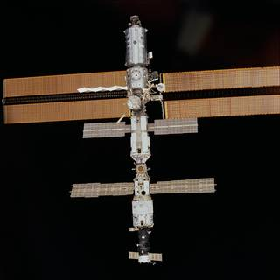
5.2.3 Satellite power requirements
A large GSO satellite will typically have an on board power requirement of 15 kilowatts, a medium size LEO such as an Iridium NEXT constellation satellite will have an on board power budget of about 500 watts and a Cube SAT has to be happy with a few milliwatts. The solar arrays on these platforms have to survive many years in space and have to be designed so that any efficiency losses through life are minimized.
Table 5.1 Typical satellite power requirements

Pico Satellites (Cube sats?) | Nano Satellites | Micro Satellites | Macro Satellites
<1 kg | < 10 kg | < 500 kg | ≥ 500 kg
Milliwatts | Tens of milliwatts | Hundreds of watts | Kilowatts
NASA | NASA | With thanks to Iridium
The Inmarsat Ka-band GSO satellites for example have solar panel arrays with a wing span of 33.8 metres with ultra-triple-junction gallium arsenide solar cells that generate 15 kW of power at start of service and 13.8 kW by end of life (15 years). The panels also power the xenon ion propulsion system. This is a massive beast with a main body the size of a double decker bus and a launch weight of over 6,000 kg. Eighty nine Ka-band user beams are generated by two transmit and receive aperture antennas with an additional six steerable on-demand spot beams.
And here it is:
Figure 5.3 Inmarsat GSO Satellite
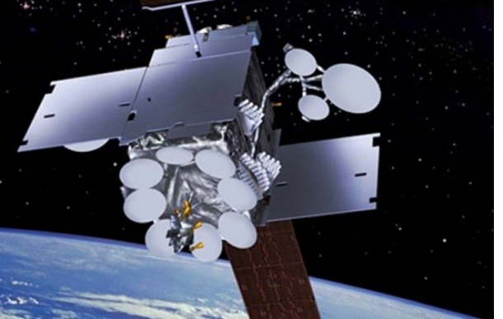

5.2.4 The power of solar power and what it is used for
Solar power is used in these near earth satellites to keep the on board processors happy both in terms of their energy requirements but also their ambient temperature, to power the systems that determine the attitude and pitch and yaw control of the satellite, typically with momentum motors and to provide RF Power for the on board transceivers that are needed both for telemetry and to provide communications to and from earth. Table 4.5 in the last chapter provided an overview of the RF systems that have to be supported, with OneWeb as the example. As a rough rule of thumb the split between the RF power requirement and on board baseband processing is 50:50.
5.3 The importance of satellite power efficiency
This explains why RF power efficiency is critically important for satellite transmitters and why power efficient modulation schemes are used together with closely controlled multiplexing with minimum AM variation. There will be a trade-off depending on whether the satellite is functioning as a repeater or a relay. A relay, generally described as a bent pipe satellite, takes an uplink signal, amplifies it and sends it back to earth. This minimises on board processor delay and power consumption but any noise on the signal is also amplified. A relay demodulates the uplink (a multiplex of many users separated in the time domain) and decodes then recodes and modulates the downlink. This will use more power but the residual bit error rate will be lower so if well implemented should realise a better efficiency on a user bit thoughput basis (or goodput as our internet friends insist on calling it). There will also be some difference in power budget distribution depending on whether intersatellite switching is used. Iridium intersatellite switch in Ka- band and Space X and LEOSAT are proposing to intersatellite switch with optical transceivers. On balance it is more complicated to have switching on board the satellite which means more processing power will be consumed and there are more functions that can go wrong due to, for example, radiation damage of microprocessors or RF components but the latency gains can be significant. (See previous chapter).
5.4 Electric satellites using ion propulsion systems
Solar panels can also be used to provide the power to fly satellites from interim orbits to their final orbit destination. This is often described as orbit raising and the satellites are described as electric satellites. Their purpose is to reduce launch costs but also to optimise though life station keeping which prolongs the life of the satellite. This is because satellites relying on hydrazine thrusters have to be deorbited before the hydrazine runs out.
Electric satellites use ion thrusters as a propulsion system. Chemical rockets as we documented in Chapter 4 can produce 200,000 kilonewtons of thrust but use a large amount of fuel to generate that thrust. The thrust efficiency is a function of exhaust velocity. Liquid oxygen and hydrogen produces an exhaust velocity of about 5000 metres per second.
ION thrusters take a noble gas such as xenon and strip or add electrons to produce plasma which is then accelerated with an electric or magnetic field producing an exit velocity out of the back of a thruster about ten times that of a chemical propellant. Xenon is easily ionised and has high atomic mass and high storage density. However unlike chemical propellants, the gas does not have power of its own to release and the thrust is therefore a function of the amount of electric power available.
Ion propulsion technology was developed in the late 1950’s and first tested in space in the early 1960’s and today is routinely used in deep space missions and to keep geosynchronous satellites at their correct location. Considerable work is being done to increase the output and efficiency of ion thrusters. Power outputs range from a few watts to kilowatts. 1 kilowatt equals 1000 newtons per second.
Boeing introduced what they claimed was the word’s first all-electric satellite in 2015. The satellite uses three Hall Effect plasma thrusters to get from a transition orbit to a final orbit position or to change orbit while in service. So for example in a Leo constellation, a satellite could be kept in a reserve orbit then flown up to operational orbit when needed. The Boeing ion thruster is rated at 5 kilowatts.
Europe has its own electric satellite project (Electra ) supported by the satellite fleet operator SES, Swedish satellite manufacturer OHB-SE and the European Space Agency aimed at satellites with a weight of 3000 kilogrammes or less at launch (similar to the Boeing 702sp satellite).
Figure 5.4 Electra - Europe’s first electric propulsion satellite
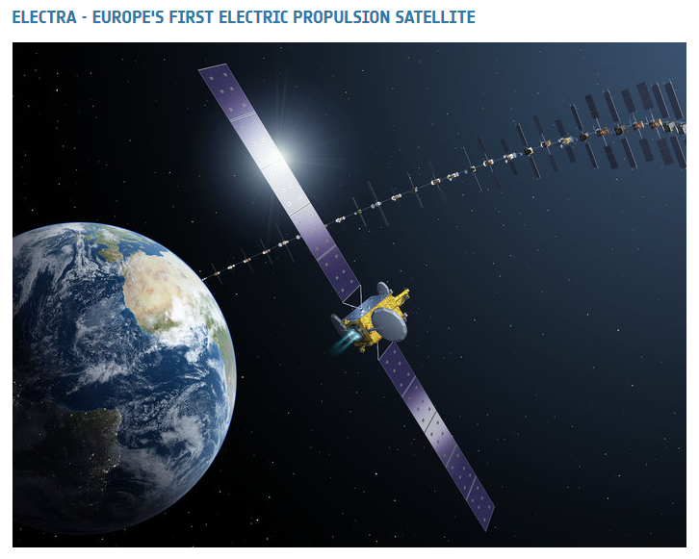
The Hispasat small GEO satellite is another example of an electric satellite. Hispasat 36W-1 uses chemical propulsion to climb into final geostationary position after separation from the rocket, and then an electric propulsion system to manage station keeping for its anticipated 15 year lifespan.
Ion thrusters are therefore an additional example of deep space technology originally developed over 50 years ago, and refined over five decades, being applied to near earth satellites to reduce launch payload costs and though life costs (by extending the lifetime of the satellite).
5.5 What happens when the sun stops shining?
Further out into space the sun becomes progressively less useful as a power source – the Oort clouds are a particularly gloomy place in space - but any journey away from the sun or in the shadow of other planets can be compromised by a shortage of solar energy.
Happily the defence community has had to solve this problem for other places where the sun does not shine, for example to power submarines that have to be capable of staying at the bottom of the ocean for months on end.
Figure 5.5 VMF Typhoon Class Submarine- Nuclear Powered and the world’s largest displacement submarine
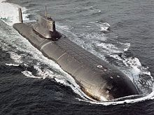
Nuclear power plants similar to those used in submarines have provided the power sources for almost every long distance space mission to date including those Voyager craft heading for the Oort clouds after a 40 year journey to the edge of the solar system. Adding a radioactive payload as a power source on a rocket is not risk free but is not uncommon and the risks can be managed, and potential radiation minimised though the insurance costs implicit in any risk of accidentally irradiating America and adjacent continents could be prohibitive. However think of it as a taking a bit of the sun into space with you and it can seem like a relativity benign option.
Practically, it comes down to using radioactive isotopes to produce power from decay heat (thermo- electric generation) or from fission and fusion. The best option depends on the amount of power needed, the time scale over which it is required, the amount and type of gamma rays or x or y ray ionising radiation produced and the cost and complexity of containing that radiation.
But consider. A uranium pellet encased in a grapefruit sized ferrite core can be held in bare hands with no short or long term material health impact. The power generated from these sources can be sufficient to produce temperatures high enough to split hydrogen and oxygen atoms from water. This offers the prospect of sustaining human life on any planet that has water but probably equally important provides the basics for manufacturing the liquid oxygen and hydrogen needed to return to earth. This is all very exciting but what we need is to understand is whether this is potentially useful for communications satellites in near earth orbits. The start point is that any of these power sources produce far more power from a much smaller size than a solar panel array so potentially there are major weight and size savings that could be achieved.
Increasing the overall market for nuclear power generation by adding high volume space applications would also help reduce the cost of nuclear terrestrial energy providing a more space efficient but equally carbon friendly way of delivering power to the grid.
5.5.1 Thermoelectric generation using radioisotope power sources for communications satellites?
Radio-isotopes have been used in space as a heat and power source for well over fifty years and are known as RTG’s, Radio-isotope Thermo-electric Generators. When used just to warm up they are known as RHU’s (Radio-isotope Heating Units).
Plutonium, specifically Plutonium-238 (Pu-238) has been widely used partly because it has been available as a by-product of the US and Russian and other country weapon programmes. It has a decay heat of -0.56 watts per gram and a half-life of 88 years. A typical RHU used to warm instruments to an efficient operational temperature would typically use just under 3 grams in a box about 3cm by 2.5 cm to produce a watt of power.
There are also many by-products of plutonium including Americium, produced when plutonium is bombarded with neutrons for example in a reactor or weapons test. Americium-241 is the most common flavour of Americium, manufactured from ageing plutonium stocks. It is used in smoke detectors so probably not a good idea to live in a cupboard with those 3000 smoke detectors you bought by accident on E-Bay. Americium-241 has a half-life of 432 years but produces ‘only’ 0.15 watts per gram (a quarter of the energy of plutonium). It produces higher levels of gamma radiation than plutonium and therefore requires more shielding (additional weight and cost). Note that shielding in manned missions is generally more onerous as it is generally considered inappropriate to irradiate astronauts at significantly elevated levels.
5.5.2 Production costs for Americium and Plutonium
Because it is a by-product, Americium is significantly less expensive to manufacture. The cost of manufacturing a kilogramme of plutonium has been estimated as $8 million dollars. The European Space Agency is paying for AM-241 recovered from the UK’s civil plutonium stocks where this cost has essentially been amortised over many years of (expensive) nuclear power generation. The cost is therefore high but already paid for by the UK tax payer.
For several decades there has been enough plutonium available from civil and military nuclear programmes including for example from the various nuclear missile reduction programmes for space use either in its raw state or processed into AM-241. In 2011, NASA and the US Department of Energy received $10 million of US tax payer funding to restart plutonium production with the intention of generating initially 1.5 kilogrammes per year at significantly lower cost. Throughout the 1990’s the US bought Pu-238 from Russia, in total about 16.5 kilograms, a by-product of START, the Strategic Arms Reduction Treaty and Glasnost. A handful of Russian individuals became very wealthy from these exchanges. When President Putin came to power, Russia decided it would no longer be a source of supply hence the focus on US based production capability. There will presumably soon be a plentiful supply of Iranium courtesy of President T.
Plutonium by the way is produced by irradiating Neptunium-237, a radioisotope with a half-life of just over two million years.
5.5.3 How long do Radio-isotope Thermo-electric Generators last?
The Voyager spacecraft that have just left the solar system are expected to keep sending back signals to earth until 2025, the best part of 50 years of operational life.
There are several dozen RTG’s presently powering US and Russian space vehicles. Cassini for example, sent to explore Saturn’s rings was powered by three RTG’s providing 870 watts of power from 33 kilogrammes of plutonium oxide. As you may remember, there was a planned deorbit into Saturn’s atmosphere on September 15 2017.
The Pathfinder Mars robot lander launched in 1996 had three RTG’s each with 2.7 grams of plutonium-238 oxide producing 35 watts of power and one watt of heat.
State of the art RTG’s today are known as General Purposed Heat Source (GPHS) Modules. The latest Mars Rover, Curiosity had at time of writing travelled 18 kilometres across the surface of Mars powered by 8 GPHS units containing a total of 4.8 kilograms of plutonium oxide producing 2 kilowatts of thermal power generating 110 watts of electricity. The Mars Rover has an earth weight of 890 kilograms, significantly heavier than a Caterham sports car.
The New Horizons spacecraft which flew by Pluto in July 2015 was launched in 2006. The 250 watt 30 volt RTG produced 200 watts from 10.9 kilograms of Pu-238 oxide which had reduced to 200 watts by the time the craft arrived near Pluto. The vehicle has 65 kg on hydrazine available to control 16 Aerojet thrusters generating a few newtons of power.
Russian RTG’s are apparently still operational in orbit on Cosmos navigation satellites launched in 1965. China’s lunar lander apparently uses Pu-238 based RTG’s.
5.5.4 Heat to electric conversion using Stirling Radioisotope Generators
RTG’s turn heat into energy by using simple thermocouples. These are almost completely reliable (no known or recorded in service failures) but not efficient (two kilowatts to heat to produce 10 watts of electricity- see above though the extra heat can also be useful).
The alternative is to use a Stirling engine.
Figure 5.6 Stirling Engine used to convert heat into electricity
With thanks to the Glenn Research Centre
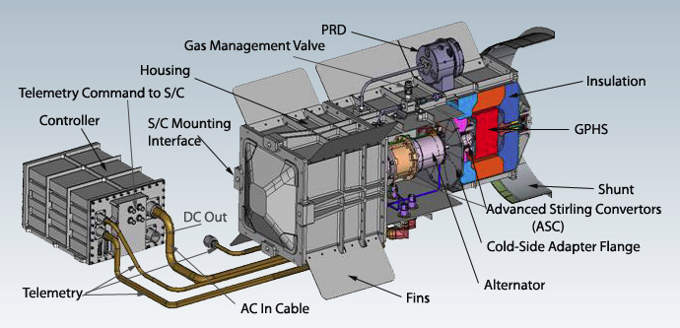
Stirling Engines can produce at least 4 times more electricity from a gram of plutonium when compared to a simple thermocouple. There is a hot end which could be for example at 650 degrees centigrade which heats up helium which then drives a free piston reciprocating in a linear alternator powered by the temperature difference either side of the piston. Two SRG’s working on about 500 watts of thermal power should produce about 140 watts of electric power from a kilogram of Pu-238.
Invented by Robert Stirling in 1817, the Stirling Engine is being promoted as a semi magic way of turning waste heat from domestic and industrial processes into useful electricity. Our particular interest in the context of space is its capability to scale to high temperature gradients. Although not as reliable as thermocouples, a space qualified SRG is not intrinsically reliable and several small engines coupled together will have a high level of redundancy.
Figure 5.7 The Reverend Robert Stirling 1790-1878
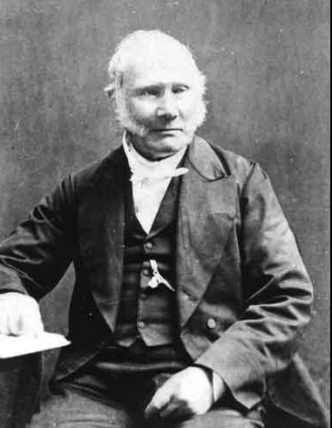
The Idaho National Laboratory's (INL) Centre for Space Nuclear Research (CSNR) in collaboration with NASA is developing an RTG-powered hopper vehicle for Mars exploration, supported by NASA. When stationary breathes in carbon dioxide from the Martian atmosphere, compresses it through a Stirling engine and freezes it. A beryllium core will store heat energy to fuel an explosive vaporisation for the next hop. When ready for the next hop, nuclear heat would vaporise the carbon dioxide, creating a jet capable of propelling the craft to an altitude of 1000 metres and a hop of 15 kilometres with payloads of up to 200 kilograms. The surface gravity on Mars is only 38% of the surface gravity on Earth. If you weigh 100 kilograms on Earth, you will only weigh 38 kilograms on Mars, an easy way to lose weight.
5.6 Fission and fusion
Not content with radioisotope thermoelectric generators, Russia has invested significant development in fission reactors for space power systems. Just as a reminder, fission and fusion are both nuclear reactions that produce energy, but fission does it by splitting a heavy, unstable nucleus into two lighter nuclei, and fusion crashes two light nuclei combine together to release a vast amount of energy very quickly. Fission is recreating the sun in a small package; fusion is capturing the power of the big bang, an altogether more cataclysmic process.
Russia has used over 30 fission reactors in space; the USA has flown only one - the System for Nuclear Auxiliary Power in 1965.
From 1959-73 there was a US nuclear rocket programme – Nuclear Engine for Rocket Vehicle Applications (NERVA) working on using nuclear power rather than chemical power for the latter stages of launches. NERVA used graphite-core reactors heating hydrogen and expelling it through a nozzle. Some 20 engines were tested in Nevada and yielded thrust up to more than half that of the space shuttle launchers. Generally it was felt that this would be altogether two hazardous for earth band mortals and the focus shifted to propulsion in space. A $19 million dollar contract has been placed by NASA with specialist nuclear energy company, BWXT Nuclear Energy Incorporated, to study the feasibility of a nuclear thermal rocket.
In 1958, the US Project Orion planned to launch a 1000 tonne spacecraft using a series of nuclear explosions. The project was stopped in 1958 by General Atomics when the Atmospheric Test Ban Treaty made it illegal.
Russia however pressed on with fission reactors for space using uranium carbide fuel at high temperature.
5.7 A minor diversion – why is Uranium cheaper than Plutonium
Because you can dig it out of the ground. Well at least you can dig Uranium 235 out of the ground and then refine it into something more useful in terms of realisable energy content (for example Uranium 233).
There are three major fissile isotopes, Uranium 235, used in the Hiroshima bomb and most nuclear power reactors, Uranium 233 used in Thorium reactors but not in weapons and Plutonium 238.
It is a bit like diesel and petrol and paraffin you take a basic ingredient and transmute it into something else; in the case of fissile isotopes, by firing neutrons at whatever you happen to have available.
The first nuclear weapons used uranium because plutonium had to be manufactured by neutron bombardment and to make plutonium you need a lot of neutrons and the only realistic way of getting these is a uranium based fission reaction.
Plutonium has more energy density than Uranium and it is easier to get plutonium to a critical mass than uranium. For weapons systems this is an advantage but for a communications satellite energy source probably a disadvantage.
And plutonium is a real pain in terms of the damage it can cause to humans. Plutonium produces lots of alpha radiation rather than beta or gamma radiation
Of the three types of ionising radiation, alpha is the least penetrating while gamma is the most penetrating. However plutonium gets into humans via the bloodstream via the lungs then keeps going into our bones, liver, and all other vital organs where it can stay for decades before it kills us, though if the dose is big enough it can kill us alarmingly quickly as firefighters at Chernobyl and Fukushima tragically demonstrated. When alpha rays get into our cells they cause between 10 and 1,000 times more chromosomal damage than beta or gamma rays. Polonium, also a by-product of Uranium, has similarly devastating medical effects particularly when added to tea.
Whatever the source, there will be need to protect electronics and for manned missions, humans, from a mix of radiation products. Shielding is dependent on the mission or application. Lithium hydride in stainless steel cans for example is often used for neutron shielding.

Another consideration is the time scale over which these sources are active. The half-life of Pu-239 is 24.100 years. Radioactive contaminants are dangerous for 10 to 20 times the length of their half-lives, meaning that dangerous plutonium released to the environment today will be with us for half a million years which make this is depressingly long term problem.

5.8 But back to Russia and the USA and China
Anyway In 2010 the Russian Presidential Commission on Modernization and Technology Development of Russia’s Economy allocated funds to design a megawatt nuclear power propulsion unit (NPPU) for long-haul interplanetary missions.
This indirectly prompted the USA and China and other nuclear states to review their own research programmes. The US had been working on conversion systems that could efficiently translate high temperatures from fission processes into electricity using heat pipes to transfer energy from the reactor core or Stirling or Brayton cycle converters. Heat pipes are essentially high tech kettles, exploiting energy release from changes of state
The Brayton cycle convertors, if you have the energy and enthusiasm to follow the URL links, are essentially based on materials innovation but are basically a kettle using carbon dioxide to make the perfect cup of tea (without added polonium).
The World Nuclear Association provides a thorough summary of progress over the last thirty years with compact fission reactors for space applications.
As a summary the heat is taken from the fissile core fuel pins to heat pipes filled with sodium vapour which transfers the heat to heat exchangers to heat up a gas which is usually a mixture of helium and xenon. The hot gas is then used to power a Stirling or Brayton engine. These devices are capable of producing many kilowatts of continuous power for very long periods of time with ongoing research on nuclear electric propulsion systems driven by plasma with a power of the order of 100 kilowatts. These nuclear propelled and nuclear powered space vehicles should provide a faster more comfortable way of getting to Mars and beyond and provide a convenient excuse for maintaining a nuclear development programme with possible space weaponry application.
Ion engines powered by small nuclear reactors are theoretically capable of producing twenty kilowatts or more of propulsion power over a 7 to 10 year life time with high fuel efficiency.
There are also plans to produce Megawatt power sources but the reactors weigh between 30 and 40 tonnes.
The World Nuclear Association produces this useful summary table of space reactor power systems
Table 5.2 Space Reactor Power Systems
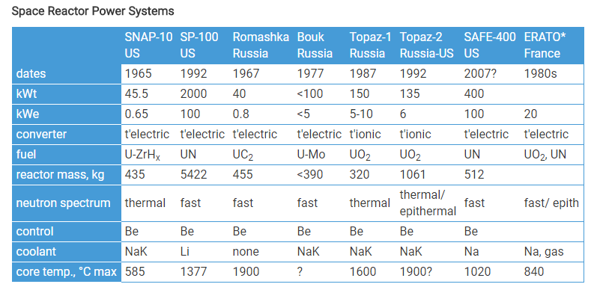
* The French ERATO programme was based on combining three 20 kW turboelectric power systems all using a Brayton cycle converter with helium-xenon as working fluid. The first system was a sodium-cooled UO₂-fuelled fast reactor operating at 670°C, the second a high-temperature gas-cooled reactor (thermal or epithermal neutron spectrum) working at 840°C, the third a lithium-cooled UN-fuelled fast reactor working at 1150°C. Thermal Neutrons are neutrons in thermal equilibrium with a surrounding medium. Epithermal neutrons have a kinetic energy greater than thermal. Epithermal neutrons produce higher core efficiency.
5.9 Regulatory issues of launching radioactive material into space
The regulatory issues associated with nuclear powered satellites are dealt with by the Office for Outer Space Affairs (UNOOSA) under the administration of the United Nations. UNOOSA implements policy decisions taken by the Committee on Peaceful Uses of Outer Space (COPUOS) set up in 1959 and now supported by 75 member states.
5.10 Risks associated with launching radioactive material into space
Environmental Groups are not always happy at the prospect of firing small or large amounts of radioactive material into space. When the Cassini-Huygens probe was launched in 1997 the United States Department of Energy estimated the chances of a launch accident that would release radiation into the atmosphere at 1 in 350, It was estimated that a worst-case scenario of total dispersal of on-board plutonium would spread the equivalent radiation of 80% of the average annual dosage in North America from background radiation over an area with a radius of 105 kilometres though the methodologies used in these calculations are always open to interpretation and legal challenge.
Figure 5.8 The Cassini-Huygens Probe
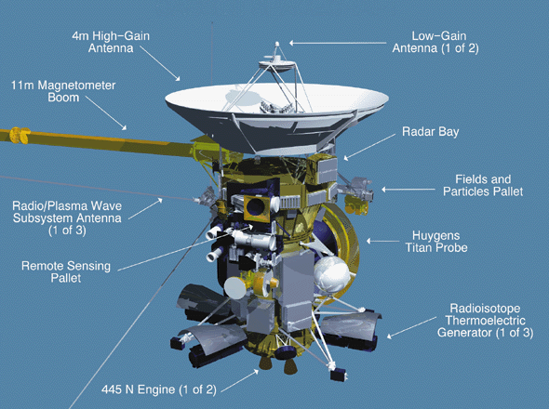
It would be different if uranium and plutonium power sources could be produced on the moon and then shipped back to near earth orbit, a not altogether impossible prospect in a 30 to 50 year time frame.
5.11 Uranium in the News
Talking of which, Uranium has recently been in the news. The LIGO and VIRGO gravitational wave detectors at time of writing this book have detected gravitational wave energy generated by the merging of two neutron stars. This followed the first detection of a gravitational wave from two collapsing black holes. These events are now calculated to happen every 15 minutes somewhere in the Universe. Merging neutron stars are a source of the heaviest chemical elements on earth including uranium, platinum and gold ejected as a fireball of radioactive chemical elements known as a kilonova, accompanied by a burst of gamma rays and visible light which were detected by a combination of earth and sky based telescopes (NASA Fermi and ESA Integral). The bursts were detected two seconds after the gravitational wave. It all happened 130 million light years away in the constellation Hydra. Neutron stars are the remains of large stars whose cores have collapsed producing a tiny ball of immensely dense neutrons. A thimble full of neutron star is the equivalent of a small mountain in weight. Two neutron stars colliding either produce a single larger neutron star or depending on their temperature and spin speed and mass, a black hole. The gamma ray burst and flash of light indicates that this latest measurement was a merging of two neutron stars (gamma rays and light rays would not normally escape from a black hole). The events also have a different wave signature. Merging black holes produce a wave that is observable for a fraction of a second. When two neutron stars merge, the gravitational waves are observed for about a minute.

The mysteries of gravitational waves, first predicted in 1916 by Albert Einstein, may see remote to the present day reality of 5G and satellites but these discoveries mark a significant advance in our understanding of energy and its nuclear origin and radiation characteristics.

5.12 Radiation in space – photons or neutrons- the final choice?
The 2011/2012 space mission to Mars measured this radiation from all sources during the 36 weeks it took to get to Mars. The space craft was exposed to an average of 1.8mSv per day suggesting a total exposure of 660 mSv for astronauts and their instruments on a two way trip. The equivalent radiation dose for astronauts on the International Space Station is of the order of 100 mSv over six months. Radiation exposure is therefore a significant motivation for the building of faster rockets.
Radiation can also cause hardware failure. First generation Globalstar satellites for example suffered failures with the on board RF power amplifiers, and Boeing had systematic failures in orbit with a number of spacecraft using their 702 bus. Hardware damage from radiation is however a well understood phenomenon with well-established mitigation measures.
The Boeing issues were related to fogging on the solar power concentrator which reduced output power from18 kW to 12 kW with litigation threatened by a number of customers including PaAmSat, Thuraya, XM Satellite Radio and Telesat. The insurance underwriters are also pursuing compensation based a claim of systematic system failure.
Solar panels are vulnerable to space damage and have to be protected with expensive space qualified glass. Nuclear power sources are arguably significantly more reliable, certainly longer lasting with the potential to scale to the tens of kilowatts needed for next generation mobile and fixed broadband satellite systems.
5.13 Cube Sat innovation
The Boeing satellites are very large geostationary satellites but innovation is also being applied to very small satellites including Cube Sats.
This includes Cube Sats with optical transceivers in which the laser is hard mounted to the spacecraft body with the orientation of the CubeSat determining the direction of the beam.
Figure 5.9 CubeSat Miniature Laser Communications in Orbit – with thanks to NASA/AMES

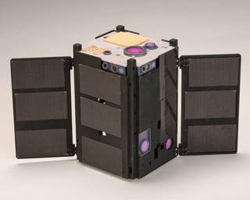
The miniature satellites are 10 centimetres by 10 centimetres by 10 centimetres (4 inch cubes) and their intended use is for high speed inter satellite and satellite to earth communications or to test novel propulsion systems including systems that use water as a propellant
The satellites will also test control systems including autonomous docking capabilities with other Cube Sats using low cost sensors or docking with larger satellites.
The ability to point accurately is critical to the throughput of an optical transceiver, Throughputs of 200 Mb/s are claimed to be achievable in free space.
5.14 Quantum Computing using optical space based transceivers
Japan’s National Research and Development Agency (NICT) have developed what they claim is the world’s smallest and lightest quantum communication transmitter on board the micro satellite SOCRATES The satellite weighs 6 kilogrammes and is 17.8 centimetres in length, 11.4 centimetres wide and 26.8 centimetres high. The satellite transmits a laser signal to earth at a rate of 10 million bits per second form an altitude of 600 kilometres at a speed of 7 kilometres per second. The project is targeted at producing an ultra-secure communications network.
Figure 5.10 Socrates Quantum Computing using optical transceivers
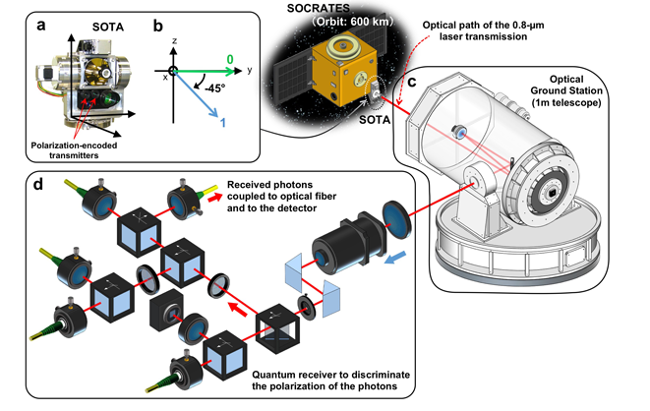
Figure 5.11 Socrates Optical Ground Station
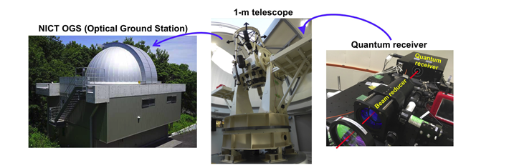
5.15 Smart phones in space - a megawatt very mobile network
The author is not aware of specific proposals to use Cube Sats as part of a mobile and fixed broadband network. The general assumption is that they would have insufficient power budget and or antenna aperture/antenna gain to support higher bandwidth space to earth and earth to space communication. However smart phones in terrestrial networks can receive and send data to and from multiple base stations and a similar approach could be taken with very high count CubeSat constellations. Sending one million ruggedized smart phones to the Karman limit with one watt of output power from each device would produce a one megawatt diversity transmit downlink with sufficient device density to deliver substantial diversity gain.
This is not as fanciful as it might seem. In 2013 a NASA sponsored team launched three ‘Phonesat’ satellites into space based on a consumer grade smart phone .This was motivated by the recognition that the processing power in an average smart phone coupled to a 40 megapixel camera and sophisticated battery with even more sophisticated power management was equivalent and often better than many small satellites but at a cost several orders of magnitude lower. Most of the team then left to start a company focused on building satellites from low cost off the shelf commercial components coupled to an imaging and earth observation data base.
5.16 Other power sources in space
Those nice people at NASA have also been working on other power sources in space including closed cycle Proton Exchange Membrane fuel cells (PEMFC) with outputs of between one and ten kilowatts, scalable up to 100 kilowatts with energy weight ratios of the order of 250 to 350 watts per kilogram of cell weight and 10,000 hour service life. PEM fuel cells are electromechanical power generation devices that convert hydrogen and oxygen reactants into electrical power, heat and water. The hydrogen and oxygen can be shared with propulsion systems and the water by product can either be used by humans or potentially used as a jet thruster for pitch and pointing control for satellites. They provide a useful alternative to battery storage including applications where the solar panels are not receiving solar power for significant periods due to orbit trajectory or pitch and pointing requirements. These power sources presently have a relatively limited service life expectation of between 1 and 2 years constrained by membrane performance.
Table 5.3 Power source comparisons- photons versus neutrons versus fuel cells
GSO Solar Array | Radioisotope Thermoelectric  Generators | Stirling or Brayton Cycle Engines | Proton Exchange Membrane Fuel Cells
30 metre span solar panels produce 15 kilowatts reducing to 12 KW at end of life (15 years) | Milliwatts to Watts to kilowatts (General Purpose Heat Source Modules)  Simple thermocouple  No moving parts  100% reliable  50 year life | 4 times better conversion efficiency than RTG’s  500 watts of thermal power=140 watts of electric power from a kilogramme of Pu-238 oxide  15 year life? | Efficient non-radioactive option  High energy weight ratio  Can be shared with propulsion system  Liquid hydrogen and liquid oxygen  Water as a by product  10,000 hour service life  (1-2 years)

5.17 Satellites and energy efficiency and carbon footprint
In later chapters we discuss some of the emerging issues of energy costs in dense terrestrial 5G networks. Though LEO, MEO and GSO satellite constellations are not specifically being targeted at improving the overall energy efficiency of terrestrial networks it could be argued that they have contributions to make in several areas including energy efficient backhaul. The fact that is sunnier in space meaning that more solar power means that the energy cost less as well. Satellites could also help improve the carbon footprint of 5G terrestrial networks.
5.18 Antenna innovation
Last but not least, the delivery economics of LEO, MEO and GSO satellite constellations are being transformed by antenna technology innovations both on the satellite and on earth based user terminals and IOT devices. We are going to cover this in the next Chapter but essentially the story can be summarised as isotropic gain, the art of ensuring that RF energy gets sent in the right direction.
5.19 5G and satellite - the nuclear option
The relevance of nuclear power sources to modern communications systems may not be immediately obvious but for deep space communication where the sun does not shine there are no other available options.
The two Voyager spacecraft that have just left the solar system after 40 years are on their way to the Oort clouds which they will reach in 300 years’ time. It will be thirty thousand years before they emerge from the other side with still many thousands of years to go before the next galaxy appears on the horizon.
The communication system will carry on working until at least 2025 which means that the Voyager transceivers will have been operating for nearly 50 years.
Mr Musk’s mission to Mars will require a range of isotope based and fissile power systems for propulsion, on board power and for hydrogen and oxygen production to sustain life on Mars and production of liquid fuel for the return to Earth. NASA, China and Russia are all working on new generations of small nuclear reactors and isotope power sources.
Mr Musk’s very large rocket can either take a relatively small payload (a few astronauts and their baggage allowance) to Mars or a very large payload, potentially several dozen satellites per launch into near low earth orbit and it can be assumed that this will be the vehicle that takes the 4000 low earth orbit satellites into space at a cost base several orders of magnitude below present satellite systems. OneWeb and LEOSAT and OneWeb have similar plans for high count LEO constellations and the required cash courtesy of Mr Bezos and his new rocket company (Blue Origin) and Mr Branson (Virgin Galactic).
5.20 Summary
This Chapter has drawn parallels with the previous chapter on rockets. In particular we have argued that deep space exploration has required innovation in propulsion and power technologies that can be equally applied to rockets and the payloads that they carry.
In practical terms this means that near earth orbiting satellites including LEO, MEO and GSO constellations now have a much wider choice of propulsion and power systems. Example include the new generation of electric satellites that can either sail into deep space of sail themselves into a near space orbit with station keeping then managed from the solar power budget rather than space and weight limited hydrazine fuel sources.
The use of nuclear power sources is common place in deep space missions and unavoidable for missions beyond Mars where the sun shines progressively more weakly.
Mars missions that are planned both by the private sector and sovereign nation space programmes are focussing significant attention on a new generation of radioisotope and fissile radioactive power sources which have energy to weight and size ratios several orders of magnitude greater than any other non-nuclear power source.
While the economics of near earth communication do not presently support the widespread use of these alternative power systems there may well come a point where the systems used for deep space exploration are repurposed to power LEO, MEO and GSO communication satellites. Avoiding the need for solar panel arrays improves the pointing accuracy of satellites and their manoeuvrability. This may be an elegant option for optimising progressive pitch as LEO satellites move towards and away from the equator. This in turn should help to optimise the angular power separation of LEO signal energy from MEO and GSO space and terrestrial based receivers (and potentially 5G terrestrial receivers as well).
The possibility that this will be the only way to meet the required protection ratios for LEO and MEO and GSO coexistence in Ku, K and Ka-band may be a compelling argument for the nuclear option though the associated cost and risk needs to be precisely assessed. There may be lower risk lower cost options such as fuel cells which may emerge as a credible alternative.
Generating sufficient power cost effectively and energy efficiently is critical for terrestrial and space based networks. Sending that power in the wrong direction makes no sense at all which brings us to our next Chapter (Chapter 6 Antenna Innovation).

http://www.azurspace.com/images/products/0004301-00-01_DB_3G30W-Advanced.pdf
http://www.spectrolab.com/history.htm
Noble gases are inert and chemically unreactive.
https://www.nasa.gov/centers/glenn/about/fs21grc.html
http://www.rocket.com/propulsion-systems/electric-propulsion
http://www.unitconversion.org/power/kilowatts-to-newton-meters-per-second-conversion.html
http://hyperphysics.phy-astr.gsu.edu/hbase/magnetic/Hall.html
https://www.safran-aircraft-engines.com/media/boeing-selects-safran-ppsr5000-electric-thruster-use-commercial-satellite-20170627
http://www.esa.int/Our_Activities/Telecommunications_Integrated_Applications/Partner_Programme_Electra
http://www.ohb-sweden.se/space-missions/
http://spacenews.com/european-soyuz-launches-smallgeo-satellite-for-hispasat/
https://solarsystem.nasa.gov/rps/docs/APP%20RPS%20Pu-238%20FS%2012-10-12.pdf
http://www.world-nuclear-news.org/F-Cosmic-recycling-2107141.html
http://ne.oregonstate.edu/rebuilding-supply-pu-238
http://www.nti.org/learn/treaties-and-regimes/treaties-between-united-states-america-and-union-soviet-socialist-republics-strategic-offensive-reductions-start-i-start-ii/
https://saturn.jpl.nasa.gov/mission/saturn-tour/where-is-cassini-now/
https://solarsystem.nasa.gov/rps/types.cfm
https://solarsystem.nasa.gov/rps/rtg.cfm
https://www.nasa.gov/centers/glenn/home/index.html
https://www.stirlingengine.com/faq/
https://www.stirlingengine.com/faq/
http://csnr.usra.edu/public/default.cfm?content=347
https://nuclear.duke-energy.com/2013/01/30/fission-vs-fusion-whats-the-difference
https://phys.org/news/2017-08-nasa-reignites-nuclear-thermal-rockets.html
https://www.reddit.com/r/explainlikeimfive/comments/1idbux/eli5_whats_the_difference_between_uranium_and/
https://www.medicalnewstoday.com/articles/58088.php
http://en.kremlin.ru/events/president/news/10453
http://propagation.ece.gatech.edu/ECE6390/project/Fall2010/Projects/group5/sites.google.com/site/inasa6390/design-overview/Power/heatpipe-power-system.html
http://www.adl.gatech.edu/research/spg/papers/InCA_IECR2012paper.pdf
https://www.nasa.gov/mission_pages/station/research/news/heat_pipes.html
http://energy.sandia.gov/energy/renewable-energy/supercritical-co2/
http://www.world-nuclear.org/information-library/non-power-nuclear-applications/transport/nuclear-reactors-for-space.aspx
http://www.unoosa.org/
http://www.unoosa.org/oosa/en/ourwork/copuos/2017/index.html
https://www.livescience.com/60695-why-gravitational-wave-discovery-matters.html?utm_source=notification
https://www.ligo.caltech.edu/
http://www.virgo-gw.eu/
Insurers may pursue Boeing over satellite power failures
https://www.nasa.gov/press-release/cubesat-to-demonstrate-miniature-laser-communications-in-orbit
https://www.nict.go.jp/en/about/
https://phys.org/news/2017-07-world-space-quantum-microsatellite.html#jCp
http://www.networkcomputing.com/wireless/lte-broadcast-horizon/1433776652
https://www.nasa.gov/offices/oct/feature/how-a-nasa-team-turned-a-smartphone-into-a-satellite-business
https://www.planet.com/
https://www.nasa.gov/content/space-applications-of-hydrogen-and-fuel-cells

