Chapter 2 - The Race for Space Spectrum
2.1 Why Spectrum is Important
Our last book, 5G Spectrum and Standards was completed just after the end of WRC2015. If you have just bought a recent copy of this book, 5G and Satellite Spectrum and Standards, then it is probably just before the next World Radio Congress to be held in 2019. If you are reading this after the WRC 2019 Congress then at least you can form a view of whether things turned out as we said they would.
The spectrum allocation and auction process is essentially adversarial and designed with the theoretic objective of maximising social and economic and occasionally political gain from spectrum as a finite though reusable and shareable asset.
World Radio Congresses are huge events requiring hundreds of thousands of hours of preparation time.
Here are the delegates limbering up for the 2015 event.
Figure 2.1 2015 World Radio Congress Opening Session- Geneva
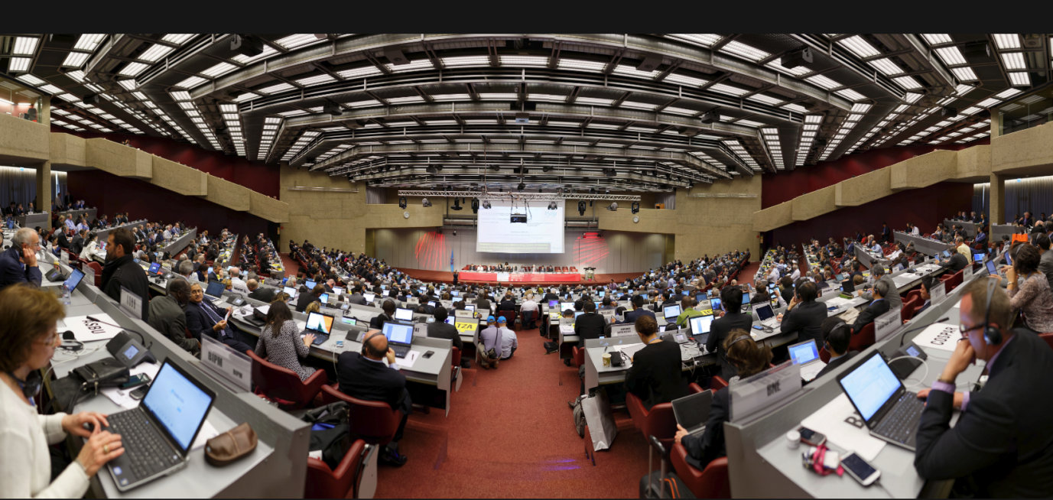
Spectrum is important for satellite systems because the quantity and quality of the spectrum made available and the usage conditions and or service and or coexistence obligations imposed on the users of that spectrum determine the capacity and coverage and hence economics of the system.
Coexistence includes the management of interference between GEO, MEO and GSO satellite systems co sharing the same bands or adjacent to other bands and interference between two way communication systems and earth based satellite TV receivers.
2.2 5G Coexistence with satellite TV and other satellite systems
Satellite TV is deployed into C band between 3.7 and 4.2 GHz, into Ku band between 8 GHz and 12 GHz (predominantly between 11.7 and 12.7 GHz which is what most of us watch at home) and in Ka band at 18.3-18.8 GHz and 19.7-20.2 GHz. The Ka band allocation (18.3-18.8 GHz + 19.7-20.2 GHz) is used for super high definition and ultra-high definition TV.
C band typically supports 250 channels of video and 75 audio services using dishes which average 7 feet in diameter. C-Band dishes are steerable, enabling C-Band users to receive signals from 20 or more satellites. 5G operators are keen to deploy 5G terrestrial services into this spectrum. The 5G community often state that C band TV is rapidly disappearing but it lives on in a surprising number of countries. My neighbour has a very large C band dish pointing at the horizon which I assume he uses to watch Turkish TV and it would be perfectly possible for a 5G C band signal from a mobile or base station to pour unwanted energy into his satellite TV front end. A 5G C band network in Singapore between 3.7 and 4.2 GHz would need to coexist with C band TV receivers in Malaysia though at least the TV dishes will be pointing more or less directly upwards.
The MVDDS coalition (Multi Channel Video Distribution Service) in the US is currently lobbying the FCC to re-examine technical limits in the 12.2-12.7 GHz band so that it can offer 2-way mobile broadband services instead of 1-way fixed service as currently permitted. The US Company, Dish Networks is an active member of this advocacy group. Dish Networks supply satellite TV in all three TV bands (C band, Ku and Ka band) and have access rights to three terrestrial cellular bands,
Unpaired AWS-3 uplink spectrum (1695 MHz to 1710 MHz)
H Block downlink spectrum (1995 MHz to 2000 MHz)
AWS-4 spectrum (2000 MHz to 2020 MHz)

In June 2016, 2016 3GPP formally approved Band 70 which aggregates these terrestrial bands together. This opens up the possibility that Dish Networks could realize a tri band LTE terrestrial network integrated with satellite TV and two way satellite services in Ku-band though this will require regulatory approval. These bands are not universally available in other markets and it would be unlikely that other mobile broadband terrestrial operators would have the same or similar terrestrial aggregated band plan suggesting that the proposal might be constrained by a lack of global scale. Sprint are another US operator specific example with their ’Gigabit LTE’ tri band proposal combining their 800 MHz, 1900 MHz and 2.5 GHz band allocations. Sprint underwent a major recapitalisation in 2012 largely financed by Softbank. Softbank is also a major investor in OneWeb suggesting that cross investment in satellite and terrestrial properties including mobile broadband and traditional broadcasting might become more common place.
Being financed by the same bank does not however solve coexistence issues. Many GSO satellite operators support a mix of TV transponders and two way communication services so can actively manage any in band or adjacent band interference. Coexistence with Ku-band LEO downlinks is more problematic and needs to be managed through angular power separation and polarization diversity (both covered in more detail in Chapters 5, 6 and 7).
The opportunity for disputes between LEO, MEO and GSO satellite operators are therefore many and various. Adding 5G territorial operators to the mix makes an already complicated picture substantially more complex.
2.3 Radar Frequency Band Designations
Frequency bands for the satellite industry (and for fixed point to point backhaul and for 5G terrestrial) are described using the IEEE Standard 521-1984 Radar Frequency Band designations, as shown in Table 2.1
Table 2.1 IEEE Standard 521-1984 Radar Frequency Bands
L Band | S Band | C Band | X Band | Ku-Band | K-Band | Ka-Band | V Band* | W Band*
1-2 GHz | 2-4 GHz | 4-8 GHz | 8-12 GHz | 12-18 GHz | 18-27 GHz | 27-40 GHz | 40-75 GHz | 75-110 GHz
GPS | MSS | TV | Military | Commercial | Military | Commercial | Military and Commercial and Automotive Radar
Licensed | Licensed | Licensed | Licensed | Licensed | Licensed | Licensed | Unlicensed

* The asterisk against V and W Band is to remind us that the description E band is also sometimes used to describe a large sub band between 60 and 90 GHz. You may also come across Q band as a designation which like E band comes from the WR22 waveguide naming system. Q band covers from 33 GHz to 50 GHz (9.1 millimetres to 6 millimetre wavelength).
Satellites can be found right through the electromagnetic spectrum from VHF though to V and W band (and higher for some military communication systems). For example the Orbcomm constellation provides narrow band IOT connectivity in the VHF band, Iridium and Globalstar are implementing their second generation LEO constellations in L band and S band and the NEWLEOS co share spectrum for user uplinks and downlinks in Ku-band, gateway uplinks and downlinks at K-band and Ka-band and telemetry and telecontrol links in K band.
2.4 5G Standards and Spectrum
The 3GPP Release 15 standards process defines possible band plans for terrestrial 5G below 6 GHz (in C band for example). The 3GPP Release 16 standards process defines possible band plans for terrestrial 5G in Ka-band and E band. HTS Ka-band satellites (high capacity GSO satellites) are normally deployed as an FDD duplex with 250 MHz channel spacing in typically a 3.5 GHz pass band. This is ideal for 5G.
The satellite industry is unhappy at the prospect of losing primary access rights to Ku-band and Ka-band spectrum and at WRC 2015 successfully limited the options for study for WRC 2019.
These are shown in Table 2.2. This includes FCC proposals to consider Upper Microwave Flexible Use as a mechanism for co sharing Ku, K and Ka band spectrum. Note that the satellite industry is particularly unhappy at the prospect of having 5G in the 28 GHz band. This is simply explained by the list of present high throughput satellites using this band which includes 28 GHZ band HTS GSO incumbents and Australian National Broadband Network satellites (2 salutes), IPStar (4 satellites), Inmarsat Global Xpress (4 satellites), O3b MEO (12 satellites), Viasat (4 satellites), Jupiter (2 satellites), Hylas/Avanti (2 satellites), Amazonas 3, Spaceway 3, Wild Blue1, Superbird4, AMC 15 and 16 and a bunch of direct TV satellites.
Table 2.2 Bands Agreed For Study at WRC 2019 (not including the 28 GHz band)
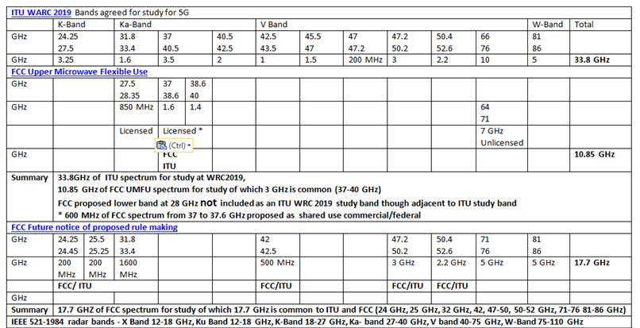
There is also a proposal to use E band either side of the 77 GHz automotive radar band. The probable band plan is shown in Table 2.3
Table 2.3 5G E Band
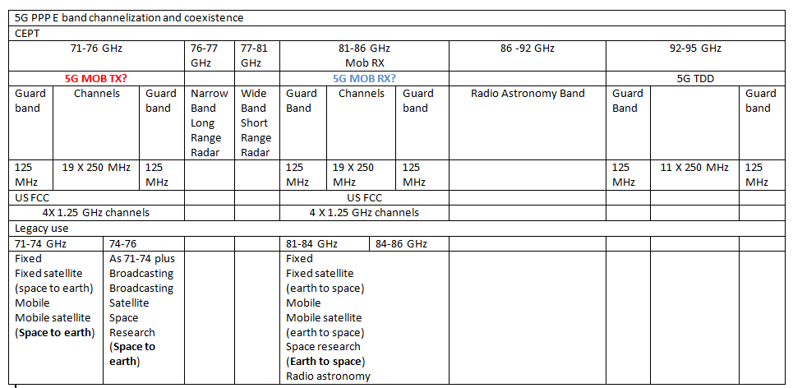
The lower band edge of the lower duplex (71-76 GHz, E-band) is also immediately proximate to the proposed extended 60 GHz Wi-Fi band which will potentially yield around 15 GHz of contiguous unlicensed spectrum.
From a satellite perspective, the significance of the extended 60 GHz band is that together with the 2.4 GHz and 5 GHz Wi-Fi band they produce a ‘no cost’ or more accurately ‘low cost’ connectivity solution which can be integrated with NEWLEO system solutions. OneWeb provides one example of this proposed approach. There is also a proposed extension of the 5 GHz Wi-Fi band for automotive connectivity.
It has always been a challenge keeping up with the alphabetic progress of 802.11 but the latest 802.11ax chip sets claim to support a headline data rate of 4.8 Gbps compared to the 1.7 Gbps available from an 802.11ac access point with multiple radios theoretically capable of supporting 10 Gbps of throughput and or up to 400 users per cell (fairly obviously not 400 users at 10 Gbps).
It is an apparently small detail but the work on 5G frame structures within 3GPP working group RAN 1 includes the specification of mini slots consisting of a minimum of two symbols within a one millisecond time frame. This is partly to support Ultra Reliable Low Latency Communication (URLLC) and URLLC pre-emption in an eMBB (enhanced mobile broadband) channel but is also intended for operation in unlicensed bands for example to start transmission directly after a successful listen before talk procedure without waiting for a slot boundary.
The integration of Wi-Fi with LTE Assisted Access (LAA) and LTE-U and 5G should ideally also take into account potential satellite use of these bands, a topic that we revisit in the Chapter on 5G and satellite standards (Chapter 10)
2.5 Existing LEO L Band, Ku, K and Ka-band allocations
Figure 2.4 shows the existing allocations for Iridium and Globalstar at L band including adjacency to Inmarsat L band spectrum, the Iridium feeder gateway downlink in K band at 19.4-19.6 GHz and gateway feeder uplink in Ka band at 29.1-29.3 GHz and the intersatellite switching allocation at 23.187-23.387 GHz in K band.
Figure 2.2 Iridium, Globalstar and Inmarsat L band spectrum and K and Ka band gateway and inter satellite switching spectrum
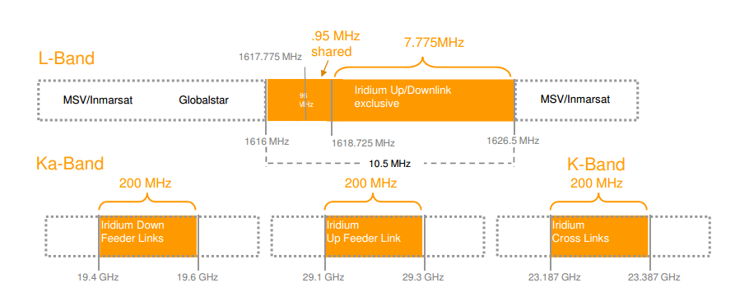
It is possible that the Legacy LEOS that use inter satellite switching, for example Iridium, could obtain permission from the FCC and ITU to use their inter satellite and earth station uplink and downlink spectrum in K-band and Ka-band for general wide area coverage using angular power separation to support frequency re-use and co-existence. This would transform Iridium’s service offer. However they would also need to scale their constellation to hundreds or thousands of satellites in order to have sufficient RF power and ‘nearly always nearly overhead’ visibility to support mass market consumer and or low ARPU mobile and fixed access internet connectivity. Iridium have not made any announcements about this and their existing constellation upgrade is probably too advanced to be able to support a change in business model. They would seem to be well positioned to continue to service their traditional high value subscribers effectively and efficiently. Note that inter satellite switching reduces the number of earth gateways needed, reduces latency and is arguably more power and bandwidth efficient and as stated earlier allows Iridium to support high added value military payloads alongside their commercial offering.
Iridium gateway links are however within the pass band of the proposed OneWeb and LEOSAT user links and O3b Ka-band MEO downlink. As existing incumbents, and probably equally important as an operator carrying critical military payloads it would be unlikely that the FCC would wish to impose any coexistence requirements on Iridium and far more likely that new market entrants will be required to meet stringent protection ratios to ensure existing and ‘Next’ generation Iridium service levels can be maintained.
In an ideal world, the mobile broadband community and satellite industry would work together to integrate band plans and technical standards and achieve mutual scale benefits. In practice mobile operators; particularly US mobile operators, are lobbying for primary access to existing satellite radio bands including spectrum in Ku-band and Ka-band and E band, an adversarial process that discourages cooperation.
As stated, there are existing fixed and mobile systems in L band and S band including LEO systems (Iridium and Globalstar) and GSO satellites (Inmarsat 4 for example).
Satellites are intensively deployed into licensed spectrum at C band (4-8 GHz) including satellite TV (also at 10 GHz), into X band (8-12 GHz), Ku- band (12 to 18 GHz), K band (18-27 GHz) and Ka band (27 to 40 GHz). The spectrum is co shared with military satellite systems though many of these are presently concentrated in X band and K band.
A satellite operator can typically accrue several GHz of spectrum across these bands. A mobile operator by comparison will have at most two or three hundred MHz across the UHF band and L band, S band and lower end of C band (TDD bands 42 and 43).
The table shows how these bands fit in to the larger spectrum picture described in terms of wavelength.
Table 2.3 Frequency and Wavelength Comparisons
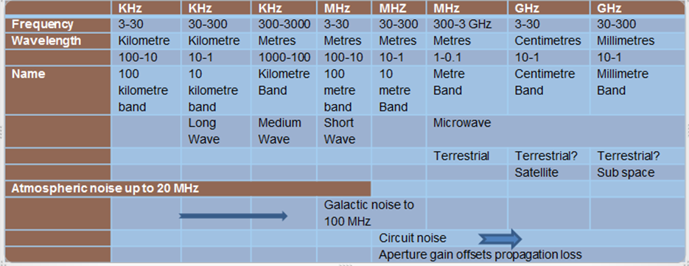
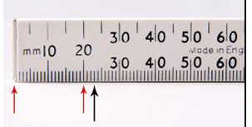
The bands of particular interest are the Metre Band (from 300 MHz to 3 GHz), the centimetre band (3 to 30 GHz) and the millimetre band (30 to 300 GHz) also known as the Sub 10 band (wavelengths of 10 mm or below). See 5G Spectrum and Standards for a more detailed analysis of this.

2.6 Benefits of higher frequencies
The significance of the shorter wavelength bands is that it is possible to construct compact phased array antennas that deliver isotropic gain, offsetting the propagation loss at these higher frequencies.
These antennas are becoming widely used in the satellite industry particularly in Ku-band, Ka- band and E band. Antennas known as fractional beam width antenna arrays with a beam width of between 0.5 % and 1.5 % can deliver a gain of more than 40 dBi. The additional propagation loss at 28 GHz compared to 900 MHz (low band cellular) is of the order of 30 dB. The antennas can track moving satellites (LEO and MEO) minimising pointing loss.
Satellites share their spectrum with deep space communication and commercial and military and weather radar at 2.7 to 2.9 GHz, 5.2-5.7 GHz, micro rain radar at 24 GHz in the water vapour resonance peak (shared with automotive radar) and cloud composition radar (cloud radar) at 35 GHz. Military applications include the telemetry and telecommand of unmanned aerial vehicles, high definition imaging and surveillance and remote weapon systems including anti-missile systems.
Each new generation of military and civilian satellite radio and radar system requires more rather than less bandwidth, increased transmit power and increase receive sensitivity. These requirements translate into the need for higher protection ratios (i.e. the ability to reject out of band signals).

2.7 Spectrum - why Ka-band is useful
Euroconsult have produced this useful Table summarising why Ka-band is a preferred band in terms of spectrum availability (3.5 GHz of presently available spectrum). It also highlights the potential of Q and V band (and of course W band/E band not included in the graphic)
Table 2.4 Ka band and other Band comparisons- with thanks to Euroconsult

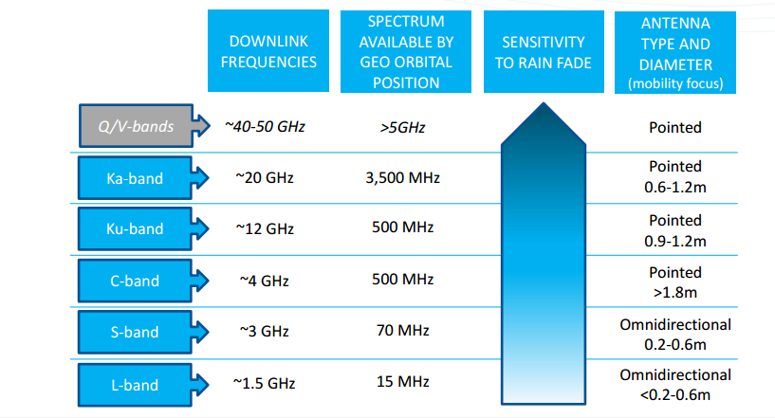
2.8 The impact of standards on 5G spectrum requirements
The standards process also has an impact on spectral policy and potentially spectral demand.
3GPP Phase 1 Release 15 due in late 2018 concentrates on sub 6 GHz (including 3.8 to 4.99 GHz). Release 16 (Phase 2) includes 28 GHz and 38 GHz beam forming and is due to be completed in December 2019 by which time the outcome of the 2019 World Radio Congress will be known. The first iteration of what is called 5G ‘Non-Standalone’ New Radio was scheduled for completion by December 2017 and at time of writing is making good progress.
Table 2.5 Alignment of 3GPP standards process and WRC 2019
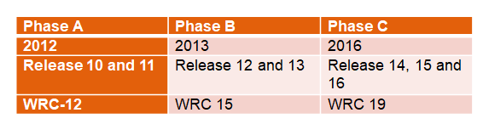
Figure 2.5 shows the present 3GPP enhanced Mobile Broadband (eMBB) standards time line.
Figure 2.6 5G New Radio (NR) Enhanced Mobile Broadband (eMBB) work plan
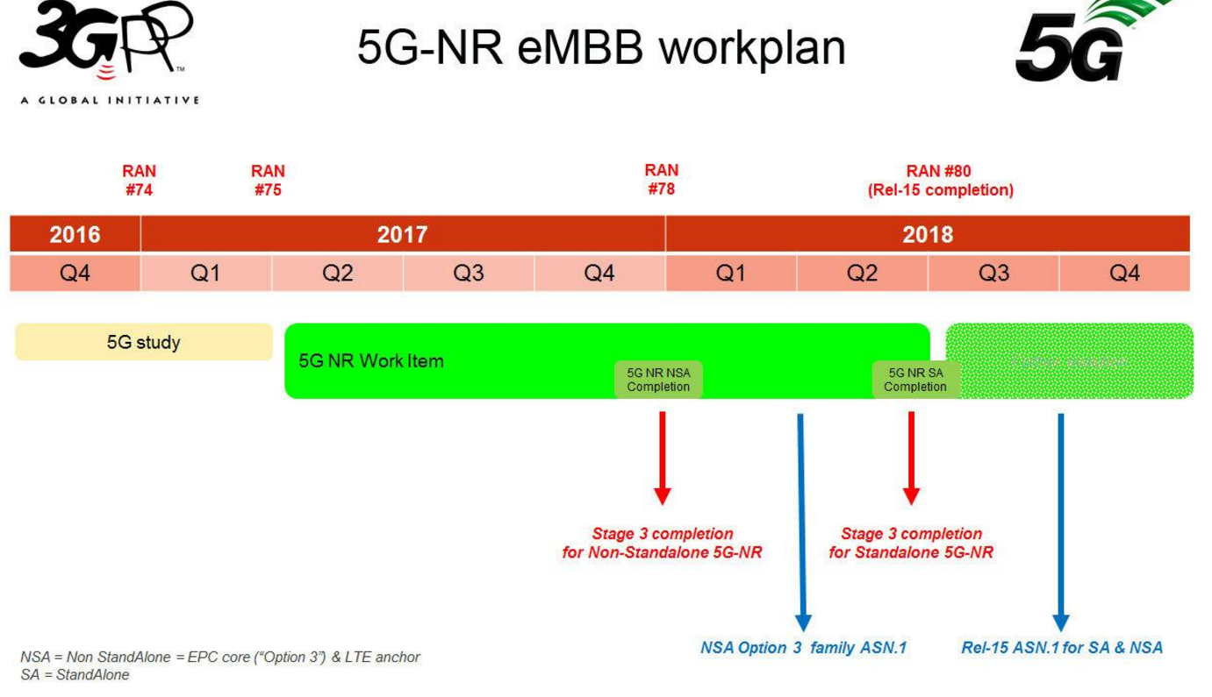
2.9 Multiplexing and modulation and coexistence
The 5G New Radio layer uses what is called a flexible numerology. What this means is that different OFDM sub carriers can be chosen depending on the required application starting with 15 KHz then 60 KHz, the 120 KHz then 240 KHz and 480 KHz. Figure 2.3 suggests 15 KHz sub carriers for use in FDD and TDD spectrum below 3 GHz for large outdoor and macro cells implemented in LTE bandwidths of 1 MHz, 5 MHz, 10 or 20 MHz. For outdoor small cells, 30 KHz sub carriers are suggested implemented into the TDD bands above 3 GHz, for example Band 42 from 3.4-3.6 GHz and Band 43 from 3.6 to 3.8 GHz with 100 MHz or 80 MHz channel rasters. 60 KHz sub carriers are suggested for indoor wideband implemented into the unlicensed band at 5 GHz using a 160 MHz channel raster. 120 KHz sub carriers are suggested for Ka band at 28 GHz on a 500 MHz channel raster. 240 KHz and 480 KHz sub carriers are specified for future use.
Figure 2.7 Sub Carrier Spacing
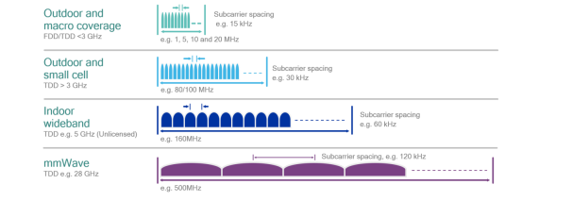
5G and satellite standards are covered in more detail in Chapter 10 but it can be seen that there is a clear expectation that channel bandwidths need to scale from the present LTE 10 MHz implemented in pass bands below 2 GHz to 500 MHz at Ka band and in the longer term to 1 and 2 GHZ in V and W band. Note that the NEWLEO filings with the FCC, for example the July 2016 OneWeb filing assume 500 MHz pass bands for the user links in Ku band (12.2-12.7 GHz uplink, 14.0-14.5 GHz downlink) and 500 MHz pass bands for the feeder/gateway links in Ka-band (19.7-20.2 GHz downlink and 29.5 to 30 GHz uplink). The assumption is that the uplink channels are implemented as 125 MHz carriers and the downlink as 250 MHz carriers. User and IOT devices demodulate all traffic on each 250 MHz downlink channel and then discard the packets with headers that are not addressed to them. Note that for reasons of power efficiency, satellite systems do not use OFDM or QAM modulation but implement relatively simple Amplitude Phase Shift Keying. This has constrained AM components and therefore requires less (power consuming) linearity from the RF power amplifier. It could be argued that APSK is less spectrally efficient than QAM and OFDM but in practice spectral efficiency is achieved through spatial separation and polarization diversity. Figure 2.6 compares the two modulation types
Figure 2.8 APSK and QAM Modulation – With thanks to Radio Electronics
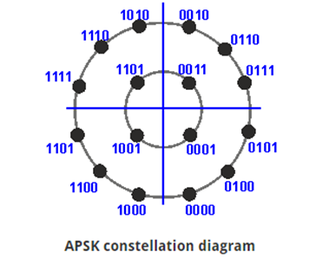 | 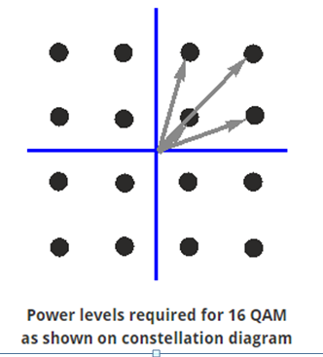
Considerable work still needs to be done on the merits/demerits of co sharing terrestrial and space spectrum with different physical layer specifications. We revisit this topic in more detail in Chapter 10.
2.10 Regional Spectrum Policy
In terms of regional policy there are some notable differences between the FCC and present ITU policy specifically around the 28 GHz and 38 GHz and 39 GHz bands. In particular the FCC is taking a robust approach to allocating primary access rights to mobile broadband operators at 28GHz and 39 GHz in response to lobbying from AT&T and Verizon. Unsurprisingly, the satellite industry is objecting to this and can be expected to adopt a strong advocacy position for more limited access rights on a co shared basis at WRC 2019.
This includes financial modelling which suggests that mobile operator terrestrial deployment in the centimetre and millimetre bands could have a negative rather than positive impact on mobile operator EBITDA and enterprise value.
Interestingly 3GPP Release 15 focuses on sub 6 GHz 5G deployment. The satellite industry take this argument one stage further by arguing the case for 5G deployment in existing LTE spectrum including the new Band 71 at 600 MHz.
Table 2.7 Sub 6 GHz Band Allocations for Terrestrial 4G and 5G spectrum
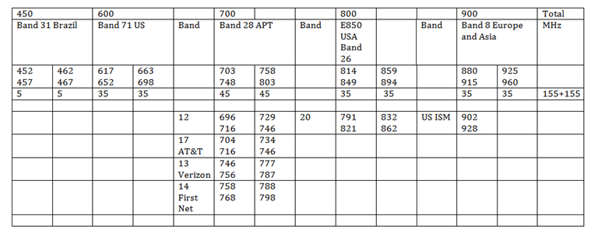
There is potentially 155+155 MHz of low band spectrum available from 450 MHz to 900 MHz. This might seem modest compared to having access to several GHz of Ku, K and Ka band spectrum but this is quality spectrum, unaffected by weather, with favourable propagation, minimal surface absorption and scatter. From a regulatory perspective, the spectrum comes with clearly defined and highly protected access rights.

2.11 5G at UHF as an alternative?
UHF could therefore provide a low cost relatively high data rate 5G connectivity option. It will be important for the satellite operators to show that they can compete with these potentially enhanced ’sparse network’ terrestrial options both in terms of price, throughput and coverage particularly given the scale economy gains that can be realized by the Chinese vendor community amortized across their local high volume 4G and 5 markets where base station shipments are counted or will be counted in millions of units, with user and IOT device shipments counted in billions of units.
From a cellular site perspective, it is hard but not impossible to implement smart antennas at these wavelengths, the challenge is to deliver performance gain within a 0.3m width envelope panel antenna (one column of elements) to meet weight and wind loading constraints.
2.12 5G in Refarmed spectrum
A friend visiting Australia this year was surprised that his admittedly elderly phone didn’t work. The reason was that Telstra have turned off their GSM network or at least made it unavailable for roaming visitors in order to optimise LTE.
With operators beginning to decommission their 2G GSM and 3G networks it becomes at least theoretically possible to implement 5G into any 4G bands anywhere from Band 31 (450 MHz) to Bands 42 and 43 (3.4-3.8 GHz).
However as we pointed out in Chapter 1, it is not only the available bandwidth that is important but the bandwidth ratios (the ratio of the pass band bandwidth to the centre frequency of operation). This means that there is no obvious home for contiguous 200 MHz 5G channels below 3 GHz even if they could be supported though a traditional acoustic filter chain in the front end of a user or IOT device which seems unlikely.
Additionally not all operators will want or need to decommission their GSM networks particularly if significant GPRS vertical market user groups need to continue to be supported. Release 13 also introduced Enhanced Coverage GSM (EC-GSM) with additional channel coding which could potentially be a cost effective option for some deep rural areas. It is therefore not immediately apparent what gains could be realized from 5G in refarmed spectrum over and above LTE Advanced and LTE Pro and enhanced legacy technology options such as EC-GSM.
An additional option is to implement 5G in discontinuous channel aggregated spectrum but presently there are so many operator specific band plan options that it seems unlikely that any global scale economy can be achieved for 4G let alone 5G user and IOT devices.
This topic is covered in greater detail in 5G Spectrum and Standards including background on some of the performance trade off implicit in supporting high bandwidth ratios and or aggregated channels. In summary, it is possible to design front end RF architectures that can process multiple existing RF bands in parallel to achieve high headline data rates. The assumption is that the ability to send data quickly will reduce power drain but this has to be set off against lower RF efficiency and physical layer clock processor overheads. It is difficult to design a front end architecture that is good for processing multiple and single bands and therefore a user could find a device that delivers high headline data rates might for example perform less well at a cell edge (low Carrier to interference) or in marginal coverage areas (low signal to noise). Traditionally these apparently rather prosaic user and IOT device RF performance compromises tend to be overlooked in physical layer design and network economic modelling.
2.13 The FCC, the ITU and Sovereign Nation Regulation- similarities and differences between terrestrial and non-terrestrial networks
This brings us reasonably neatly to a discussion on the differences that exist region to region and country to country in terms of how spectrum is allocated, auctioned and regulated and the commonalities and differences between terrestrial spectrum management and space spectrum management.
The first obvious difference is that satellite systems are servicing users from space. Strictly speaking non-terrestrial systems also include LTE Air to Ground used for example to provide two way communications with helicopters. Studies have also been made using low cost drones to provide on demand coverage for emergency response and disaster relief.
Figure 2.8 shows an example of Air to Ground LTE and an LTE pico base station being flown on a drone in a Verizon test
Figure 2.9 LTE Air to Ground and a Drone based LTE Base Station
If this becomes at all common it implies a need to reconfigure terminals and their antennas to receive signals vertically from above rather than on a more or less horizontal or at a low elevation angle. If 5G air to ground or drone based 5G is deployed in the same bands as 5G NGSO and GSO satellites then it can be considered either as a problem (mutual interference) or an opportunity (shared channel bandwidth between 5G and NGSO/GSO networks.

From a regulatory viewpoint, satellite systems are generally characterised as being either ‘GSO’ (geostationary) or ‘Non-GSO’ (‘NGSO’). NGSO includes MEO and LEO satellites and any satellite that appears from the ground to be moving. GSO systems are obviously also moving but at the same speed as the earth’s rotation and therefore appear stationary as seen from earth. Because of their fixed orbital position above the earth, a GSO constellation (a number of GSO satellites) can clearly be dealt with on a regional or country-by-country basis - in addition, interference issues are generally related to fixed entities and are reasonably easy to manage.
In contrast, NGSO systems, for example LEO satellites, overfly many regions and countries requiring them to be compliant with many (and potentially various) different regulatory regimes in order for them to be allowed to deliver service to users. Interaction and interference with GSO systems also needs to be managed, with GSO systems taking the ‘higher ground’ (in more ways than one).
In this book, we use the term ‘NGSO’ when referring to regulatory issues, although to all intents and purposes ‘NGSO’ and ‘LEO’ are interchangeable in terms of the actual systems being discussed.
In order to get a satellite project literally off the ground there are a number of initial hurdles that have to be overcome. The NEWLEO entities including OneWeb and Space X have dealt with some but not all of these.
For US companies in particular the process generally starts with a filing submission to the FCC as the US is still the largest and most influential sovereign entity in the global satellite sector, though China and India are catching up quickly.
Every sovereign nation in the world has the right to determine how radio spectrum is used in, and theoretically above its territory and in particular a right to demand that particular and occasionally country specific coexistence conditions are applied.
The World Trade Organization, within the framework of the General Agreement on Trade in Services (GATS) while recognising this sovereign right of States to manage the frequency spectrum in terms of their own objectives, works to develop the instruments required so that exercise of that right does not result in barriers to trade in services between its members. In this context, the establishment of standards at regional and global levels facilitates efficient and economical use of the spectrum and the development of radio services. The ITU works in parallel with the WTO to provide a regional framework that allows sovereign nations to submit and discuss their spectrum requirements at regional level (Regions 1, 2 and 3). This is shown in Figure 2.8.
Figure 2.10 The ITU Regions
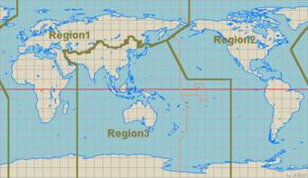
The outputs from these regional meetings then go forward into the four yearly World Radio Congress (WRC) process. The last WRC took place in 2015; the next will take place in November 2019. These meetings are enormous with typically 7000 delegates with a flag system implemented in plenary sessions to adjudicate national sovereign representation.

2.14 Why Country and Regional Differences are important for global connectivity
One of the more compelling reasons to consider satellite systems for global connectivity is that potentially a car, truck, bus, ship, plane, train or other large or small moving or static object could be shipped to any country in the world and any place in any country, and be seamlessly and continuously connected ideally through one integrated global network.
This is already the case for example with the Orbcomm VHF services provided to John Deere, Volvo, Caterpillar and Hitachi Construction and from users of the Iridium system. However these are relatively narrow band systems (1+1 MHz at VHF for Orbcomm and 10+ 10 MHz at L band for Iridium), with clear and well documented access rights across the world.
By comparison OneWeb and Space X and other NEWLEO contenders propose to deploy a wide band radio system with a 2 GHz downlink pass band and 1 GHz uplink pass band in Ku band and are sharing that spectrum with TV broadcast, video distribution (MVDSS), GSO and MEO satellite systems, other two-way communications systems including military radio, deep space radio and radio astronomy. The gateway links are deployed in K and Ka band and have similar coexistence issues that have to be addressed.
Critically, there are regional and sometimes country specific differences in the way that spectrum band plans and radio system technologies are deployed, with the result that in-band and out-of-band (OOB) emission requirements can be significantly different on a regional and country basis.
The established satellite operators (‘legacy sats’) have had technical and regulatory teams addressing these differences in some cases for the past fifty years. Iridium and Globalstar, the ‘new kids on the block’ have more than twenty years of experience. The NEWLEOS have to deal with this regulatory complexity in a compressed time scale (deployment by 2019/2020 to meet FCC requirements). To an extent this can be achieved by recruiting regulatory capability but sometimes mature boys and girls just want to head for the golf course or other more enticing pursuits.
The ITU specifies that GEO satellites have priority over LEO satellites with regard to frequency usage. The problem is that the NEWLEO satellites will be regularly passing between users on the ground and GEO and MEO satellites, while using the same Ku/K and Ka-band frequencies.
So it is important to understand the particular inter system interference mitigation measures proposed by the NEWLEOS. Generally these tend to be documented in FCC filings, a consequence of the historic market dominance of the US satellite industry and consequent regulatory influence of the FCC.
We recommend readers study the original OneWeb 2016 FCC filing as a starting point. Interference mitigation measures and the software models associated with them need to be agreed by the ITU and can be challenged by other entities including incumbent operators’ sharing this spectrum.
The OneWeb filing referenced above is based on a proposal for 720 satellites. Recent press statements from OneWeb indicate that they have production options for 2000 satellites. Adding satellites to a constellation increases capacity but also increases flux density. OneWeb will have to demonstrate that a higher count constellation will still conform with EIRP and flux density limits (see Chapter 7) and provide guidance on how this might affect the number of ground (earth gateway) stations needed and their likely location and composite uplink and downlink power.
Like other ITU filings, the rights to use these frequencies for an NGSO are granted on a first come first served basis. As there are multiple NGSOs in the planning and implementation stage, (OneWeb, LEOSAT, SpaceX, Telesat), progress is dependent on the seniority of the entities in the filing process.

2.15 RF Power and Interference
Satellite operators are licensed to operate in defined frequency bands with defined maximum (transmit) power levels, and with conditions applied relating to interference with other systems.
Transmit power is normally specified as EIRP (Effective Isotropic Radiated Power, the measured radiated power in a single direction).
The result of this transmitted power, the design (polar response) of the transmit antenna on the satellite, and the orientation of the satellite relative to the receiver on the ground (i.e. overhead or at a glancing angle) is the Power Flux Density (PFD). For a ground-based user terminal, the flux density, when combined with any antenna gain, will dictate the signal level at the receiver input.
Interference at a receiver caused by other transmitters may be ‘in-band’ or ‘out of band’. A ‘Protection Ratio’ may be specified which defines the minimum value of the wanted-to-unwanted signal ratio, usually expressed in decibels at the receiver input, to achieve a specific reception quality (e.g. bit error rate and throughput).
2.16 The Importance of intersatellite switching
The 2016 OneWeb filing identifies a need for 50 ground stations and additional stations at high latitude to support telemetry and control, to manage through-life maintenance and orbit keeping and end of life deorbiting. Securing licensing and landing rights for the gateways in 50+ locations around the globe will be challenging for OneWeb and other NEWLEO operators and may be the dominant pacing issue for revenue operations and global deployment. Increasing the satellite count from 720 to 2000 which is presently proposed by OneWeb may require more gateways though this is not stated. A gateway is essentially an antenna farm with multiple dishes (of about 2.5 metre diameter) pointing at different parts of the sky and the higher count could presumably be supported by more antennas per site but the site will of course get bigger. This may seem a trivial point but someone has to find suitable sites, purchase or lease land and arrange planning permission across a range of different planning regimes (and source electrical power and backhaul connectivity). The alternative is to uplink to a MEO or GSO and then return via the GSO downlink back to earth. This is used in military radio systems (and Hubble and the International Space Station) but introduces additional latency.

2.17 Landing Rights
We have said that satellite operator assets can be summarised as spectrum access rights, orbital rights and landing rights (permission to deliver services into and out of a sovereign country) but also gateway assets (see above).
The technical issue with landing rights is that it requires RF power to be focused on a country or region from a satellite or satellites either over flying the land mass (NGSO) or always visible at a fixed inclination angle (GSO). User devices and ground stations will also be transmitting on the uplink.
If a sovereign country considers that existing satellite systems or terrestrial systems including military satellite and terrestrial radio or satellite TV receivers could be compromised by a newly proposed service, then they can request and insist that spot beams from the satellite are turned off or that RF output power is reduced. Therefore there may be countries in which OneWeb and other NEWLEO operators cannot provide coverage or can only provide coverage at lower RF output power.

2.18 Interference Management
The additional mechanism used by OneWeb and all other proposed high throughput Ku, K or Ka band NGSO systems to meet country specific EIRP and flux density limits is angular power separation. Essentially this means that at high latitudes, the assumption is that there will nearly always be a LEO nearly overhead delivering RF energy via a spot beam to a group of geographically proximate users within a cell. A car for example will be demodulating 250 MHz of channel bandwidth which will have a number of users sharing the bandwidth. The traffic of interest is identified from the TCP/IP packet headers.
Note in passing that the contention ratio will have a direct impact on the available bandwidth. This is an important consideration for JLR and needs to be included in network test plans. On the uplink a similar TDM (Time Division Multiplex) contention protocol is used across a 125 MHz channel bandwidth subdivided into narrower (<20 MHz) channels. Contention rates are an important parameter that require careful specification in Service Level Agreements.
The basis for frequency sharing is that terrestrial systems or GSO systems will be receiving RF energy from a much lower elevation angle (the satellite TV dish on the side of your house being a good example) and therefore system cross talk will be minimised. We cover this in more detail in the next section.
Conversely nearer the equator, GSO satellites will be shining directly downwards. To avoid interference, OneWeb and other new LEOs use a technique known as progressive pitch which means that RF energy is delivered at an inclined angle from satellites either side of the equator rather than above the equator. RF power is then turned down or off as the satellite moves across the ‘cone of visibility’ of the victim receiver with service delivered from a satellite nearer the horizon. Progressive pitch can also be achieved by altering the pitch of the satellites as they traverse over the equator. This is achieved by using reaction wheels to establish the spin rate and direction on each equatorial traverse (every 55 minutes).
The impact of this on user links needs to be considered. For moving objects like cars or trucks or buses, a key reason to use high count LEO constellations is that they are Nearly Always Nearly Overhead which minimises blocking from buildings and trees. This advantage would potentially disappear due to the need to meet country specific EIRP and flux limits by using a low elevation angle. Note that this will also result in a longer path length which will increase atmospheric fading and require a higher rain fade margin.
This would be potentially a problem in equatorial countries with tall buildings, Singapore being one example.
Thus it can be seen that detailed country specific regulatory requirements, with the implied need to meet EIRP and flux density limits determined by angular power of arrival and departure could have an impact on service availability and service quality, and could mean that the user experience could be variable from market to market and occasionally unavailable.
On a more positive note it can be seen that NEWLEOS could be a useful complement to terrestrial 5G particularly for terrestrial 5G implemented in Ku, K or Ka band where building and surface scatter absorption will be significant. In particular the angular separation between the Nearly Always Nearly Overhead LEO signal at higher latitudes and the signal energy coming in at effectively a 90 degree off set suggests opportunities for in band frequency re-use particularly if polarization diversity is also used.
How well this works will be a function of the antenna design, a topic that we tackle in Chapter 6.

2.19 Spectrum Access Rights

Spectrum access rights are closely analogous to property rights and the regulatory and legal frameworks are similar for satellites and terrestrial systems though NGSO satellites are more complex because they are moving.
Spectral access rights can be either primary access, co-primary access or secondary access with primary access being implicitly the most valuable asset:
Table 2.8 Spectrum Access Rights
Primary Access | Guaranteed sole usage and protection from interference (including the ability to stop competitors deploying systems on the basis that they might cause interference rather than waiting for the interference to happen and be detected and measured)
Co-Primary Access | Agreed shared usage by 2 or more operators based on enforceable technical (co-existence) standards
Secondary Access | Usage allowed on a secondary basis - must accept interference from other users (who must themselves comply with agreed power limits)
By definition with LEO NGSO we are talking about shared access regimes where the existing (GSO) incumbents have well established existing primary access rights.
Regulators judge a newly proposed service on the basis of its potential economic value (impact on national, regional or global GDP), social value (for example bridging the digital divide) and political value (satellite TV being a prime example).
Mr Greg Wyler, the founder of OneWeb has proved adept at playing this regulatory game of poker. His previous company, O3b acquired spectrum from Teledesic, a high count Ka band LEO constellation which ran out of money in 2002 having absorbed the best part of $1 billion dollars of Mr Craig McCaw’s considerable fortune.
Figure 2.12 O3b Frequency plan – formerly the band plan for Teledesic

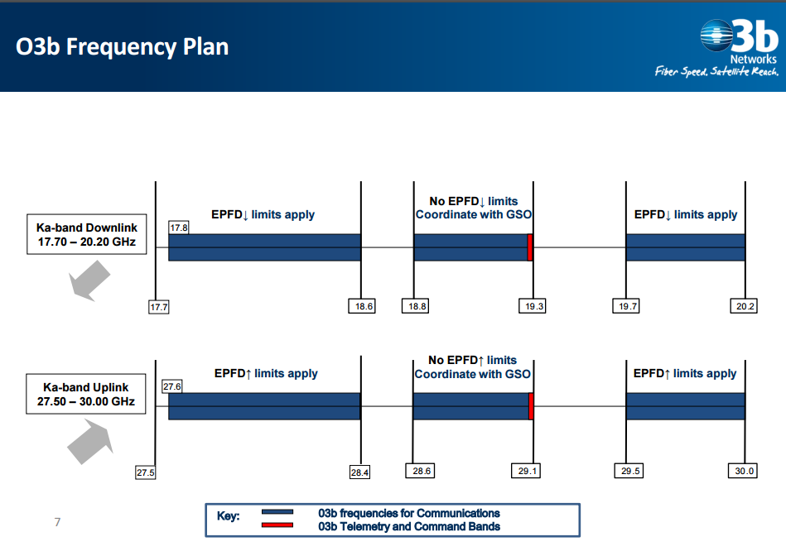
The spectrum is divided into sub bands with designated Equivalent Power Flux Density Limits (EPFD) and bands where there are no limits but where interference has to be coordinated with GSO operators.
The FCC submission was for a MEO constellation and the stated market/business model was connecting the unconnected ‘other’ three billion, hence the name.
03b inconveniently had to raise capital in the year that Lehman Brothers went bankrupt (2008) and it is a tribute to the persuasive skills of the Wyler management team that the constellation launched and more or less met its business plan objectives.
However it achieved this by substantially altering the market focus of the business which now supplies internet connectivity to cruise ships 40 degrees either side of the equator. The average cruise ship now consumes in the region of 500 Mbps of internet bandwidth in peak hours, a highly profitable market (though O3b claim they also provide service to some parts of the Amazon and the Pacific Islands). Cruise ships of course have the advantage that they operate for most of the time outside sovereign jurisdiction meaning that O3b could avoid the whole pesky business of negotiating country by country landing rights.
This illustrates that serviced markets can change substantially from the initial FCC filing.
Mr Wyler left O3b in 2012 and founded OneWeb initially called WorldVu. The entity also uses the alternate name L5 in regulatory filings with the ITU and is registered in the US and Jersey (for tax avoidance).
In March 2017 OneWeb submitted a filing with the FCC for an additional 2000 satellite constellation in V band (40-75 GHz) though at this stage this must be considered an essentially speculative move. Space X and Boeing and a number of other potential new LEO entities have also submitted V band constellation proposals.
OneWeb managed to acquire the spectrum and access rights owned originally by Skybridge Inc., a US entity established in the 1990s to roll out a high satellite count LEO constellation in Ku band (user uplinks and down links) and Ka band (gateway uplinks and downlinks). Skybridge went into administration before the constellation could be realised.
The pass bands are shown below with designated access rights from the FCC for the US with a listing of other entities sharing the spectrum including mobile and fixed services and broadcast services.
Figure 2.13 Ku-band spectrum rights acquired from Skybridge by OneWeb (from the July 2016 FCC Filing).
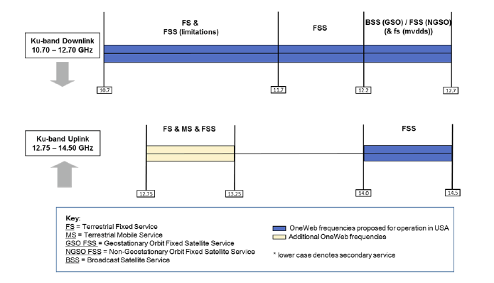
Figure 2.14 shows the K and Ka-band spectrum access rights
Figure 2.14 Ka-band spectrum access rights acquired from Skybridge by OneWeb (from the FCC OneWeb filing July 2016.
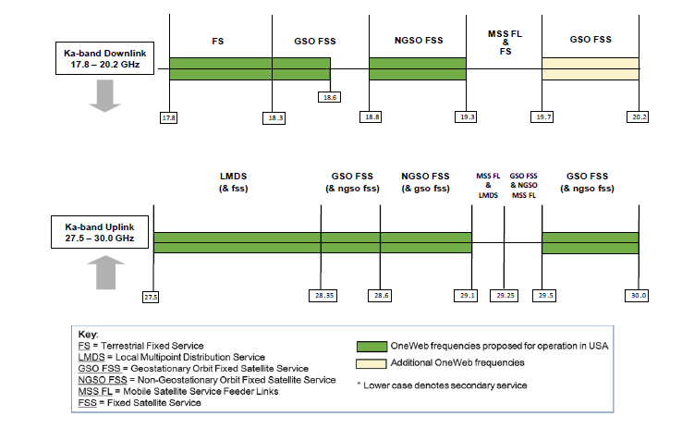
The OneWeb submission closely follows this band plan with some minor amendments. The band plan submission is shown in Table 2.9
Table 2.9 OneWeb FCC Submission July 2016
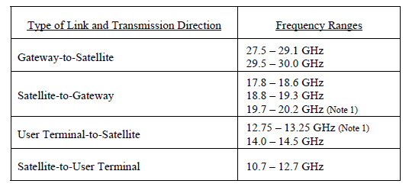
Note 1 refers to the fact that although OneWeb satellites have the capability to operate in the earth to space direction in the 12.75-13.25 GHz band and the space to earth direction in the 19.7 -20.2 GHz band, FCC authorization is not being requested for these bands and they will not be used in any US territories.
OneWeb commit in the filing to providing the FCC with the requisite deployment time scales for satellite deployment in accordance with FCC Article 25.118(f).
2.20 NGSO to GSO interference mitigation
Skybridge had progressive pitch angular power separation in their original FCC filing submissions as a mechanism for meeting US Ku-band EIRP and flux density limits and protection ratios to the shared services supported in and adjacent to the pass band. The FCC was subjected to significant lobbying from these entities sharing the spectrum who questioned the validity of the models used to calculate interference levels and the efficacy of the proposed mitigation measures. This continues today with a present example being the MVDDA/MVDS coalition representing companies such as Echostar/Dish Networks who are deploying, have deployed or propose to deploy Multi Channel Video Distribution Services and or 5G services. Space X is similarly challenging the interference models presently used by the FCC on the basis that they were developed prior to and for the WRC2000 meeting and fail to take into account the dynamic interference capabilities of high satellite count LEO constellations based on progressive pitch and power control and in the case of Space X, inter satellite optical switching.
Heading off these technical and legal challenges and advancing these technically complex coexistence arguments will be an ongoing and onerous task for OneWeb and other new LEO GSO entities. The legal and litigation process will absorb management time and money and may delay deployment in the US and other global markets.
An FCC Fact sheet produced in June 2017 summarises the obligations that OneWeb will have to meet in order to deploy a network in the proposed pass bands. This includes coexistence with GSO operators, other NGSO operators, terrestrial operators, Upper Microwave Flexible Use Service, and operators in the 17.8-18.6 GHz where OneWeb will only be only permitted to operate on a non-interference non-protected basis.
Figure 2.15 OneWeb Market Access Grant Fact Sheet
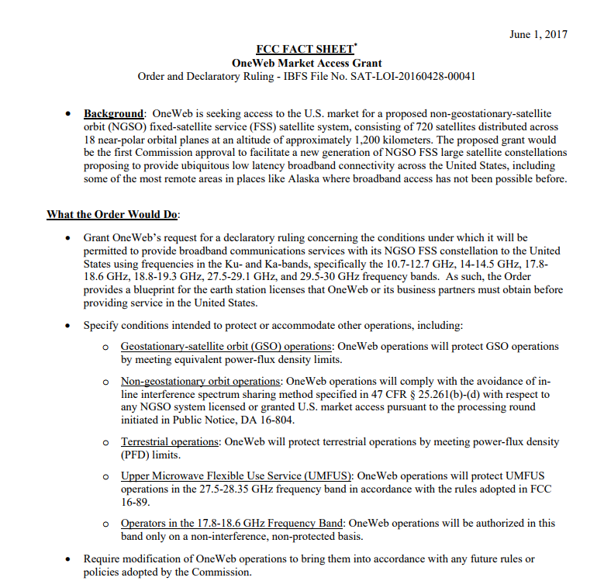
Note that this is described as market access rather than spectral access rights. This might seem like a detail but the access grant ruling is only applicable to the US market.
This is therefore not substantially different from terrestrial mobile spectrum access rights which also have to be negotiated and bid for on a country by country basis though note that these satellite bands have not historically been auctioned but are made available in return for specific service obligations including geographic coverage requirements.
2.21 FirstNet and the 2012 Spectrum Act
One analogy to this would be the AT&T agreement with FirstNet and the US government and the 2012 Spectrum Act determining that $7 billion dollars would be allocated to fund network construction. AT&T has draw down rights on this construction subsidy budget together with access to 20 MHz of 700 MHz spectrum though with onerous service obligations attached. A similar regulatory approach to Ku, K and Ka band spectrum could potentially involve incentives to provide fibre equivalent access to remote rural communities. The NEWLEOS might also be in a good position to provide additional coverage for First Responder user groups presently being supported on Release 8 LTE.
2.22 Fibre access and wireless access rights
Incidentally the collapse of Teledesic in 2002 continues to make waves, some of them positive. The fibre assets of the holding company XO Communications (formerly Next Link), were recently purchased by Verizon for $1.8 billion with an option to acquire some of the residual spectrum access rights of the company at 28 GHz.
Figure 2.16 Next Link Spectrum Coverage Permission Rights at 28 GHz
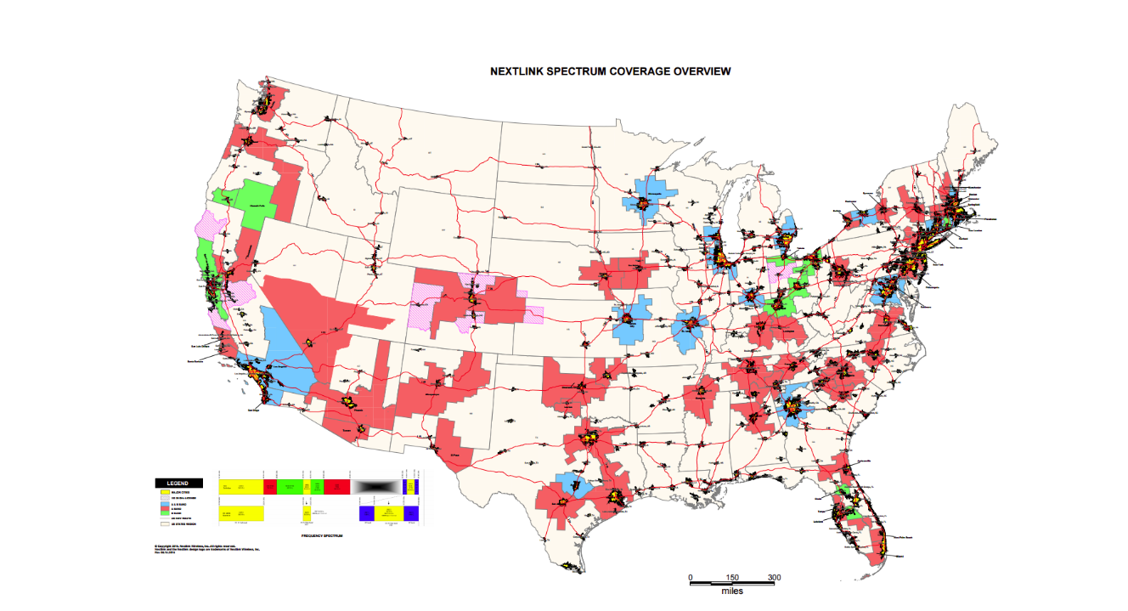
In April 2017 AT&T paid $1.25 billion to acquire the access rights of Straight Path at 28 GHz and 39 GHz.
Next Link and Straight Path are both examples of entities set up to establish local multipoint distribution services (LMDS) but it can be seen that coverage rights do not extend to all or indeed many of the 289 cellular market areas designated by the FCC and there is a particular lack of deep rural coverage. These were essentially speculative spectrum acquisitions by companies with limited engineering resource or network roll out experience and it might be argued that they were really only set up to be bought out by Verizon or AT&T. Note that the LMDS license conditions specify fixed but not mobile services.
This implies a need for line of sight between the base station/access point and user/IOT fixed terminal or customer premises equipment (CPE) to avoid the high scatter losses and surface absorption losses at these shorter wavelengths/higher frequencies.
This is hard to realize both in urban and rural areas and involves insupportably high real estate costs particularly if potential new operators do not have tower or building assets. Operators such as AT&T and Verizon can at least build out from their existing cellular and backhaul infrastructure and site assets. Even bearing this in mind it can be seen that there are some persuasive arguments in favour of direct line of sight from above, the NEWLEO ‘nearly always nearly overhead’ access model. Note that GSO coverage at higher latitudes will be at a low elevation angle and will therefore suffer from blocking from buildings and foliage and from surface scatter (similar to the terrestrial propagation model). Conversely NEWLEO elevation over the equator will need to be inclined in order to meet GSO protection ratios and will similarly suffer from blocking. Note that wet foliage will have a higher absorption loss and it rains a lot in the tropics.
The best option is to combine LEO, MEO and GSO footprints to deliver always overhead downlink and uplink visibility. This would potentially fill pretty much all those coverage gaps shown in Figure 2.13 and more importantly would scale easily to other global markets. We revisit this topic in Chapter 7, Constellation Innovation.
These US specific spectrum acquisitions explain why US operators supported by the FCC are intent on developing 5G at 28 GHz and 39 GHz irrespective of the reservations and objections put forward by other operators in other sovereign countries.
2.23 Fixed Point to Point and Point to Multi Point Microwave Backhaul
LMDS to all intents and purposes was a US regulatory construct designed to encourage new market entrants to provide an alternative to fibre in places where fibre operators did not want to go. As such it depended on realizing a capex and opex cost base lower than fibre on an actual and cost per bit basis which was always going to be optimistic particularly given the failure of previous attempts to realize cost effective fixed access wireless broadband.
We would however refer the reader to Chapters 9 and 10 in 5G Spectrum and Standards where we reviewed the spectrum and band plans used for terrestrial backhaul and microwave links. These are effectively identical in hardware terms to LMDS though with a different purpose (backhaul rather than internet broadband access to individual users and sites) Just to summarise in case you do not have a copy to hand, licensed link equipment at 28 GHz typically delivers 400-Mbps peak throughput through a 56 MHz channel with 38 dBi of isotropic gain through a dish antenna. A 38 GHz link with a 56-MHz aggregated channel supports 500 Mbps with 50 dBi of antenna gain. Spectrum at 42 GHz, 70 GHz or 80 GHz use 112 MHz or 250 MHz channel spacing with high level modulation to deliver 1 Gbps. The 70 and 80 GHz links can also achieve a headline 1 Gbps data rate by aggregating four 250 MHz channels together. The additional bandwidth means lower order modulation can be used.
Clearly there are opportunities to realize scale economy benefits by reusing or cross amortising link hardware for more general point to multipoint and multipoint to multipoint networks. Satellites could also play a greater role in providing back haul. The NEWLEO operators seem particularly confident that they can deliver backhaul at lower cost with adequate latency control.
2.24 Legacy LEO and GSO Operator Spectrum
OneWeb, Space X and LEOSAT (and Sky Space Global and Boeing) are between them producing a constant flow of announcements and proposals for NEWLEO constellations. All of them are actively engaged in producing FCC filings and ITU submissions.
This occasionally frenetic activity should however be viewed in the context of ongoing upgrades by exiting LEO operators Iridium and Globalstar and ongoing GSO upgrades
Iridium and Globalstar are engineering these upgrades within their existing spectrum allocations. Figure 2.1 earlier in the Chapter summarised the Iridium band plan. Globalstar have similar bandwidth constraints to Iridium with user links supported in L band between 1620 and 1618 MHz.
In December 2016, the FCC adopted rules permitting Globalstar to deploy a terrestrial low-power broadband network using 11.5 MHz of the Company's 2.4 GHz (S band) spectrum (2483.5-2500 MHz) to support small cell deployment for LTE networks. It utilizes a 22 MHz wide Channel 14 in 2.4 GHz including 11.5 MHz on a licensed and 10.5 MHz on an unlicensed basis for Terrestrial Low Power Service (TPLS Wi-Fi). In contrast to Iridium, Globalstar do not use inter satellite switching (this is known as a bent pipe system). This reduces cost and constellation complexity but reduces end to end latency control.
GSO constellation upgrades divide into Ku-band and Ka-band upgrades with the Ka upgrades generally described as HTS (high throughput satellite) constellations. The Ka-band constellations (26 - 40 GHz) require a higher rain fade margin but can deliver more isotropic gain from the shorter wavelength fractional beam width antennas and will typically have anything between 12 and 100 spot beams. The pass bands are channelized on 250 MHz channel rasters (similar to the proposed 3GPP Release 16 5G standard).
The graphic below shows one of the Inmarsat pass bands. Compare this for example with the Iridium uplink and down link in L band of 10 by 10 MHz, a two order of magnitude difference in available bandwidth.
Figure 2.17 Inmarsat Ka pass bands with 250 MHz channelization

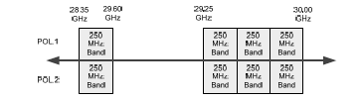
2.25 V and W Band
At the time of writing, Boeing and five other companies, SpaceX, OneWeb, Telesat, O3b Networks and Theia Holdings have all informed the FCC that they have plans to field constellations of V-band satellites in non-geosynchronous orbits to provide communications services in the United States and in Rest of the World markets.
The FCC originally deferred on Boeing’s request to operate between 42 GHz and 42.5 GHz and 51.4 to 52.4 GHz band but Boeing subsequently submitted a new application to the agency asking to use the 37.5 to 42.5 GHz range of V-band for downlinking from spacecraft to terminals on Earth, and two other bands (47.2 to 50.2 GHz and 50.4 to 52.4 GHz) for uplinking back to the satellites. The company’s proposed constellation would consist of 1,396 to 2,956 low-Earth orbit (LEO) satellites in 35 to 74 orbital planes at 1200 kilometres providing a footprint of thousands of 8-11 kilometre cells. The industry rumour mill in 2017 suggested Apple was providing finance or had at least expressed interest in financially supporting the Boeing V band constellation.
Theia Holdings is a break out company from the European Space Agency specialising in small cube sats for communications and remote sensing. The other submissions describe their use of V band spectrum as extensions to their Ku, K and Ka band proposals. SpaceX, for example, proposes a “VLEO,” or V-band low-Earth orbit (LEO) constellation of 7,518 satellites to follow the operator’s initially proposed 4,425 Ka and Ku band satellites Canada-based Telesat describes its V-band LEO constellation as one that “will follow closely the design of the Ka-band LEO Constellation,” using the same number of satellites as the initial proposal (117 satellites excluding spares) as a second-generation overlay. OneWeb have informed the FCC that it wants to operate a sub constellation of 720 LEO V-band satellites at 1,200 kilometres, and another constellation in Medium Earth Orbit (MEO) of 1,280 satellites. Added together, this would expand the OneWeb constellation by 2000 satellites. OneWeb intend to dynamically assign traffic between the LEO and MEO V-band constellations based on service requirements and the data traffic within coverage areas. OneWeb’s application for MEO V band orbit and access rights follows the VIASAT submission for 24 MEO satellites to augment their existing Viasat 3 constellation based on the companies three terabit-per-second-throughput satellites currently being planned and built or rather, financed. VIASAT coupled its submission for the use of V-band with its application for the MEO Ka-band orbit and access rights. O3b has told the FCC that it wants market access to V-band for up to 24 additional satellites that would operate in a circular equatorial orbit as a constellation called O3bN.
2.26 Summary
Many of the established GSO operators have over 50 years of experience delivering broadcast and two way communication services to terrestrial customers including consumers, government agencies, the military and industry and business sectors. Even when privatized they are still regarded as critical national assets and their spectral access rights are conferred accordingly
There are now two NGSO operators, Iridium and Globalstar, who have been providing connectivity from their polar orbit LEO constellations for over twenty years Their customers include government agencies, the military, public protection and disaster relief agencies, mining and exploration industries and anyone who needs connectivity more or less anywhere at any time. Though both constellations required refinancing they are presently in good technical shape and undergoing substantial constellation upgrades.
GSO and NGSO satellite have also been used for many years for earth sensing and imaging. The paths of successive hurricanes in 2017 were tracked with exquisite precision from space. GSO and NGSO satellites are also used to track moving objects including aeroplanes, ships and the odd missile heading towards Japan. These safety critical life critical system requirements are reflected in protection ratios designed to ensure that levels of interference are kept to a minimum.
The NEWLEOS are confident that they can meet these interference conditions and coexistence criteria and on this basis should be allowed to share spectrum presently used exclusively by these incumbent operators.
If this can be made to work there are substantial social, economic and possibly political gains that could be achieved.
From a technical perspective, there are compelling reasons for the industry to move towards a mixed constellation model in which users are serviced from a combination of LEO, MEO and GSO satellites providing always directly overhead (as opposed to nearly always nearly overhead) connectivity.
There is a persuasive argument that 5G terrestrial services could be added to this connectivity offer with all entities coordinated to allow uplink and downlink services and terrestrial services to be mutually complementary.
There are however a legion of regulatory and competition policy and national security and sovereign nation issues and concerns that need to be resolved before this can become a practical reality.
In the next ten chapters we explore the arguments for and against this mixed constellation model and the related regulatory and commercial implications.

http://www.itu.int/en/ITU-R/conferences/wrc/2015/Pages/default.aspx
http://about.dish.com/blog/policy/mvdds-5g-coalition-files-comments-fcc
http://newsroom.sprint.com/softbank-to-acquire-70-stake-in-sprint.htm
https://www.orbcomm.com/
https://www.iridium.com/network/iridiumnext
https://www.globalstar.com/en/
https://apps.fcc.gov/edocs_public/attachmatch/FCC-16-89A1.pdf
http://www.qorvo.com/newsroom/news/2017/qorvo-80211ax-portfolio-provides-broader-faster-lower-cost-wi-fi
www.erodocdb.dk/Docs/doc98/official/pdf/ECCRep166.pdf
https://www.itu.int/dms_pub/itu-r/opb/rep/R-REP-SM.2093-2-2015-PDF-E.pdf
Sometimes referred to as ‘co-sharing’ spectrum
Multichannel Video and Data Distribution Service - TV and Internet delivery technology licensed for use in the US by the FCC. This terrestrial based wireless transmission method reuses Direct Broadcast Satellite (DBS) frequencies for distribution of multichannel video and data over large distances.
https://www.fcc.gov/document/oneweb-processing-round-initiated
http://spacenews.com/oneweb-weighing-2000-more-satellites/
https://www.fcc.gov/document/oneweb-processing-round-initiated
http://spacenews.com/oneweb-weighing-2000-more-satellites/
These are standard fitment to satellites to alter spacecraft orientation - they are also known as ‘momentum wheels’: see Reaction wheel - Wikipedia. A major supplier is Blue Canyon Tech
http://www.investopedia.com/articles/economics/09/lehman-brothers-collapse.asp
https://www.itu.int/newsarchive/press/WRC97/SkyBridge.html
http://spacenews.com/dish-network-battles-oneweb-and-spacex-for-ku-band-spectrum-rights/ http://www.fiercewireless.com/tech/dish-led-mvdds-coalition-urges-fcc-to-act-12-2-12-7-ghz-band-for-5g-asap
https://www.wirelessweek.com/news/2017/06/verizon-locks-early-federal-approval-acquire-nextlinks-28-ghz-spectrum
https://wireless.fcc.gov/services/index.htm?job=service_home&id=lmds
http://www.theiaspace.com/
https://www.appleworld.today/blog/2017/3/11/apple-may-be-funding-boeing-internet-satellite-development

